The Department of Developmental Services

Individual Support Plan

Policy and Procedure Manual

-FOURTH EDITION-
November 1, 2012

Prepared by the Office of Field Operations

with assistance from the

Office of Quality Management

General Counsel’s Office

Office of Policy, Planning and Children’s Services

This manual is designed to provide Department of Developmental Services staff with information regarding how to comply with DDS regulations, policies, and practices regarding the Individual Support Plan process. This Manual is not meant to substitute for legal counsel or advice or a thorough understanding of the governing regulations and statutes. If you have any questions regarding the contents of this Manual or the ISP process, please consult the Operations Division of the Department. In the event that the provisions of the contents of this Manual conflict with any provision of law or regulation, such laws or regulations shall take precedence over the provisions of the Manual that are in conflict.

Department regulations governing the ISP process are found at 115 CMR 6.20-6.25. The ISP regulations set forth the standards and procedures for the development, modification, and review of Individual Support Plans (ISPs). Except as to individuals who have special eligibility pursuant to 115 CMR 6.04, provision of an ISP and of any supports identified therein is subject to the availability of resources.

This Manual is effective as of November 1, 2012 and supersedes all previous manuals and guidance materials specific to the ISP. Governing law, regulations, practice, and policy may be amended from time to time; be sure to consult the current version of the law and regulations or contact the Operations Division of the Department for information on the most current information.

TABLE OF CONTENTS

Introduction 5
Overview 6
Conceptual Framework 7
ISP Process Overview 7
The ISP Document 8
ISP Requirements and Timeline 10
Who Receives An ISP? 11
Creating The Vision Statement 12
Preparing for the ISP Meeting 14
Service Coordinator Responsibilities 14
Requesting Assessments 18
Service Provider Responsibilities 20
Conducting the ISP Meeting 22
Completion, Review and Mailing the ISP Document 23
Monitoring ISP Implementation 24
Annual ISP Update 25
Modifying the ISP 26
Completing the ISP Document 28
Vision Statement 29
Current Supports 33
Safety and Risk 38
Legal/Financial/Benefit Status 39
Successes, Challenges, Emerging Issues, Unmet Needs 39
Goals 41
Objectives 41
ISP Appeals 42
ISP Forms 45
Using the Forms 46
Annual ISP Form
Update ISP Form
Service Provider Support Agreement
ISP Progress Summary Form
ISP Modification Form
Emergency Fact Sheet
Identification form
ISP Assessments 52
DDS ISP Safety Assessment
DDS ISP Health and Dental Assessment
DDS ISP Financial Assessment
DDS General ISP Assessment

TABLE OF CONTENTS

ISP Letters 53
Notification Letter: Invitation to ISP Meeting
ISP Distribution/Delivery Letter to Individual
ISP Distribution/Delivery Letter to Guardian
ISP Distribution/Delivery Letter to Service Provider
ISP Response Sheet and Appeal Notification to Guardian and/or Individual
Ricci Class Member ISP Response Sheet and Appeal Notification
to Guardian and/or Individual
ISP Response Sheet for Service Provider(s)
Ricci Class Member ISP Response Sheet for Service Provider(s)
Appendix 54
Talking Points for Service Coordinators 55
Convening and Running A Meeting 56
ISP Timeline Guide 57
ISP Workflow 58
Sample ISP Documentation Cover Sheet 62
Related Guidance 63
Service Coordinator Case Note Documentation Requirements 64
Guidance Regarding Frequently Requested Assessments 67
MASSHEALTH Eligibility Representative Designation Form 69
S.M.A.R.T.E.R. Objectives 71

INTRODUCTION

I am pleased to announce that the Department of Developmental Services has completed enhancements to the Individual Support Planning process, including revisions to DDS regulations that reflect these improvements. The last substantial revision to the ISP occurred nearly 20 years ago. Since then, we have expanded the community services system, created a rich variety of services and supports for individuals with intellectual disability, and created a new emphasis on self-determination and self-directed services. Refreshing our planning process is the logical next step to promoting the Department’s mission:

The Department of Developmental Services is composed of people dedicated to creating, in cooperation with others, innovative and genuine opportunities for individuals with intellectual disability to participate fully and meaningfully in, and contribute to, their communities as valued members.

The new Individual Support Planning process will:

- Strengthen the individual’s Vision Statement to make the ISP a more person-centered, living document that reflects the hopes and dreams of the individual.
- Promote greater opportunities for individuals to exercise choice and self-determination.
- Emphasize ISP Goals and Objectives that relate to the individual’s Vision Statement and promote on-going growth and development for the individual.
- Enhance and promote collaboration among ISP Team members by establishing a new sequence of activities, more consistent expectations, and a streamlined ISP document that creates a clear road map for the ISP Team to follow in support of the individual.

The Individual Support Planning process continues to begin with an individual's personal Vision Statement and will take the concept of self-determination from theory to practice. I look forward to working with you as we move forward in supporting individuals with intellectual disability.

Elin M. Howe
Commissioner
September 2012

OVERVIEW

CONCEPTUAL FRAMEWORK

ISP PROCESS OVERVIEW

THE ISP DOCUMENT

CONCEPTUAL FRAMEWORK

One of the most important supports that the Department provides to individuals is a robust and thoughtful planning process that culminates in an Individual Support Plan (ISP) that clearly articulates the hopes, desires, and needs of the individual, describes his/her life circumstance, and charts a path for the Individual Supports Team (ISP Team) to follow in supporting the individual to meet his or her Goals.

The ISP is intended to capture a moment in time and the emphasis is on the present and the future. Service Coordinators are responsible for assuring that the individual’s voice is clearly heard while balancing competing desires and needs. For example, an individual may clearly articulate a desire to spend time alone, yet be unsafe in crossing streets or assessing risks in the community. Guardians may prefer that the individual be protected rather than taking a chance on something new that has a risk of failure. Service Providers may be more oriented to specific tasks than to an overall process or vice versa.

All of these elements need to be taken into account and integrated into an ISP that keeps the person at the center of the process and provides clear direction to team members on the individual’s priorities, needs and Goals for the next 2 years. This is not always an easy task but is a rewarding one with which staff of the Department are very familiar, having worked with many individuals in a myriad of situations over the years. The ISP is designed to describe the supports and resources available to the individual while meeting the Department’s legal and regulatory obligations and assuring that each ISP is unique in reflecting the individual’s abilities and needs. DDS staff are responsible for assuring that the ISP adheres to the DDS regulations, policies, and procedures.

ISP PROCESS OVERVIEW

Individual Support Plans are developed every 2 years and are reviewed in the intervening year by the ISP Team at an Annual Update meeting. The ISP Team includes the individual, guardian (if any), authorized family members, the DDS Service Coordinator, Service Providers, and other representatives that the individual and/or guardian identify. The DDS Service Coordinator works with the ISP Team to prepare for and schedule the ISP meeting, facilitates the ISP Meeting, completes the ISP document, and distributes it to the ISP Team for review and approval. Service Providers implement the ISP and report progress on Goals and Objectives to the Service Coordinator and individual and/or guardian at least every 6 months.

ISP Teams are in regular communication throughout the year for a variety of reasons. However, face to face meetings with the entire ISP Team may be infrequent. To assure that ISP meetings promote effective collaboration among the members of the ISP Team, comprehensive preparation is required of all members of the ISP Team.

THE ISP DOCUMENT

The purpose of the ISP is to assure that people who support the individual have a clear picture of the individual’s Vision Statement and current circumstances, the supports in place to address his or her needs, Goals for the future and the specific Objectives that the ISP Team will be addressing during the 2-year ISP cycle. The emphasis is on the present and future.

The ISP document will be no longer than 6 pages, exclusive of supporting documents (i.e. assessments, support strategies, etc.) and is divided into the following 7 Sections.

I. Vision Statement
To emphasize the importance of the individual’s wishes, the ISP begins with a Vision Statement. The Vision Statement is an exploration of what is important to the person in his or her life. It must describe the individual’s preferences on how he or she wishes to live, work, and spend leisure time as well as the interests, relationships, and activities that are important to him or her. When completed, it will reflect a clear picture of the individual’s hopes, wishes, and dreams for the future over the next 2 years.

Service Coordinators have an affirmative role in supporting the individual to articulate the Vision Statement, in collaboration with the individual’s guardian (if any) and support network. While the entire ISP Team may have insights and opinions as to what is most essential to the individual, the Vision Statement does not belong to the team, but to the individual.

II. Current Supports (Services, Settings, and People)
In contrast to the Vision Statement which articulates the person’s wishes, the Current Supports section of the ISP describes his or her life circumstances and needs. This section of the ISP must clearly articulate where the individual lives, how he or she spends the day, the individual’s assessed needs, and the services and supports that are provided to address those needs.

This Section of the ISP may reference related documents as attachments to the ISP where appropriate and is divided into several subsections: Home/Community, Employment/Day, Health and Dental, Medications, Adaptive Equipment/Assistive Technology, and Clinical.

This Section of the ISP also identifies the manner in which services are provided: Traditional, Self-Directed, or Agency with Choice.

III. Safety and Risk
This Section of the ISP identifies the individual’s safety skills and supervision needs; situations, if any, in which the individual poses a risk to him/herself and/or the community; and strategies to address these safety and risk issues.

IV. Legal/Financial/Benefit Status
This Section of the ISP includes the individual’s legal status, the benefits they receive, and information regarding his or her financial resources. It is intended to support the ISP Team in assuring that the individual maintains essential supports, including entitlement income, health insurance, and support in decision-making.

V. Successes, Challenges, Emerging Issues, Unmet Needs
This Section of the ISP provides the opportunity to highlight specific events and experiences that have had a significant impact on the individual over the past 2 years or are anticipated to have a significant impact in the future. Satisfaction with services, requests for changes in Service Providers, and requests for different or new services will be reflected in this section.

VI. Goals
This Section of the ISP lists the Goals that the ISP Team has determined are priorities to address over the next 2 years. The Goals should reflect what is important to the individual and relate to his or her Vision Statement and/or assessed needs. Goals may be addressed by multiple members of the ISP Team using a variety of approaches specific to their area of responsibility.

VII. Objectives
This Section of the ISP lists the Objectives the ISP Team will address to promote attainment of the individual’s Goals. Objectives may relate to the Vision Statement and/or assessed needs to promote independence and self reliance to the greatest degree possible and desired.

ISP REQUIREMENTS

WHO RECEIVES AN ISP?

ISP TIMELINE

CREATING THE VISION STATEMENT

PREPARING FOR THE ISP MEETING

SERVICE COORDINATOR RESPONSIBILITIES

SERVICE PROVIDER RESPONSIBILITIES

CONDUCTING THE ISP MEETING

COMPLETING THE ISP DOCUMENT

COMPLETION, REVIEW & DISTRIBUTION
OF THE ISP DOCUMENT

MONITORING ISP IMPLEMENTATION

ANNUAL ISP UPDATE

MODIFYING THE ISP

ISP REQUIREMENTS: Who Receives An ISP?

An ISP will be developed with:

- All Ricci Class members;
- All individuals enrolled in an adult Home and Community-Based DDS Waiver program;
- All individuals receiving residential supports provided or purchased by DDS, including supports that supplement Adult Foster Care;
- All individuals receiving day or employment supports provided or purchased by DDS, including supports that supplement Day Habilitation programs; and
- All individuals receiving Day Habilitation or Adult Day Health Services funded in whole or in part by DDS.

Individuals receiving minimal supports may or may not receive an ISP at the discretion of the Department. For guidance regarding these supports, the Service Coordinator should consult the Area Director.

An ISP must be developed within 60 days of the provision of supports.

ISP TIMELINE: Creating The Vision Statement

“Dream lofty dreams, and as you dream, so shall you become.

Your Vision is the promise of what you shall one day be.

Your Ideal is the prophecy of what you shall at last unveil.”

~ James Allen

SUPPORTING THE INDIVIDUAL

The ISP cycle begins with a consultation with the individual and guardian (if any) about what is most important to him or her now and in the future to support the development of the Vision Statement. This is the area where the Service Coordinator should encourage the individual to dream beyond the confines of service provision. The Vision Statement will be used by the ISP Team to identify Goals and Objectives that will promote growth for the individual and support the individual’s dreams to move towards reality.

Service Coordinators are responsible for supporting the individual and guardian to create a well-developed Vision Statement and will consult with other members of the ISP Team when needed and appropriate. When complete, the Vision Statement will be person-centered, clearly state what is most important to the individual and reflect his or her capacity and desire for self-determination. The individual’s Vision Statement will be shared with the ISP Team and will provide direction during the ISP Meeting, in the development of Goals and throughout the implementation of the ISP to assure the ISP Team continues to maintain the focus on the individual and his or her hopes, dreams, and preferences.

The Vision Statement will be developed by seeking the answers to 4 key questions:

- What does he/she identify as important activities and relationships to continue to be involved in? What other things would he/she like to explore?
- What does he/she think someone needs to know in order to provide effective supports?
- What does he/she think are his/her strengths and abilities?
- What would he/she like to see happen in his/her life over the next two years?

Service Coordinators will determine, based on their knowledge of the individual, the most effective means of supporting the individual to articulate the Vision Statement. The Service Coordinator should begin with a discussion of the Vision Statement questions with the individual and encourage him or her to express direction for the ISP Team to the greatest degree possible. In those instances where the individual is unable to fully express his or her wishes, the Service Coordinator will solicit input from people who know the individual well, including the guardian (if any), friends, family members, and Service Provider staffs who work with the individual.

For many individuals, the answers to the 4 questions will evolve over time. The individual may need time to reflect and consult with trusted supporters on what they truly wish the ISP Team to know. In other circumstances, the individual will be specific and clear at the onset of the conversation. What is important is that the process used to develop the Vision Statement is respectful, keeps the individual in the forefront, and assures he or she has sufficient opportunity and support to determine the course he or she wishes to follow for the next 2 years.
In those circumstances where the ISP Team encounters conflict between individual’s Vision Statement and the perspective of other ISP Team members, the Vision Statement should still reflect the individual’s wishes. Other areas of the document will be available to reflect the concerns of other members of the ISP Team and/or related DDS concerns.

In those circumstances where neither the individual nor their guardian is able to answer the questions that formulate the Vision Statement, a notation will be included in the ISP document indicating that the Vision Statement was developed by supporters rather than by the individual/guardian.

In many circumstances, the Service Coordinator will be able to support the individual to develop the Vision Statement during the course of his or her duties on behalf of the individual through direct, cumulative knowledge of what is most important to the individual and/or guardian.

However, the Service Coordinator must conduct a face to face meeting to develop the Vision Statement:

- For the individual’s first Individual Support Plan;
- When significant changes have occurred or are anticipated in the individual’s life;
- At the request of the individual/guardian; and,
- When directed by the Area Director/designee.

ISP TIMELINE: Preparing for the ISP Meeting

Service Coordinator Responsibilities

The Service Coordinator has the primary, foundational role in creating a person-centered ISP. The Service Coordinator is responsible for identifying the members of the ISP Team with the individual and guardian (if any), scheduling the meeting, gathering and sharing relevant information, facilitating the ISP meeting, and distributing the ISP document based on the Goals and Objectives finalized at the ISP meeting and consistent with DDS regulations and policies.

Thoughtful preparation is the key to a successful ISP that acknowledges the individual’s abilities, strengths and needs and creates a teaching plan that will support the individual to achieve his or her Goals. The Service Coordinator must facilitate the fullest possible participation of members of the ISP Team, including family members where desired by the individual and guardian, if any. The Service Coordinator must provide reasonable assistance and accommodations to enable the individual and other members of the ISP Team to participate meaningfully in the development, review, and implementation of the ISP.

At least 45 days prior to the ISP Meeting, the Service Coordinator needs to:

- Consult with the individual and guardian (if any) in order to:
- Explain the purpose of the ISP and the ISP meeting;
- Develop an understanding of the individual’s Vision Statement, Goals, current circumstances, and satisfaction with his or her current services;
- Determine the issues to be reviewed at the ISP meeting;
- Determine who should be invited to attend the ISP meeting, including family members;
- Determine when and where the ISP meeting should be held; and
- Determine what assessments or professional consultations are necessary for the development of the ISP.

In many circumstances, this consultation will occur through cumulative information gathered by the Service Coordinator during the execution of his or her responsibilities to monitor services and supports to the individual. However, in several circumstances a face to face meeting is required:

- For the individual’s first ISP meeting;
- When significant changes have occurred or are anticipated in the individual’s life;
- At the request of the individual or guardian; and,
- When directed by the Area Director or Area Director Designee.

In cases where the guardian is not readily available, the Service Coordinator may contact the guardian by telephone or use other technological means (i.e. Skype) to complete the consultation with the guardian.

2. Consult with authorized family members, if any, regarding the individual’s current status and circumstances from the family members’ perspective.

3. Solicit input from Service Providers to identify potential Goals for the upcoming year.

4. Review and analyze existing information from the previous year, including the following:

- The previous ISP, including assessments and modifications, if any, since the last meeting of the ISP Team;
- ISP Progress Summaries
- MEDITECH Notes
- HCSIS Reports
- Health Care Record (if any)
- Site Visit Reports
- Meeting Minutes

5. The Service Coordinator should also review the following aspects of the individual’s current circumstances as part of their preparation for the ISP meeting:

The Individual’s Living Environment and/or Life Circumstances

Is the individual living in a supportive environment with his or her:
- Family members?
- Social network?
- Guardian(s)?
- Landlord?

Is the individual’s home:
- Safe, clean, in good repair and include basic utilities (heat, electricity, water)?
- Appropriate to the individual’s needs (if any) for accessible housing?
- In a safe neighborhood?
- Accessible to the community?

Is the individual’s employment or day program:
- Supportive of their Goals relating to employment and/or community participation?
- Providing sufficient income to meet his or her needs and desires?

In the last 6 months has the individual experienced:
- Decreased access to the community?
- A change in caregivers?
- A change in housemates or housing?
- A change in employment?
- Suffered the loss of a friend, family member, or caregiver?
- Indicated a desire for a different living situation?

Health Status

What is the general health status of the individual?

Has the individual had regular medical and dental appointments in the past year?

Is the individual capable of managing his or her own health care or does he or she need support?
Is the individual self-medicating or not? When was the last time the individual was assessed regarding the ability to manage their own medication?

Has there been a significant change in the individual’s health over the past year, such as but not limited to:
- Increase or decrease in overall fitness and well being?
- Significant change in weight?
- Frequent ER visits?
- Multiple medication changes?
- Refusing to participate in health care appointments/take medications?

Does the individual have a diagnosis of seizures/epilepsy? If so,
- Are the seizures well controlled?
- Has the individual been hospitalized because of seizures within the past six months?
- Has the individual experienced changes in the frequency and/or severity of seizures within the past 6 months?
- Has the individual had seizure medication(s) changed in the past 6 months?

Does the individual have a diagnosis of diabetes? If so,
- Is the person’s blood sugar checked regularly and, if so, by whom?
- Has a special diet been recommended for the individual?
- Does the individual follow the recommended diet?
- Does the individual take insulin?
- Has the individual been hospitalized for diabetes in the last 6 months?
- Has the individual gained significant weight in the last 6 months?
- Has the individual been diagnosed with pneumonia in the last 6 months?

Does the individual experience swallowing or eating issues such as:
- Poor dentition?
- Eating at an unusual pace (very quickly or very slowly)?
- Ingesting or mouthing non-food items?
- A history of choking or poor swallowing?
- Coughing during and/or after meals?
- Refusing to eat?
- Unintended, significant change in weight?
- A change in digestion or bowel habits over the last 6 months?

Bowel and Urinary Tract issues: Does the individual:
- Appear to have abdominal pain?
- Have unusually infrequent or frequent bowel movements?
- Experience frequent urinary tract infections?

Mobility: In the past 6 months, has the individual experienced:
- A change in his or her ability to move about?
- A change in his or her ability to use stairs?
- A change in his or her ability to participate in personal hygiene?
- More frequent falls?
- Falls resulting in injury or ER visits?
- Adaptive equipment in need of repair?
Mood or Manner: In the past 6 months, has the individual experienced or demonstrated:
- A change in alertness, orientation, or ability to communicate?
- A change in desire for or in initiating social activities?
- A change in ability to follow tasks?
- Appear more forgetful, confused, sleepy, aggressive, unhappy?
- An increase in self-injurious behavior?
- A change in decision making ability?

Individual Habits and Behaviors

Is the person participating in activities that put them at risk, such as, but not limited to:
- Ingesting inedible objects?
- Smoking?
- Substance abuse?
- Gambling?
- Unsafe sexual activity?
- Other personal habits that are hazardous, such as traveling alone at night?
- Frequently eloping or wandering from their home?
- Engaging in behavior(s) that pose a risk to others?

A thorough review of this information will support the Service Coordinator in developing a broad understanding of what has occurred for the individual during the past year. Analysis of the information can identify themes or patterns that may indicate changing needs or the need for a different approach in addressing the individual’s Goals.

For example, data from HCSIS may show an increase in self-injurious behavior that has resulted in emergency restraint. This information would trigger further analysis regarding the causes of this pattern, possible solutions and may point to the need for additional, specific assessments or consultations.

After review of all available information, the Service Coordinator, in conjunction with the individual and other ISP Team members, will determine what assessments and/or professional consultations are needed to identify the individual’s needs and fulfill DDS requirements.

Requesting Assessments

The purpose of ISP assessments is to obtain specific information that will assist the ISP Team in identifying the individual's capabilities, support needs, and opportunities for skill development. The content of the assessments will support the ISP Team in establishing Goals, Objectives and Support Strategies that are the least restrictive and likely to be effective in assisting the individual to attain his or her Goals. The chart below identifies standardized assessments required by regulation (see 115 CMR 6.22(3)) for the services most frequently purchased or provided by the Department.

SERVICE NAME | ACTIVITY CODE NUMBER | SAFETY ASSESSMENT | HEALTH AND DENTAL ASSESSMENT | FINANCIAL ASSESSMENT
Placement Services (also referred to as Shared Living | 3150 | Always | Always | Always
Vendor Operated 24-hour Residential Supports | 3153 | Always | Always | Always
Community Based Day Supports | 3163 | Always | If Supports are Relevant to  Health Care Needs | If Supports are Relevant to Financial Needs
Individual Supported Employment | 3168 | Always | Never | If Supports are Relevant to Financial Needs
Center- Based Work Services | 3169 | Always | Never | If Supports are Relevant to Financial Needs
Competitive Integrated Employment Services | 3180 | Always | Never | If Supports are Relevant to Financial Needs
Group Employment (also referred to as Enclave) | 3181 | Always | Never | If Supports are Relevant to Financial Needs
Emergency Stabilization Residence | 3182 | Always | As Determined by Contractual Obligation | As Determined by Contractual Obligation
Day Habilitation Supplement | 3285 | Always | If Supports are Relevant to  Health Care Needs | If Supports are Relevant to Financial Needs
Supplemental Adult Supports (for individuals enrolled in Adult Foster Care) | 3287 | Always | If Supports are Relevant to  Health Care Needs | If Supports are Relevant to Financial Needs
Individual Supports and Community Habilitation | 3749 | As Determined by Contractual Obligation | As Determined by Contractual Obligation | As Determined by Contractual Obligation
Community Living Supports | 3798 | Always | Always | Always
State Operated Residential Supports | 4157 | Always | Always | Always
State Operated Center-Based work | 4169 | Always | Never | If Supports are Relevant to Financial Needs
The Service Coordinator may determine that additional assessments are needed. When requesting additional assessments, Service Coordinators should be guided by the purpose of the service and the Goals the individual has identified. Circumstances that are likely to trigger a request for additional assessments are:

- The individual is previously unknown to DDS;
- There has been a change in the capacity of the individual since the last ISP;
- Information is needed to address one or more of the individual’s Goals.

Please see the Appendix for guidance regarding frequently requested assessments and professional consultations.

At least 30 days prior to the ISP Meeting, the Service Coordinator needs to:

- Notify the ISP Team of the time, date, place and purpose of the ISP meeting.
  - Individuals/guardian(s), including Ricci class members must be notified by regular mail.
  - Other members of the ISP Team may be notified by other means, such as email. All precautions to maintain confidentiality of information and individual identity (i.e. using initials and omitting personal identifiers), must be employed.

- Share the individual’s Vision Statement and any proposed Goals that the individual and guardian(s), if any, have identified they would like to pursue over the coming year with the rest of the ISP Team.
- Share dissatisfaction with services and other matters of concern with appropriate ISP Team members before the ISP meeting when possible. Early notification of such issues will minimize unnecessary surprises at the ISP meeting.
- Request assessments and professional consultations from appropriate Service Providers.

At least 7 days prior to the ISP Meeting, the Service Coordinator needs to:

- Review assessments and professional consultations submitted by Service Providers to assure they are individualized, current, complete, accurate, and include the individual’s strengths, needs, and opportunities for development.
- Make assessments and professional consultations available to authorized ISP Team members if requested (see 115 CMR 6.21 (5)(c)).
- Complete the Assessment of Ability and HCBW Assessment in MEDITECH for review at the ISP Meeting.

The Service Coordinator may develop a draft of the ISP as a working document that will assist in organizing and verifying the information that the Service Coordinator has gathered prior to the ISP Meeting.

Service Provider Responsibilities

Service Providers have an equally important role in preparing for the ISP meeting. They should review progress reports, meeting notes and other information related to their legal and contractual responsibility for the individual before completing the assessments and/or professional consultations requested by DDS.

Information a Service Provider may need to review includes the individual’s progress on current ISP Goals and Objectives, current circumstances, health, habits, and behaviors as well as HCSIS reports (if any) from the previous year. Service Providers may also consult with the individual about his/her Vision Statement and Goals.

At least 15 days prior to the ISP Meeting, the Service Provider needs to:
  - Submit required assessments in DDS-approved format to the Service Coordinator and consistent with DDS standards.
    - DDS standards for ISP assessments and professional consultations are as follows:
      - Individualized
      - Current
      - Complete
      - Accurate
      - Includes relevant strengths and needs
      - Identifies opportunities for development
  - Submit ISP Progress Summaries in DDS approved format to the Service Coordinator.
  - Develop preliminary Goals and Objectives with input from the individual and/or guardian(s).

At least 15 days prior to the ISP Meeting, the Service Provider needs to:

1. Submit proposed ISP Objectives and Support Strategies consistent with the following DDS standards:

OBJECTIVES
    - Individualized
    - Measurable
    - Include methods for evaluating progress
    - Relate to Vision Statement and/or assessed needs

SUPPORT STRATEGIES
- Individualized
- Specific
- Measurable
- Action oriented
- Relevant to the individual’s abilities and needs
- Time-limited
- Effective
- Regularly reviewed and reported
Objectives may relate to the Vision Statement and/or assessed needs to promote independence and self-reliance to the greatest degree possible and desired. Objectives are often necessary to address functional limitations in skills or adaptive behavior including but not limited to:

- Conceptual Skills—language; reading and writing; money, time, and number concepts.

- Social Skills—interpersonal skills, social responsibility, self-esteem, gullibility, naïveté (i.e., wariness), follows rules/obeys laws, avoids being victimized, and social problem solving.

- Practical Skills—activities of daily living (personal care), occupational skills, use of money, safety, health care, travel/transportation, schedules/routines, and use of the telephone.

Objectives should be developed based on the Vision Statement and Goals identified by the individual and/or guardian as well as assessed needs identified by Service Providers. Objectives will identify the first step(s) in the plan toward achieving the individual’s Vision and Goals. Objectives should be written in person-centered, behavioral terms, with one measurable action and specific performance criteria that will be used to determine whether or not the individual has successfully met the Objective. Once an Objective has been met, a new Objective that logically reflects the next step toward achievement of the Goal will be identified and addressed. This pattern is repeated until the individual and team determines that the Goal has been achieved.

As part of the implementation plan or Support Strategy for each Objective, the Service Provider(s) responsible for its implementation must be clearly identified. Wherever possible and appropriate, Service Providers should coordinate their efforts to address Objectives in a consistent, coordinated manner. While the specific Support Strategy employed may vary based on the type of service and its location, the Objectives should be addressed by multiple Service Providers when possible.

It is important to bear in mind that Service Providers are responsible for assuring that the Assessments, Professional Consultations, Objectives and Support Strategies that they submit meet DDS criteria and that Service Provider staff are properly trained to meet those standards. The Service Coordinator should refer Service Providers to the S.M.A.R.T.E.R. Objectives training information in the Appendix for further details on writing effective Objectives.

ISP TIMELINE: Conducting the ISP Meeting

The Service Coordinator is responsible for convening and facilitating the ISP meeting and ISP Update meeting in accordance with DDS regulations and policies.

At the ISP Meeting, the Service Coordinator will assist the ISP Team to:

- Support the Individual and guardian(s), if any, to further articulate the Vision Statement;
- Discuss the individual’s current circumstances;
- Review recent experiences and life events that may affect the individual’s immediate future, general health, safety, or long term Goals;
- Review all sections of the ISP;
- Review and prioritize Goals for the 2-year ISP cycle;
- Finalize Objectives and Support Strategies that support achievement of Goals;
- Review the dates when progress reviews will be submitted by each Service Provider for each Objective (monthly, quarterly, or semi-annually);
- Select a date for the Update ISP Meeting no more than 365 days after the ISP meeting; and
- Verify and, if needed, update the Identification Sheet, Emergency Fact Sheet, and Detailed Individual Data Sheet (from MEDITECH).

At the conclusion of the meeting, the ISP is considered finalized with the following exceptions:

- If new Goals, Objectives and/or Support Strategies are identified at the ISP meeting, the responsible Service Provider must submit the new Objectives and Support Strategies to the Service Coordinator within 7 days.
- If previously submitted Assessments, Objectives, and/or Support Strategies need to be revised to meet DDS standards, the responsible Service Provider must do so and submit them to the Service Coordinator within 7 days of the ISP meeting.
- If the Emergency Fact Sheet has been revised at the ISP meeting, the Residential Service Provider (if any) must submit the new Emergency Fact Sheet to the Service Coordinator and the Day Program Service Provider (if any) within 7 days.

ISP TIMELINE:

Completion, Review & Distribution of the ISP Document

No more than 30 days after the ISP meeting, the Service Coordinator must:

  - Complete the ISP document;
  - Gather related material (i.e. assessments, behavior plans, etc.); and,
  - Submit the ISP and related documents to their Supervisor for review.

This allows 15 days for supervisory review, Area Director/designee approval, final assembly of the ISP packet for distribution, and, where needed, management follow-up on outstanding documentation with the Service Provider.

No more than 45 days after the ISP meeting, the ISP must be distributed for approval in accordance with the Department’s regulations (see 115 CMR 6.23(5)), confidentiality standards, and HIPAA requirements. The date the ISP was mailed must be maintained by the Area Office.

The ISP Packet for an Annual ISP consists of the following documents:

- ISP Distribution/Delivery Letter
- Individual Service Plan (6 page limit)
- Attendance Sheet
- Service Provider Objectives and Support Strategies
- Service Provider Assessments and Professional Consultations (if not previously distributed)
- Functional Needs Assessment (for Title XIX Facilities only)
- Day Habilitation Plan, if any
- Health Related Protocols, if any
- Psychotropic Medication Treatment Plan, if any
- Behavior Plan(s), if any
- ISP Response Sheets
- Appeal Rights

The following documents are not mailed with the ISP packet but are filed in the individual’s Confidential Record:

- Assessment of Ability
- HCBW Assessment
- Health Care Record, if any

Any participant with a right to appeal will be deemed to agree to the plan unless an appeal is filed within 35 days of the ISP or of the explanatory meeting (if any), pursuant to 115 CMR 6.23 (5).

35 days after the ISP is mailed: the appeal period expires

ISP TIMELINE: Monitoring ISP Implementation

The implementation of the ISP is primarily the responsibility of Service Providers. The Service Providers are responsible for training the appropriate staffs within their organization so that they can effectively implement the ISP using the Support Strategies developed for each Objective.

The Support Strategy identifies where, when, and how the Objective is addressed, as well as the method for data collection and the frequency of review. The data that is collected provides information on the effectiveness of the Support Strategies and will be used by Service Providers to prepare ISP Progress Summaries based on the frequency the ISP Team has determined (monthly, quarterly, or semi-annually). From this information the Service Coordinator and/or other members of the ISP Team can determine if the individual is making progress and, if not, what changes need to be made.

The Service Coordinator is responsible for monitoring the implementation and effectiveness of the ISP. The purpose for monitoring the ISP is to assure that Service Providers are fulfilling their contractual obligations relating to the ISP, that Goals and Objectives are being implemented consistent with the ISP, and that the individual is making progress in achieving his or her Goals.

SEMI-ANNUAL REVIEW

The Service Coordinator must review the implementation of the ISP at least every 6 months based on the following:

- The ISP Progress Summaries submitted by the Service Providers.
- Information gathered through conversations with ISP Team members, meetings and site visits.
- Observations of the individual.
- HCSIS Reports
- MEDITECH Notes

The Service Coordinator must record a MEDITECH Note of the Semi-Annual Review that includes the following information:

- The date of the Service Coordinator’s review;
- A statement indicating whether the ISP Objectives are being addressed as described in the ISP and if the individual is making progress, and;
- If necessary, a statement that the ISP has been or needs to be modified.

In the event that the Service Coordinator determines that the ISP is not being implemented as required or that a change in the ISP is warranted, he or she will follow up with the appropriate Service Provider and may convene an ISP Team meeting to review the issue that has been identified. Where warranted, the ISP may be modified (see Page 26).

ISP TIMELINE: Annual ISP Update

The ISP Team will meet to review and update the ISP no more than 365 days after the ISP meeting. The notification and assessment requirements are the same as for the ISP Meeting (see 115 CMR 6.24). At the meeting the Service Coordinator will assure the ISP Team:

- Reviews all Sections of the ISP. Updates will be recorded where needed and appropriate.
- Reviews progress on the Goals and Objectives based on ISP Progress Summaries prepared by Service Providers.
- Reviews any significant changes in the individual’s abilities or circumstances.
- Determines whether the Goals and Objectives are consistent with the individual’s current desires.

No more than 45 days after the ISP Update meeting, the Update ISP must be distributed for approval in accordance with the Department’s regulations (see 115 CMR 6.23(5)), confidentiality standards, and HIPAA requirements. The date the ISP was mailed must be maintained by the Area Office.

The packet for an ISP Update consists of the following documents:

- ISP Distribution/Delivery Letter
- Individual Service Plan with update attached
- Attendance Sheet
- Service Provider Objectives and Support Strategies
- Service Provider Assessments and Professional Consultations (if not previously distributed)
- Functional Needs Assessment (for Title XIX Facilities only)
- Day Habilitation Plan, if any
- Health Related Protocols, if any
- Psychotropic Medication Treatment Plan, if any
- Behavior Plan(s), if any
- ISP Response Sheets
- Appeal Rights

The following documents are not mailed with the ISP packet but are filed in the individual’s Confidential Record:

- Assessment of Ability
- HCBW Assessment
- Health Care Record, if any

Any participant with a right to appeal will be deemed to agree to the updated plan unless an appeal is filed within 35 days of the updated ISP or of the explanatory meeting (if any), pursuant to 115 CMR 6.23 (5).

35 days after the updated ISP is mailed: the appeal period expires

ISP TIMELINE: Modifying the ISP

The ISP must be modified when necessary to reflect changes in the individual’s Goals or needs, to promote a quality of life consistent with DDS Outcomes (see 115 CMR 6.23(2)) or to provide the least restrictive, most adequate and appropriate supports consistent with the individual’s desires and needs.

An ISP Modification is required whenever any of the following changes are proposed to be implemented prior to the individual’s next ISP review:

 Any change in the Goals for an individual;
 Any change in the types of supports or services that will be used to help the individual to attain his or her outcomes or in the duration and frequency of such supports;
 A change in the strategies that will be used to meet unmet support needs;
 A change in the priority for services or supports assigned to the individual’s needs where such a change will affect the services or supports provided and available to the individual;
 Initiation of a behavior modification plan or modification of any part of a behavior modification plan involving the use of an aversive or intrusive technique; and
 A change in the location of an individual’s home, from a home or Developmental Center operated by the Department or a provider certified by the Department to another such home.

Any proposed changes not listed above do not require an ISP modification; however, a meeting of the ISP Team may be appropriate or useful, even if not required.

PROCEDURE
Any of the following people may contact the Service Coordinator when a change in one of the above-listed areas has or will occur and explain the nature of the change and the reason for the request for modification:

 the individual;
 the individual’s guardian, if any;
 family members of the individual who are not guardians, if the individual does not object to their request; or
 a current provider of services or supports to the individual.

The Service Coordinator also may initiate an ISP modification.

Within 30 days of a request for a modification, the Service Coordinator must call a meeting to decide whether a requested modification should be made. The Service Coordinator will provide at least 10 days’ notice to the following persons, who must be invited to attend the ISP modification meeting.

 the individual;
 the individual’s guardian, if any;
 the family members of the individual who are not guardians, if the individual does not object to their presence; and
 Representatives of providers of services or supports to the individual.
(Note: all providers of supports to the individual should be notified, but the Service Coordinator may waive participation by providers who do not have an interest in the issue which is the subject of the proposed modification.)
WAIVING THE ISP MODIFICATION MEETING
At the Service Coordinator’s discretion, the modification meeting and any timeline related to such meeting may be waived with the documented approval of:

 the individual, if not under guardianship and capable in fact of understanding the consequences of the waiver;
 the individual’s family, if the individual is not capable in fact, is not under guardianship, and does not object; or
 the individual’s guardian, if any, if the individual does not object.

Documentation of approval to waive an ISP meeting must be maintained in the individual’s confidential record.

Within ten days after either the modification meeting or waiver of such meeting, the Service Coordinator must notify those required to be invited to the modification meeting of both the decision on the requested modification and of their right to appeal the modification to the ISP to the extent provided by the applicable regulations. See Page 43 for information regarding when an ISP modification may be appealed.

COMPLETING

THE

ISP DOCUMENT

VISION STATEMENT
CURRENT SUPPORTS
SAFETY AND RISK
LEGAL/FINANCIAL/BENEFIT STATUS
SUCCESS, CHALLENGES,
EMERGING ISSUES, UNMET NEEDS
GOALS
OBJECTIVES

COMPLETING THE ISP DOCUMENT

I. Vision Statement

The Vision Statement section of the ISP must describe the individual’s preferences on how he or she wishes to live, work, and spend leisure time as well as the interests, relationships, and activities that are important to him or her, including what is already in place that the individual wants to continue.

When completed, it will reflect a clear picture of the individual’s hopes, wishes, and dreams for the future over the next 2 years. If the individual is not able to fully express him or herself and/or the guardian is unable to provide answers to the 4 Vision questions, a notation must be included in the ISP document indicating that the Vision Statement was developed by supporters rather than by the individual/guardian, so that readers understand how the Vision Statement was developed. This notation is recorded in the first section of the ISP, prior to the Vision Statement questions themselves.

Example: Esther provided all of the information to answer the 4 Vision Statement questions for her ISP.

Example: I met with Juan at his home and reviewed the 4 Vision Statement questions with him. Juan asked me to include his father in the discussion. Both of them contributed information to develop the Vision Statement. This is Juan’s first ISP.

Example: I visited Marta at her home and work program over the past 4 months and discussed the Vision Statement questions with her each time. Marta was unable to fully answer the 4 Vision Statement questions and indicated that I should ask her house staff and her Job Coach about the questions. I reviewed the information they provided with Marta to develop the Vision Statement.

Example: I spoke with David’s guardian to review the 4 Vision Statement questions.

The following section details what information should be included for each of the 4 Vision Statement questions. In those instances where the individual is not the sole source of the information used to answer the questions, the Service Coordinator should indicate who else provided the information given.

- What does he/she identify as important activities and relationships to continue to be involved in? What other things would he/she like to explore?

- The answer to this question should list those relationships that are currently in place for the individual that the individual views as important, as well as the relationships he or she would like to cultivate or develop in the future.
- The answer should also include activities that are important to the individual and those activities he or she would like to maintain or pursue in the future.
- These activities and relationships should provide a springboard that will support the individual and his/her team to create and pursue Goals in areas including, but not limited to, skill development, employment, connections to the community and building relationships.
Example Esther’s family is very important to her. She has 8 siblings, all of whom she speaks with weekly. She also visits them regularly in New York City and in the Dominican Republic when her financial resources permit her to do so. Esther is a member of her local synagogue and this is very important to her spiritually as well as providing many activities and social connections. She contributes both her time and resources to this community and plans to continue this connection. Esther works full time and she finds her work rewarding. Esther would like to find more time for friends.

Example: Juan lives with his father and 2 younger brothers, and they are very important to him, even though he sometimes argues with his brothers. Juan also has an older sister, Ana, who recently married and moved far away. Juan misses her and would like to see her more often. Juan recently graduated from high school and has 2 close friends, Sal and Bill, that he wants to stay in touch with now that they are all out of school. Juan is anxious to start working after taking the summer off. His father also thinks it would be good for Juan to have a job, but he wants to be sure that Juan’s income stays the same or goes up so that he can continue to help with household expenses.

Example: Marta’s House Manager, Christine, reports that Marta has a very good relationship with 3 of the 4 women she lives with at Edgewater Road. She struggles sometimes with Judy, but they are generally able to resolve their differences. Christine also reported that Marta enjoys walking in her neighborhood and that she knows all of the dogs on her block, as well as their owners (but she knows the names of the dogs better than the people). She especially likes walking with her neighbor, Carol. Marta would love to have a dog herself and wants to see if that is possible in the next year.

Marta’s Job Coach, Steve, reports that Marta is a very good worker, easily mastering most of the jobs that come into the Work Center. Steve believes she is capable of more independent work but she wants to maintain her relationships and friendships at the work center.

Example: David’s guardian reports that he seems to like most of the people that work with him because he smiles whenever someone comes to check on him in his room. He seems most responsive with Julie who worked with David when he was still living with his parents and was recently hired as a support worker at David’s new home. David spends most of his time in bed in his room and enjoys visits. He enjoys activities where he can use his hands such as knitting or doing puzzles.

2. What does he/she think someone needs to know in order to provide effective supports?

- The answer to this question should describe the information the individual believes people need to know to support him or her to achieve what is important in his or her life.
- The answer should describe how the person chooses to communicate and any assistive technology they use to communicate.

Example: Esther is very independent and wants anyone who supports her to respect her ability to make decisions for herself even if they do not always agree with what she wants to do. She uses a Dynavox Maestro to communicate and her supporters need to understand how to use this device.

Example: Juan communicates verbally. He speaks both English and Spanish but prefers Spanish. He wants people to understand he is a man and to respect his privacy by knocking on his door before coming into his room. He wants people to know that his dad helps him make decisions.

Juan’s father reported that Juan is blind in his left eye and he is easily startled if people come up on this side and he doesn’t see them. When Juan was in school, his teacher always made sure his seat was where he could see people coming in the door and coming up beside him. His father makes sure that he sits on Juan’s left side at the movies and at ball games because of this.

Example: Marta communicates using a mixture of a few words, hand gestures, and by indicating her likes and dislikes with facial expressions and gestures. She will point at what she wants. Marta has a seizure protocol, and people need to know what to do if she has a seizure and that she needs to rest after a seizure.

Marta is very attracted to dogs and both Christine and Steve report that she will approach them without regard for her safety.

Example: David is entirely bed-ridden as a result of a progressive neurological disease and his guardian wants his staff to follow all of his medical protocols very carefully to assure he maintains the best possible health.

David communicates through facial expressions. Staffs need to know David well in order to interpret some of the more subtle indications that he is uncomfortable. David’s guardian says that Julie is very effective in reading these cues and has helped other staff to understand David better since she came to work at his house.

3. What does he/she think are his/her strengths and abilities?
- The answer to this question should include any positive traits, characteristics, accomplishments and strengths the individual identifies.
- The qualities the individual represents can support the ISP Team to capitalize on strengths as they support the individual to address Goals.

Example: Esther says that she is a good listener and is a kind and supportive person to her family, her friends, and to the members of her faith community. She believes she has the ability to accomplish anything she sets her mind to given enough time and the right kind of support.

Example: Juan says he is very strong and can work hard at things like painting, gardening, and lawn mowing. He likes to do a very good job and takes the time to make sure that he pulls all the weeds in his flower garden every week. Juan’s father says that Juan is very soft-hearted. He shows concern for others and will go to people and pat them on the shoulder if he thinks they are sad.

Example: Marta says she is a very good worker and almost never misses work. She does all her chores at home when Christine reminds her and likes to make sure everything is very well organized, especially her sock drawer. She likes all kinds of animals and has become more patient with people, especially her housemates.

Example: David’s guardian and staff say he has a great sense of humor and is very patient in trying to make his wishes known. He has shown great courage over the past year since his mother passed away and he moved into his current home.

4. What would he/she like to see happen in his/her life over the next two years?
- The answer to this question should describe the life circumstances the individual wants to achieve over the next 2 years.

Example Esther would like to explore the possibility of working part time so that she has more time to spend with friends. Ideally, she would like to work 3 days a week but is concerned about whether or not she will be able to maintain her current lifestyle on a reduced income. She wants some help to figure this out.

Example: Juan said that he likes living with his dad and brothers and he wants to keep living with them. He wants to get together with Bill and Sal more often (his father says he has not seen them since they all graduated). Juan would also like to get a job, especially if he can get a job that lets him work hard.

Example: Marta wants to keep the same job she has now and she wants to keep living at Edgewater Road. She wants to get a dog of her own and learn how to take care of it.

Example: David’s guardian would like to explore the possibility of assistive technology that would allow David to communicate more effectively. He would also like David to be able to have more social contact than he does currently. Although David is bedridden much of the time, he has good days when he can be up in a chair for a few hours at a time.

II. CURRENT SUPPORTS (SERVICES, SETTINGS and PEOPLE)

Where the Vision Statement articulates the person’s wishes, the Current Supports section of the ISP describes his or her life circumstances and needs. This section of the ISP must clearly and concisely describe where the individual lives, how he or she spends the day, his or her assessed needs and the services and supports that are provided to address those needs. This section of the ISP may reference related documents (i.e., assessments, professional consultations, treatment plans) as attachments to the ISP where appropriate and will also include information reviewed at the meeting. For individuals living in their family home or independently, the ISP Team will rely on reports of family members and caregivers.

Current Supports is divided into six sub-sections: Home/Community, Employment/Day, Health and Dental, Medications, Adaptive Equipment/Assistive Technology, and Clinical.

This Section of the ISP also identifies the manner in which services are provided: Traditional, Self-Directed, or Agency with Choice for each type of service.

HOME/COMMUNITY: Include the following information:

- Where and with whom the person lives.

- Support the individual receives in his or her home, including the form of support. For example:
- Natural support from family members or housemates
- Generic services available to the general public
- DMA (Mass Health) funded services
- DDS funded services

- The nature of the services/supports are provided, for example:
- DMA funded Adult Foster Care (AFC), including DDS supplemental services , if any and the focus of the DDS supplemental services;
- DMA funded PCAs hours, if any;
- DDS funded 24 hour residential services, including the number of PSS hours, if any. Also note if the individual spends weekends or other significant periods of time away from the service.
- DDS funded Placement Services, including the number of PSS hours, if any. Also note if the individual spends weekends or other significant periods of time away from the service;
- DDS funded Community Living Supports including the average number of hours per week the agency is contracted to provide and the focus of the services;

- DDS funded Individual Supports and Community Habilitation Services including the average number of hours per week the agency is contracted to provide and the focus of the services;
- Support Services provided in the family home, if any, and the focus of the support.

- Describe the assessed needs (for Title XIX facilities, functional need statements) of the individual and the support the individual needs to assure health and safety and to promote independence including, but not limited to:
- Activities of Daily Living
- Money Management
- Housekeeping
- Meal planning and preparation

- Briefly note the areas that the individual/guardian have identified to develop additional skills.

- Note equipment or procedures, if any, in the individual’s home that restrict the rights of the individual to visitation, possessions, or privacy and the reason for the restriction. Please note that such restrictions are subject to due process procedures as defined in Chapter 5 of the DDS regulations.

EMPLOYMENT/DAY: Include the following information:

- What the individual does during the day and where.

- Support the individual receives during the day including the form of support. For example:
  - Natural support from the employer
  - Generic Services available to the general public
  - DMA (Mass Health funded services)
  - DDS funded services

- The nature of the services/supports provided. For example:

  - Competitive Integrated Employment Services, including the average number of hours per week the Service Provider is contracted to provide support and the focus of the support.
  - Supported Employment, including the average number of hours per week the Service Provider is contracted to provide the support and the focus of the support.
  - Group Supported Employment, including the typical number of hours/day and the number of days/week the individual attends the program.
  - Center-based Work including the typical number of hours/day and the number of days/week the individual attends the program.
  - Day Habilitation Services including DDS supplemental services , if any and the focus of the DDS Supplemental services.
  - Community Based Day including the typical number of hours/day and the number of days/week the individual attends the program.
  - For individuals who are competitively employed, include employer and the average number of hours/week the individual works.

- Briefly describe the assessed needs (for Title XIX facilities, functional need statements) of the individual in their day/ work activities and the support provided.

- Briefly note the areas that the individual/ guardian have identified to develop additional skills.

- Describe the transportation used by the individual to support his or her participation in the employment or day program. For example:

- Public transportation
- ADA transportation
- DMA transportation
- DDS-funded transportation

HEALTH and DENTAL

General Guidance: In preparing information for the Health and Dental Section of the ISP, the Service Coordinator should use existing documentation as the primary source of information, including the Health and Dental assessment and Health Care Record, if any. All diagnoses and health care protocols must be supported by documentation from a licensed health care provider with relevant expertise.

Include the following information:
- Briefly summarize the individual’s health and dental support needs, the names of health care providers including specialists, if any.

- Include the dates of the most recent annual physical and dental examinations.

- Record any special staffing supports required for health care.

- List any and all health care protocols, for example:
- Special diets
- Dining guidelines including meal texture
- Seizures
- G or J Tube
- Catheterization
- EpiPen®

- List any allergies.

- List any significant health risks (obesity, diabetes, PICA, ingesting inedible objects, heart disease, etc.) and the supports provided to address and minimize these risks to the greatest degree possible.

Guidance specific to HIV Status and Treatment: For individuals with HIV, both the HIV status and any medications used to treat HIV are highly privileged and must NOT be referenced in the ISP, ISP Health and Dental Assessments. This information is shared only on a “Need to Know” basis. (See HIV and AIDS Policy and Procedure, Policy No. 99-8.)
MEDICATIONS:

- List the medications prescribed for the individual and their purposes including behavior modifying medications and PRN medications. For individuals who do not have DDS funded support in this area, list the information that is available and the source of the information.

- List any allergies to medication and history of atypical reactions to medication, if any.

- Identify whether the individual is able to manage his or her medication independently and if not, who administers the prescribed medication. Also note if support is provided, or recommended to be provided, to assist the individual in gaining independence in this area.

ADAPTIVE EQUIPMENT/ASSISTIVE TECHNOLOGY:

- List the types of adaptive equipment and/ or assistive technology the person uses at work, day program, and/or at home. For example:

- Mobility devices (wheelchairs, walkers, canes, braces, etc.)
- Mealtime devices, (i.e. mats, adaptive cutlery, adaptive bowls, etc.)
- Aids to individuals who are deaf (bed shakers, strobe lights, adaptive telephones)
- Aids to individual with limited or no sight
- Devices to support employment activities (jigs, color coded wiring diagrams, etc.)
- Communication devices (TTY machines, communication technology, communication boards, etc.)

- Identify who monitors the equipment for wear and breakage.

- Identify who arranges for and provides repair to adaptive equipment when needed.

- List any Health Related Supports and Health Related Protections required (see 115 CMR 5.12). Health Related Supports are defined as supports needed to achieve proper position and balance, to permit the individual to participate in ongoing activities without risk of injury, and/or to prevent re-injury while healing. For example:
- Protective headwear
- Supportive body bands
- Orthopedic appliances, etc.

Health Related Protections are those ordered by a physician or clinician during a specific medical or dental procedure or during a time that a condition is undergoing treatment. Example of a Health Related Protection is a pre- medication.

CLINICAL:

General Guidance: The reason for and effectiveness of the clinical supports provided over the past year will be included in the assessments developed by Service Providers and reviewed at the ISP meeting.

- List the type(s) and frequency of clinical support the individual receives. For example:
  - Occupational Therapy
  - Physical Therapy
  - Speech Therapy
  - Psychiatry
  - Psychotherapy

- Note if the individual has a behavior plan and if so, include the following information;
- Behaviors that are addressed
- Date of the plan
- The level of the plan
- Progress the individual has made since the last review

- If the individual is treated with behavior modifying medication, a Psychotropic Medication Treatment Plan is required and should be referenced in the ISP (i.e. see Psychotropic Medication Treatment Plan dated xx/xx/xx).

- If the individual is prescribed anti-psychotic medication overseen by the Probate Court and a Roger’s Monitor, note “refer to Roger’s Order for details.”

- If the ISP Team identifies any need for a clinical support/ consultation as part of the ISP development and meeting, please note this and the plan the Team has developed to obtain the supports needed.
III. SAFETY AND RISK

This Section of the ISP will identify the individual’s safety skills and supervision needs, situations, if any, where the individual poses a risk to him/herself and/or the community and strategies to address the safety and risk issues.

SAFETY

This Section of the ISP will reflect the individual’s safety skills at home, at work, and in the community, his or her supervision needs, and under what circumstances, if any, he or she can be alone. Information included here must be consistent with the Safety Assessments completed by Service Providers but need not replicate all details as the assessments are included in the ISP packet distributed to ISP Team members. However, key information from the assessments needs to be including the following:

- For individuals in 24 hour residential programs, indicate his or her ability to evacuate in case of emergency within 2.5 minutes. If a waiver related to evacuation has been authorized, please note it here.
- For individuals in 24 hour residential programs, indicate his or her ability to be unsupervised with specific information regarding the safeguards that are in place for the individual, where they can be safe (i.e., at home or in the community or both), and for how long.
- If an individual needs close supervision during activities of daily living note the support needed to assure safety.
- If the individual requires close supervision while in the community, note the support needed to assure safety.
- For individuals who receive transportation services, please note under what circumstances, if any, the individual may be safely dropped off at home without supervision.

RISK

This Section of the ISP should briefly describe circumstances, diagnoses or behaviors if any, where the individual poses a significant risk to him/herself and/or the community. This Section must also include a description of the supports provided to the individual that minimize risks to the individual and others, including specific supervision needs related to the identified diagnoses, identified risk factors, and behavior(s). Include specific staffing requirements in each program setting required to mitigate risk to the individual and or community (i.e. line of sight, 1:1, arm’s length, supervision in public bathrooms, etc.).

For individuals who are involved in the criminal justice system, please note any special requirements that are in place (restraining order, probation, registration with SORB, etc.) including the duration of the requirement and any special reporting mechanisms that are required.

For individuals for whom the Department has an established Risk Plan, please note “The individual is followed by the Area Risk Management Team.” Do not refer to the Risk Plan specifically.

IV. LEGAL/FINANCIAL/BENEFIT STATUS

This Section of the ISP includes the individual’s legal status, benefits they receive, and information regarding his or her financial resources. The Service Coordinator must cross reference this section of the ISP with the annual Assessment of Ability completed in MEDITECH and assure they are consistent. It is intended to support the ISP Team in assuring that the individual maintains essential supports, including entitlement income, health insurance, and support in decision-making.

Most questions in this section of the ISP are self explanatory.

V. SUCCESSES, CHALLENGES, EMERGING ISSUES, UNMET NEEDS

This Section of the ISP provides the opportunity to highlight specific events and experiences that have had a significant impact on the individual over the past 2 years or are anticipated to have a significant impact in the future. Satisfaction with services, requests for changes in service provisions, and requests for different or new services will be reflected in this section.

SUCCESSES/POSITIVE EVENTS

This section should list the major successes and other positive occurrences that have taken place in the individual’s life over the past 2 years. The list should be all encompassing, including home life, work life, and any other areas that are important to the person. Any member of the ISP Team may identify events that warrant celebration.

CHALLENGING ISSUES

This section should list any issues and/or concerns that present difficulty to the individual in her/his efforts to engage in activities and achieve desired Goals. These issues may reflect issues relating to the individual’s skills, abilities, and unmet desires, including requests for new or different services.

Example: Esther’s brother moved out of state several years ago and Esther continues to miss him despite weekly phone calls and visits during holidays. She would like to see him and his children more often.

Esther and her mother have requested residential placement. Esther was assigned Priority 2 for residential services but she continues to live at home with her parents.

Example: Juan would like to get a job now that the summer is over, but an opening has not been identified for the day program he has chosen.

Example: Marta struggles to follow the diet her primary care physician has recommended despite the encouragement of her ISP Team.

Example: David has limited social contacts due to his health status and the distance between his hometown and where he lives now. He would like to see some of his old friends and neighbors.

EMERGING ISSUES

This section should briefly identify any new challenges or areas of concern that have become evident during the past year that need to be assessed, or that require specific, timely intervention. These would primarily consist of apparent changes in the individual’s abilities and/or life circumstances (health related, behavioral changes, personal relationships, significant change in personal interests and resulting vision for the future, etc.) and may indicate the need for a change in services and/or methods of support.

Example: Esther was diagnosed with a progressive neurological disorder which is affecting her ability to climb the stairs to her apartment.

Example: Juan lives with his father and two brothers. His youngest brother has begun experiencing health concerns which is impacting the family, including Juan in several ways. Juan is no longer able to participate in as many of his preferred social activities.

Example: Marta’s pedestrian safety skills have declined over the past year. On two occasions she ran across the street without looking when she saw a neighbor walking her dog.

UNMET NEEDS

This section should briefly identify needs and strategies to address such needs as have been identified through appropriate assessments conducted by either the Department (e.g. MASSCAP assessment of the need for residential supports) or by a clinician or professional (e.g. a Clinical Team Report indicating a need for guardianship services). If the latter, the clinical or professional assessment should relate to the area of expertise of that clinician or professional.

Example: Mary’s recent Assessment of Ability indicated a possible decrease in her ability to make decisions; her case was referred for a CTR which indicated that she is in need of a guardian to make informed decisions on her behalf. A prospective guardian was identified and the case was referred to the Legal Office and has been filed at the Probate Court.

Strategy to Address Unmet Need: Follow-up with Legal Office regarding legal process necessary to appoint a guardian. Monitor Mary in case an emergent issue arises that may require the appointment of a temporary guardian.

Example: Susan’s recent HCBW assessment indicates a comprehensive need in the area of Lift/Transfer and Ambulation. Susan uses a wheelchair and her home does not have a ramp that allows safe entry and exit.

Strategy to Address Unmet Need: Support Susan and her family to pursue funding for a wheelchair ramp through Mass Health and MRC.

Example: John, who lives with his family, requested 24-hour residential supports, or John’s family requested residential supports.

This is not an “unmet need” because the there is no assessed need at this time. John (or his family’s) request may be identified as either an emerging issue or may be part of his Vision Statement.
Example: John has an assessed need (Priority 1) for 24-hour residential supports; however, John’s Service Coordinator has not yet identified a clinically appropriate placement.

This is an unmet need and a strategy to address the need must be identified. Although locating an appropriate residence for John may not occur immediately, it should be actively addressed as an unmet need.

Strategy to Address Unmet Need: Continue to refer John for potential placement options; provide the in-home services if necessary.

VI. GOALS

This Section of the ISP lists the Goals that the ISP Team has determined are priorities to address over the next 2 years. The Goals should reflect what is important to the individual and relate to his or her Vision Statement and/or assessed needs. Goals may be worked on by multiple members of the ISP Team, using a variety of approaches specific to their area of responsibility.
As a result of establishing the individual’s comprehensive Vision Statement of the future and assessing his or her skills, abilities, and needs as it relates to that Vision Statement, the ISP Team will develop a series of Goals that formulate a plan for the next two years in supporting the individual to work toward or attain components of the Vision Statement. Goals designed to promote and enhance individual skills should be logical, developmental, and sequential in nature. Goals designed to provide support to assist an individual in using skills already acquired must be realistic and attainable.

VII. OBJECTIVES
This Section of the ISP lists the Objectives the ISP Team will address over the next year to promote attainment of the individual’s Goals. The Service Coordinator must assure that the Objectives developed at the ISP meeting are recorded here and that the Objectives and Support Strategies submitted by Service Providers and distributed as part of the ISP packet are consistent with those recorded in this Section of the ISP.

For most individuals, Objectives will be action oriented and focused on learning or improving skills. However, for some individuals Support Objectives may be appropriate. These Objectives identify supports needed to assure an individual maintains a previously achieved goal and will often be on-going. Examples include, but are not limited to:

- Provision of support in coordinating medical care.
- Provision of support in arranging transportation to desired activities.
- Provision of on-going support to sustain employment (i.e. follow-along supports by the Job Coach).

Support Objectives should only be used if the individual does not need to develop skills to enhance independence. Typically these Objectives help the individual maintain involvement in an activity that would not be possible without support.

ISP APPEALS

ISP TIMELINE: ISP Appeals

RIGHT TO APPEAL

In cases that an individual is not satisfied with the ISP process or the ISP issued after the ISP meeting, he or she may appeal. Appeal information is provided to the individual, guardian, along with the ISP or ISP modification. At the Department, the appeal process may proceed to two steps, an informal conference and a fair hearing. See 115 CMR 6.30-6.34.

SUBJECT MATTER OF AN APPEAL

There are nine issues which may be appealed under Department regulations; seven of them directly relate to the ISP:

1. Whether the assessments performed or arranged by the Department or the provider are sufficient for the development and review of an individual's ISP;
2. Whether the goals identified in the ISP pursuant to are consistent with and promote the outcomes in the regulations;
3. Whether the types of supports identified in the ISP are the least restrictive, appropriate and available supports to meet the goals stated in the ISP;
4. Whether the use of behavior modification procedures, medication, and limitations of movement are consistent with the regulations;
5. Whether the recommendation of the ISP team with regard to the individual's ability to make personal and financial decisions is consistent with the available evidence and whether the type of decision making support recommended is consistent with the regulations;
6. Whether the ISP was developed, reviewed, or modified in accordance with the procedures set forth in the regulations; and
7. Whether the ISP is being implemented.

INITIATION OF AN APPEAL

Deadline to File an Appeal: An appeal must be filed in writing within 30 days after receipt of the ISP or modification; except that appeals regarding implementation of the ISP may be initiated at any time.

Who Can File an Appeal: Any of the following people can file an appeal by writing to the Regional Director for the Department Region in which the applicant or individual resides: the individual, or his or her guardian, designated representative, or family; however, if the individual has a guardian, only the individual or his or her guardian or designated representative can file an appeal. Appeals may not be filed over the telephone.

Filing an Appeal: An appeal is initiated by notifying in writing the Regional Director for the Department Region in which the applicant or individual resides. Individuals who reside in Developmental Centers should file an appeal by writing to the Facility Director. Appeals may not be filed over the telephone.
APPEALS PROCESS

Informal Conference: The Appeals Process begins with an informal conference. The informal conference is held by the Regional or Facility Director or his or her designee or by an ombudsperson if requested by the Appellant. The informal conference should be held within 30 days of the receipt of the appeal notice from the appellant. The designated official will notify the individual’s family, guardian, designated representative and family, if authorized, of the date and location for the informal conference.

The purpose of the informal conference is to reach agreement on as many issues as possible, clarify areas of disagreement for further appeal, and determine the parties’ agreements, if any, regarding the facts of the matter. Statements made at an informal conference may not be used in a subsequent fair hearing or court proceeding unless they are contained in an agreed statement of facts.

Fair Hearing: If the issues being appealed are not resolved at the informal conference, then the appealing party may petition the Commissioner, within 30 days of the conclusion of the informal conference, for a fair hearing. The resolution letter sent to the appellant following the informal conference should contain details about how to request an informal conference.

The Department will hold a fair hearing on the appeal in a manner consistent with the Administrative Procedures Act, M.G.L. c. 30A and Department regulations within 60 days of the filing of the appeal. Fair hearings are conducted by impartial hearing officers designated by the Commissioner, and individuals have the right to be represented at the hearings at their own expense. The appellant and the Department have the right to present any evidence relevant to the issues on appeal including calling and examining witnesses. The standard of proof at a fair hearing is a preponderance of the evidence. Fair hearings are not open to the public.

Implementation of the ISP Pending the Appeal: The portions of the ISP that are being appealed will not be implemented until after the informal conference, unless the parties agree prior to implementation or implementation is necessary to respond to a serious threat to health and safety of the individual or others. Implementation of any portion of a support plan that is the subject of appeal shall not result in prejudice to any party.

Judicial Review: If the appellant is not satisfied with the Department’s decision after the fair hearing, he or she may choose to appeal the decision to the Superior Court in accordance with M.G.L. c.30A, §14. The Appellant has 30 days in which to file his or her appeal.

ISP FORMS

USING THE FORMS
ANNUAL ISP FORM
UPDATE ISP FORM
SERVICE PROVIDER SUPPORT AGREEMENT
ISP PROGRESS SUMMARY FORM
ISP MODIFICATION FORM
EMERGENCY FACT SHEET
IDENTIFICATION FORM

Utilizing the New ISP Forms and the New Assessment Forms

The new ISP and Assessment forms are delivered as Document templates, which have a .dot file extension. All of the forms are meant to be used in the same way.

There are two basic ways to use these new templates to create one of the following documents: an ISP Document, an ISP Update Document, a Safety Assessment, a Financial Assessment, a Health and Dental Assessment, or a Service Provider Support Strategy.

Regardless of the method used in your office, there are some steps that apply in either case that are required in order to enable the automated Spell Checking feature in these forms. All of the forms are designed to have information typed into predefined form fields. In order to use Spell Checking, there are built in modules called “Macros” which actually accomplish the checking. This method is used to prevent unintended changes to the forms. In order for the macros to run, we need to change the standard security level for Microsoft Word, by following the steps below. This only needs to be done once, unless you change computers.

Enable Macros by opening Microsoft Word, without any documents by clicking the Word icon on your Desktop.


Click on Tools, then Macro, then Security.

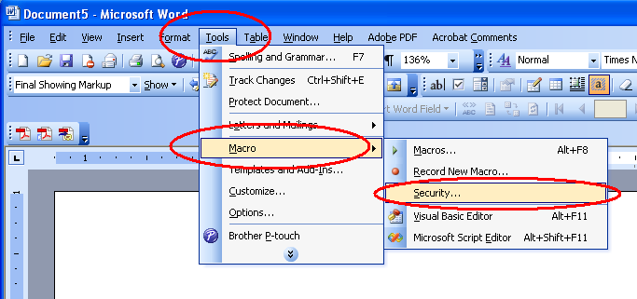

On the next screen, click on Medium, and then Click OK
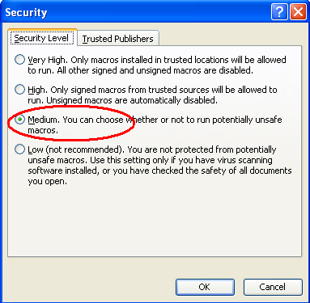

Opening a new document which contains Macros will now cause a warning message to be displayed and you will be asked if you want to enable macros for that document. Clicking “Enable Macros” will allow the Spell Checking macros to run.

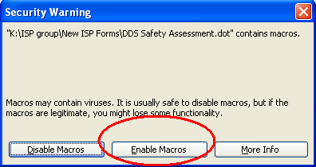

First Method to Start a New Document Using Form Templates

The first method requires all users from an Area Office or Facility to use a common storage area for the templates. Most DDS offices already have a “Template” folder located on their N: Drive and users should already be using the templates stored there to create new documents.

To create a new ISP document using this method, you first open Microsoft Word as you did above, then Click on File, then New.

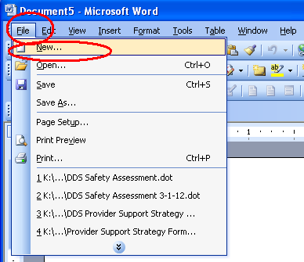

Next, at the right side of the screen, Click “Templates on My Computer”.


You should see a screen similar to this. Click on the Tab for the ISP Forms. The Tab may have a different name in your office.

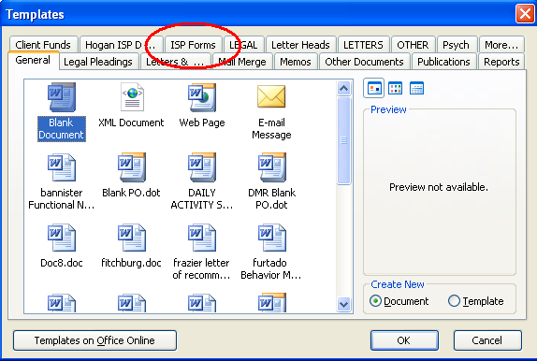

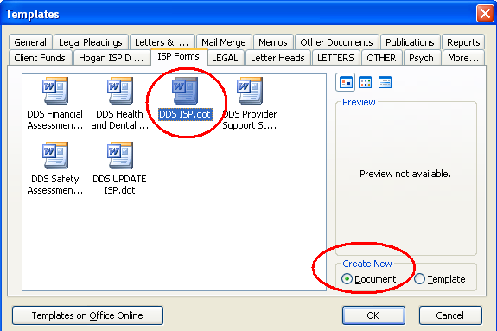
Select the correct template for the document you want to create, select Create New Document, then Click OK.

You should see the Macro warning message mentioned earlier. Click Enable Macros, to continue. All of the forms are designed to open with the cursor in the first form field so you can start entering information.
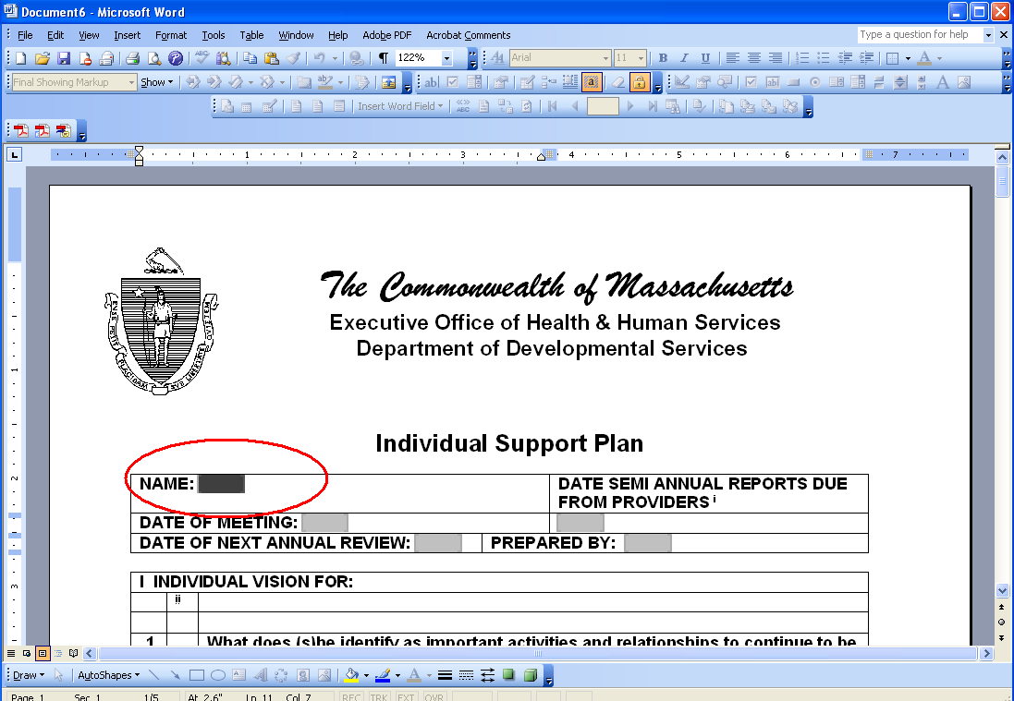

Second Method to Start a NEW Document Using
Form Templates

The second method for opening a new document, using any of the new forms, requires each user to have a copy of the templates on their own computer. To Open a new document, use Windows Explorer to open the folder where the templates are stored and Double-Click the appropriate template.
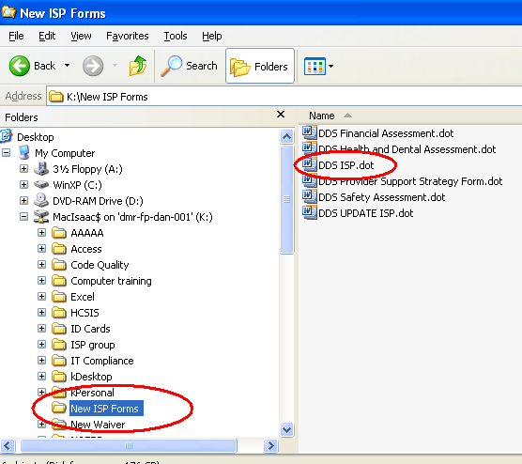

This will cause Microsoft Word to open and create a new document based on that template. You can then proceed with filling in the required information.

Filling in the Form Fields

Once you have entered the information for the first field, you should advance to the next field by pressing the Tab key on your keyboard. This will ensure that fields are filled out in order with none skipped so that certain fields that automatically get filled in based on earlier fields, will not give you an error message. Continue filling in fields and tabbing to the next field. Once you have filled in the final field in any of the forms, when you press the Tab key to exit that field, the Spelling Checker macro will automatically run. Entering and exiting that final field is the only way to make the Spelling Checker run. If you later decide to edit any of the form entries, and you wish Spell-check the edited entries, simply click in the final field, then click outside of it and the checker will run again.

Saving the Form

When you create a new document, using either of the methods above, Microsoft gives the document an arbitrary name of Document1.doc or some higher number. This arbitrary name is not very helpful for identifying the subject of the document. If you save the document, either by Clicking the disc button


or by Clicking File, then Save,


This name will be retained and the file will end up in the default folder, which could make it hard to locate, later.


You should form a habit of saving the document with a name that is helpful to you, immediately after opening the new document.

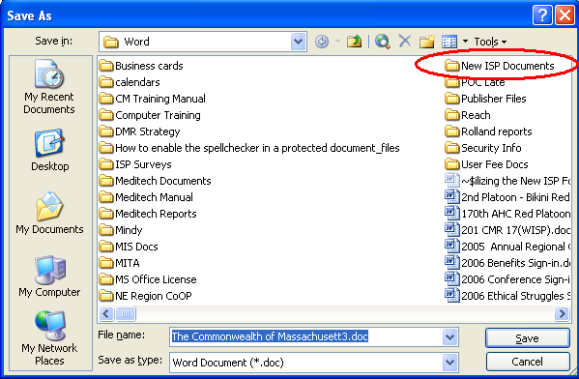
Click on File then Save As. The Save As screen will appear. Select the correct folder by double clicking it. You should save your filled-in documents in a different folder from the folder holding the templates.

Type a name for the document that will identify it for future use, check that the Save In window has the correct folder name in it and Click Save.

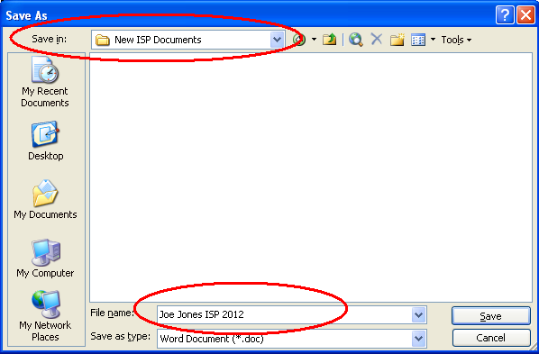

Once you have named the file using the Save As feature, you can make later saves by just using the Disc button or the File Save features. The name and location will be retained.

ISP ASSESSMENTS

DDS ISP SAFETY ASSESSMENT
DDS ISP HEALTH AND DENTAL ASSESSMENT
DDS ISP FINANCIAL ASSESSMENT
DDS GENERAL ISP ASSESSMENT

ISP LETTERS

NOTIFICATION LETTER: INVITATION TO ISP MEETING

ISP DISTRIBUTION/DELIVERY LETTER
TO INDIVIDUAL

ISP DISTRIBUTION/DELIVERY LETTER
TO GUARDIAN

ISP DISTRIBUTION/DELIVERY LETTER
TO SERVICE PROVIDER

ISP RESPONSE SHEET AND APPEAL NOTIFICATION
TO GUARDIAN AND/OR INDIVIDUAL

RICCI CLASS MEMBER ISP RESPONSE SHEET
AND APPEAL NOTIFICATION
TO GUARDIAN AND/OR INDIVIDUAL

ISP RESPONSE SHEET FOR SERVICE PROVIDER(S)

RICCI CLASS MEMBER ISP RESPONSE SHEET
FOR SERVICE PROVIDER(S)

APPENDIX

TALKING POINTS
CONVENING AND RUNNING A MEETING
ISP TIMELINE GUIDES
ISP WORKFLOW
SAMPLE DOCUMENTATION COVER SHEET
TALKING POINTS FOR SERVICE COORDINATORS IN PRESENTING THE ISP TO INDIVIDUALS, GUARDIANS, AND FAMILIES

I want to give you an idea of what to expect at the ISP meeting this year.

DDS’s ISP document is the way we learn what is important to the individual and how we organize supports to help the individual. Our goal is to make the ISP a document and the process we use to develop the ISP person-centered, is easy to understand and provides a road map for staff to follow in supporting the individual. We make changes to the ISP process and document from time to time. In 2012 we made some significant changes that we believe will make the ISPs more person-centered and focused on helping people to achieve their Goals.

One of the most significant parts of the ISP is the first section, The Vision Statement. In the Vision Statement, we will be asking 4 questions that we hope to use to explore what is important to the individual in his or her life. We will describe the individual’s preferences in where/ how he or she lives, works, and spends leisure time. We also want to reflect his or her interests, relationships, and activities that he or she would like to continue to explore. I will be consulting with the individual and his or her guardian and using information from my visits/observations over the past year to begin to draft the Vision Statement for the Service Providers to use and for the ISP Team to review to prepare for the ISP Meeting. I will also ask Service Providers to develop assessments and professional consultations that are needed and to propose Goals and Objectives that focus on the individual’s Vision Statement before coming to the meeting.

At the meeting, we will talk as a Team, as we do now, about what has gone well over the past year, what some challenges have been, and what the Goals for the next 2 years will be. We will finalize the Objectives and Support Strategies that will be used over the next year with a renewed focus on teaching skills and coordinating our efforts to help the individual. For individuals for whom teaching Objectives will be challenging due to significant medical issues, etc. we will still be focusing on the next 2 years to ensure that the individual’s needs are met and that they continue to have a good quality of life. It is the Department’s goal that the ISP be a person-centered plan that reflects the hopes and dreams of the individual, and that it provides important information in a streamlined format that is easy to read and is user friendly for all of the members of the ISP Team.

CONVENING AND RUNNING A MEETING

The ISP is the individual’s meeting, and he or she should be empowered to contribute as much as possible. In planning for the meeting, special accommodations should be considered and arranged for to enhance the individual’s participation. These accommodations could include but are not limited to the following: interpreters for the deaf and hard of hearing, foreign language interpreter, availability of adapted communication devices etc. These accommodations should be arranged for as far in advance as possible to insure their availability.

At the ISP meeting, the Service Coordinator’s role is as a facilitator, insuring that the individual’s Vision Statement is clear and accurate. Although the Vision Statement is discussed prior to the ISP meeting, it is refined at the meeting. Information pertaining to current supports, safety and risk, legal/financial/benefits status, successes, challenges, emerging issues and unmet needs are also reviewed to ensure accuracy. Goals and Objectives, along with strategies are discussed and then finalized. Again, although Goals are discussed and Objectives are proposed prior to the meeting, during the meeting revisions to draft Objectives or new Objectives can be proposed.

It is important that during the ISP meeting everyone has an opportunity to participate with their input acknowledged. There will be times that the discussion may need to be refocused and brought back to the individual. The Service Coordinator can accomplish this through paraphrasing or reframing the conversation. If there is a disagreement among members or an issue unrelated to the ISP itself is brought up that can not be resolved in the meeting, offer another meeting to address the issue.

In wrapping up the meeting the Service Coordinator should summarize the Goals, Objectives and commitments. Meeting participants should be reminded of how the information will be used and what the next steps in the process are, along with relevant timelines. Any unresolved issues should be acknowledged and a time set when they will be discussed.

“Although it is impossible to accurately predict what will happen
when a group of people join together to create something unique,
it is possible to structure the creative process based on the probability that
certain dynamics, issues, and challenges are likely to occur.”

Elements of Design, by Patty Cotton, M.Ed.

Individual Support Plan
Timeline

ISP
MEETING

ISP Information
and
Development of
The Vision Statement
ISP Approval and
Distribution
ISP Implemented
Appeal Period Ends
ISP Progress
Summaries
Due
ISP Meeting Notification
Proposed
Objectives and
Support Strategies Due
Assessments Due
Including
Progress
Summaries

-60 TO -45 -30 -15 -15 THE +24 +45 +80 180
DAYS DAYS DAYS DAYS DAY HOURS DAYS DAYS DAYS

ANNUAL
UPDATE
MEETING

Updated
ISP
Progress
Summaries
Due
ISP Development and
Review of
The Vision
Statement
Updated
Assessments Due
Including
Progress Summaries
Updated
ISP Approval and
Distribution
Updated
ISP
Implemented
Appeal Period Ends
ISP Meeting Notification
Proposed
Objectives
and
Strategies Due

-60 TO -45 -30 -15 -15 UPDATE +24 +45 +80 180
DAYS DAYS DAYS DAYS MEETING HOURS DAYS DAYS DAYS

ISP WORKFLOW

WHEN | WHO | WHAT | DOCUMENTATION
60 to 45 Days Prior to the ISP Meeting | Service Coordinator  Individual  Guardian  Authorized Family Member  (Other people familiar with the individual may participate at the discretion of the individual or when the individual/ guardian is unable to answer Vision Statement questions) | SC gathers information from relevant parties to develop the individual’s Vision Statement and determine what assessments or professional consultations will be needed for the ISP.  SC also discusses satisfaction with current supports and services with the individual/guardian.  For the first ISP, this discussion occurs at a face-to-face meeting. Subsequent Vision Statement discussions can be through other means of contact (phone, cumulative meetings with the individual).  SC provides information on the purpose of the ISP to the Individual/ Guardian.  SC informs the individual and guardian of the different methods of service delivery (Traditional, Self-Directed, Agency with Choice). | Date and time of the ISP Meeting is documented in MEDITECH Data and Letters.  Satisfaction is indicated as discussed on the MEDITECH Data and Letters CDS.

WHEN | WHO | WHAT | DOCUMENTATION
At Least 30 Days Prior to the ISP Meeting | Service Coordinator | Provides written notification to ISP Team members of the date, time and place of the ISP meeting.  Informs the Service Providers of the individual’s Vision Statement and preliminary Goals (if any) for the purpose of developing draft Objectives and Support Strategies.  Informs the Service Providers of required assessments and/or professional consultations required. | ISP Notification Letter: Invitation to the ISP
15 Days Prior to the ISP Meeting | Service Providers of services that are provided or purchased by DDS | Complete all assessments and professional consultations consistent with DDS requirements.  Send them to Service Coordinator. | Written assessments using the forms and standards determined by DDS.
At Least 15 Days Before the ISP Meeting | Service Providers of services that are provided or purchased by DDS | Draft Objectives and Strategies submitted to the Service Coordinator for review consistent with DDS requirements | Written Objectives and Support Strategies using the forms and standards determined by DDS.

WHEN | WHO | WHAT | DOCUMENTATION
At Least 7 Days Before the ISP Meeting | Service Coordinator | Assessments are available to the ISP Team members upon request.  Review documentation sent by Service Providers.  Return any assessments, Objectives and Support Strategies that do not meet DDS criteria. | If assessments and professional consultations are requested and sent to relevant parties, enter MEDITECH Note with relevant information.  Note in MEDITECH Notes under ISP Development that ISP documents from Service Providers were received and reviewed.  If any documents were not accepted, record which documents were returned to the Service Provider and why.
Prior to the ISP Meeting | Service Coordinator | Prepare draft ISP document (optional) | Note in MEDITECH Notes under ISP development that the draft ISP was completed
Day of Meeting | Service Coordinator | Facilitate the meeting. Assure Vision Statement is clear and accurate.  Finalize Goals, Objectives and Support Strategies.  Finalize ISP. | Individual Support Plan.  Date of meeting entered into MEDITECH ISP Meeting and Status screen.

WHEN | WHO | WHAT | DOCUMENTATION
No Later Than 45 Working Days From the ISP Meeting | Service Coordinator, Service Coordinator Supervisor,  Area Director | ISP is reviewed, approved by DDS and mailed to ISP Team members for approval | ISP Distribution Documented in MEDITECH Notes  Complete the ISP Meeting and Status in MEDITECH to reflect Current  Record of Mailing Date
Within 10 Days of Receipt of the ISP | Individuals,  Guardians,  Authorized Family Members | Have a right to a meeting with the SC to review the ISP | MEDITECH Notes if meeting is requested
35 Days After the ISP Has Been Mailed to Relevant Parties | Service Coordinator, Service Coordinator Supervisor,  Area Director | ISP is accepted unless otherwise indicated by the individual or guardian. | No Documentation
35 Days After the Mailing of the ISP | Area Office | Appeal Period Ends | No Documentation

Sample ISP Documentation Cover Sheet
◻ Done
Name of Individual: ISP Date:
◻ Ricci Class Member SC Name:
◻ Rolland Class Member ◻ First ISP
◻ Risk

ISP Approval and Mailing Packet:
◻ ISP ◻ Entered Date in ISP Meeting & Status Screen
◻ Response Sheets ◻ HCBW Assessment Updated
◻ Attendance Sheet ◻ Assessment of Abilities Updated

◻ Assessments – Date Received:
Residential Day Support

◻ Support Strategies: Residential ◻ N/A ◻ Yes ◻ No
Day ◻ N/A ◻ Yes ◻ No
Support Services ◻ N/A ◻ Yes ◻ No
HCBW
On The Waiver: ◻ Yes ◻ No LOC: ◻ Yes ◻ No Score:

Date ISP Submitted to Supervisor:
◻ Supervisor Name ◻ Supervisor Name ◻ Supervisor Name

Related ISP Documentation:
Med Treatment Plan ◻ N/A ◻ Present ◻ Requested from Provider
Health-Related Protocols ◻ N/A ◻ Present ◻ Requested from Provider
Behavior Treatment Plan Level ◻ N/A ◻ Present ◻ Requested from Provider
Day Hab Plan ◻ N/A ◻ Present ◻ Requested from Provider

SCII to Area Clinician for Review
Dining Guidelines ◻ N/A ◻ Present ◻ Requested from Provider

SCII to Nurse/Nurse Practitioner for Review

Date ISP Reviewed, Signed, and Changed to Preliminary by Supervisor:

Date ISP Reviewed and Changed to Current in MEDITECH by
Area Director/Management Designee

Comments/Questions from Area Director/Management Designee Review:

Mailing ISP: # of ISP Copies Needed ____
Date SC Submitted ISP for Mailing: ◻ Delivery Letters
Given To: ◻ Admin Name ◻ Admin Name ◻ Self-Addressed Envelope(s)

Date ISP Mailed Out: Date Added to Mailing Tracker:

^{Revised September 2012}

Related Guidance

SERVICE COORDINATOR CASE NOTE
DOCUMENTATION REQUIREMENTS

GUIDANCE REGARDING
FREQUENTLY REQUESTED ASSESSMENTS

MASSHEALTH ELIGIBILITY
REPRESENTATIVE DESIGNATION FORM

S.M.A.R.T.E.R. OBJECTIVES

ISP FILING GUIDELINES

Service Coordinator Case Notes

Documentation Requirements

This document is intended to establish professional standards for documentation of contact with or on behalf of individuals served by DDS effective October 1, 2010.

All Case Notes are to be recorded as MEDITECH Notes. Hard Copy Notes previous to October 1, 2010 must be filed in the Confidential Record.

MEDITECH Notes are considered a part of the individual’s Confidential Record. Individuals and/or their guardian(s) are entitled to review these records upon request. It is essential that MEDITECH Notes be accurate, timely and written in a neutral manner as a matter of professional practice.

BILLING FOR TARGETED CASE MANAGMENT

The Department bills CMS for Targeted Case Management on a monthly basis provided there has been activity with or on behalf of an individual during the previous month. Documentation of these activities must be recorded in MEDITECH and be consistent with CMS expectations. Information can be obtained through regular visits, emails to/from the guardian, family, Service Providers and telephone conversations. Care must be taken regarding email to use initials and avoid identifying information. In the case of telephone conversations, actual contact with the relevant person (i.e. guardian, family, Service Providers) is necessary for it to be considered activity. Leaving a message would not be considered activity. In keeping with these requirements, DDS requires the following information be included in MEDITECH Notes:

- Name of the individual. (This is automatically designated in MEDITECH.)
- Date and nature of the activity.
- Statement of the reason for the activity*
- Outcome of the activity, if any.*
- Signature (This is automatically included by MEDITECH)

*Service Coordinators may copy and paste information into their case notes from emails they have sent to others or have received from other DDS staff with the exception of any communication with attorneys or any communication related to investigations. All information that is copied and pasted into case notes must be carefully edited to ensure adherence to standards of neutral writing. Any information that is copied and pasted from emails received from DDS staff (program monitors, clinicians) should not be included without getting approval from the sender. Given the fact that once notes are entered they cannot be deleted or changed it is very important that copy and paste entries be done with great care. Under no circumstances can e-mail correspondence with a DDS attorney be copied into MEDITECH without permission of the attorney as it undermines Attorney/Client privilege.

It should be noted that Canned Text alone is insufficient except in specific circumstances (see below).

EXAMPLE #1:

HSC NOTE: Canned text: ISP Development

Visited John Smith at his home on 1/29/09 to discuss his upcoming ISP. John would like to continue working on the Goals identified last year and add an additional goal to expand his community activities. He had no additions to his Vision Statement.

Steve Jones 1/29/09

EXAMPLE #2:

HSC NOTE: Canned Text: ISP Development

Called John’s mother (guardian) to confirm her attendance at the upcoming ISP and to review any matters she would like addressed at the ISP. She indicated she would like an update on the community activities John participated in last year. She had no other issues or information to add.

Steve Jones 2/1/09

USE OF CANNED TEXT

In some instances, DDS accepts Canned Text in MEDITECH as sufficient for billing. These instances are limited to the following:

- When hard copy documentation regarding the activity is maintained in the individual’s Confidential Record.
- When supporting documentation regarding the activity is maintained in other DDS systems (HCSIS Incident Reports, Site Visit, etc.)

In these instances, it is necessary to note that supporting documentation is on file, but it is not necessary to re-write the information in MEDITECH Notes.

EXAMPLE #3:

Canned Text: ISP Development

Completed ISP document and forwarded to my supervisor for review. See ISP.

Signature and date are automatically designated by MEDITECH

EXAMPLE #4:

Canned Text: SITE VISIT with date of visit accurately recorded.

Signature and date are automatically designated by MEDITECH).
FREQUENTLY ASKED QUESTIONS

- Is it acceptable to write Case Notes in Microsoft Word (for ease in spell checking) and then copy them into MEDITECH?

YES, provided the requirements detailed above are met.

- Is it acceptable to copy and paste multiple activities/contacts into one MEDITECH Note?

YES, this is an approved option in specific circumstances where multiple contacts and/or activities occur in a brief (72 hours) time period. The dates of all contacts and activities must be included in the MEDITECH Note.

- Is it acceptable to keep Case Notes regarding individuals in a desk drawer or notebook?

NO. Case notes must be maintained in MEDITECH or the individual’s Confidential Record.

- Is it acceptable to record details and activities regarding an open investigation in MEDITECH Notes?

NO. Information regarding an open investigation should not be recorded in MEDITECH Notes as it may compromise the investigation.

- In that case, what should I record when a complaint is filed?

Note that a DPPC has been filed, including the DDS case number if feasible, and whether or not protective actions were needed.

GUIDANCE REGARDING FREQUENTLY REQUESTED ASSESSMENTS AND RELATED DOCUMENTS

SELECTED SERVICES
CODE | SERVICE NAME | HEALTH CARE RECORD | SAFETY ASSESMENT | HEALTH & DENTAL ASSESMENT | FINANCIAL ASSESMENT | BEHAVIOR ASSESMENT | EMPLOYMENT ASSESSMENT/ EVALUATION | BEHAVIOR MODIFYING MEDICATION TREATMENT ASSESSMENT | ACTIVITIES OF DAILY LIVING ASSESSMENT
3150  And  3288 | Placement Services  (Shared Living) | Always | Always | Always | Always | Based on Individual’s Need | Never | Where Required by Regulation | Based on Individual’s Need
3153 | Residential Supports  (24 hour) | Always | Always | Always | Always | Based on Individual’s Need | Never | Where Required by Regulation | Based on Individual’s Need
3163 | Community Based Day Supports | Never | Always | Never | If Supports are Relevant to Financial Needs | Based on Individual’s Need | Based on Individual’s Need | Where Required by Regulation | Based on Individual’s Need
3168 | Individual Supported Employment | Never | Always | Never | If Supports are Relevant to Financial Needs | Based on Individual’s Need | Always | Never | Based on Individual’s Need
3169 | Center Based  Work Services | Never | Always | Never | If Supports are Relevant to Financial Needs | Based on Individual’s Need | Always | Never | Based on Individual’s Need
3180 | Competitive Integrated Employment Services | Never | Always | Never | If Supports are Relevant to Financial Needs | Based on Individual’s Need | Always | Never | Never
3181 | Group Employment  (also referred to as Enclaves) | Never | Always | Never | If Supports are Relevant to Financial Needs | Based on Individual’s Need | Always | Never | Based on Individual’s Need
3182 | Emergency Stabilization Residence | As  Determined  by Contractual  Obligation | Always | If Supports are Relevant to Health Needs | As  Determined  by Contractual  Obligation | Based on Individual’s Need | Based on Individual’s Need | Where Required by Regulation | Based on Individual’s Need
3285 | Day Habilitation Supplement | Never | Always | If Supports are Relevant to Health Needs | If Supports are Relevant to Financial Needs | Based on Individual’s Need | Based on Individual’s Need | Where Required by Regulation | Based on Individual’s Need
3749 | Individual Supports and Community Habilitation | As  Determined  by Contractual  Obligation | As  Determined  by Contractual  Obligation | If Supports are Relevant to Health Needs | If Supports are Relevant to Financial Needs | As  Determined  by Contractual  Obligation | Never | Where Required by Regulation and as Determined by Contractual  Obligation | As Determined by Contractual  Obligation
CODE | SERVICE NAME | HEALTH CARE RECORD | SAFETY ASSESMENT | HEALTH & DENTAL ASSESMENT | FINANCIAL ASSESMENT | BEHAVIOR ASSESMENT | EMPLOYMENT ASSESSMENT/ EVALUATION | BEHAVIOR MODIFYING MEDICATION TREATMENT ASSESSMENT | ACTIVITIES OF DAILY LIVING ASSESSMENT
3798 | Community Living Supports | Always | Always | Always | Always | Based on Individual’s Need | Never | Where Required by Regulation | Based on Individual’s Need
4157 | State Operated Residential | Always | Always | Always | Always | Based on Individual’s Need | Never | Where Required by Regulation | Based on Individual’s Need
4169 | State Operated Center-Based Work | Never | Always | Never | If Supports are Relevant to Financial Needs | Based on Individual’s Need | Based on Individual’s Need | Where Required by Regulation | Based on Individual’s Need

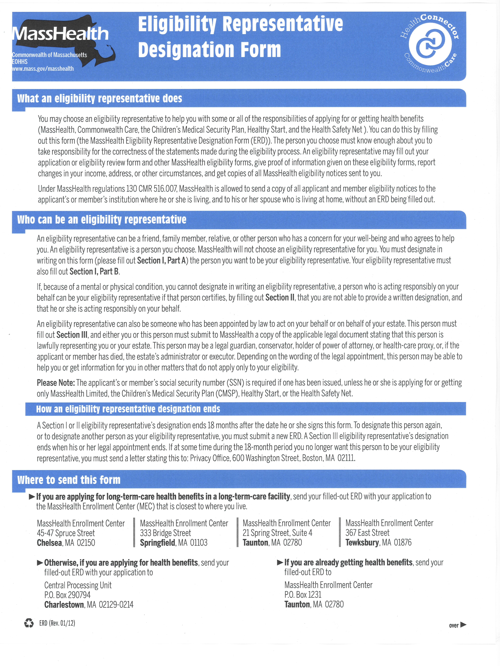
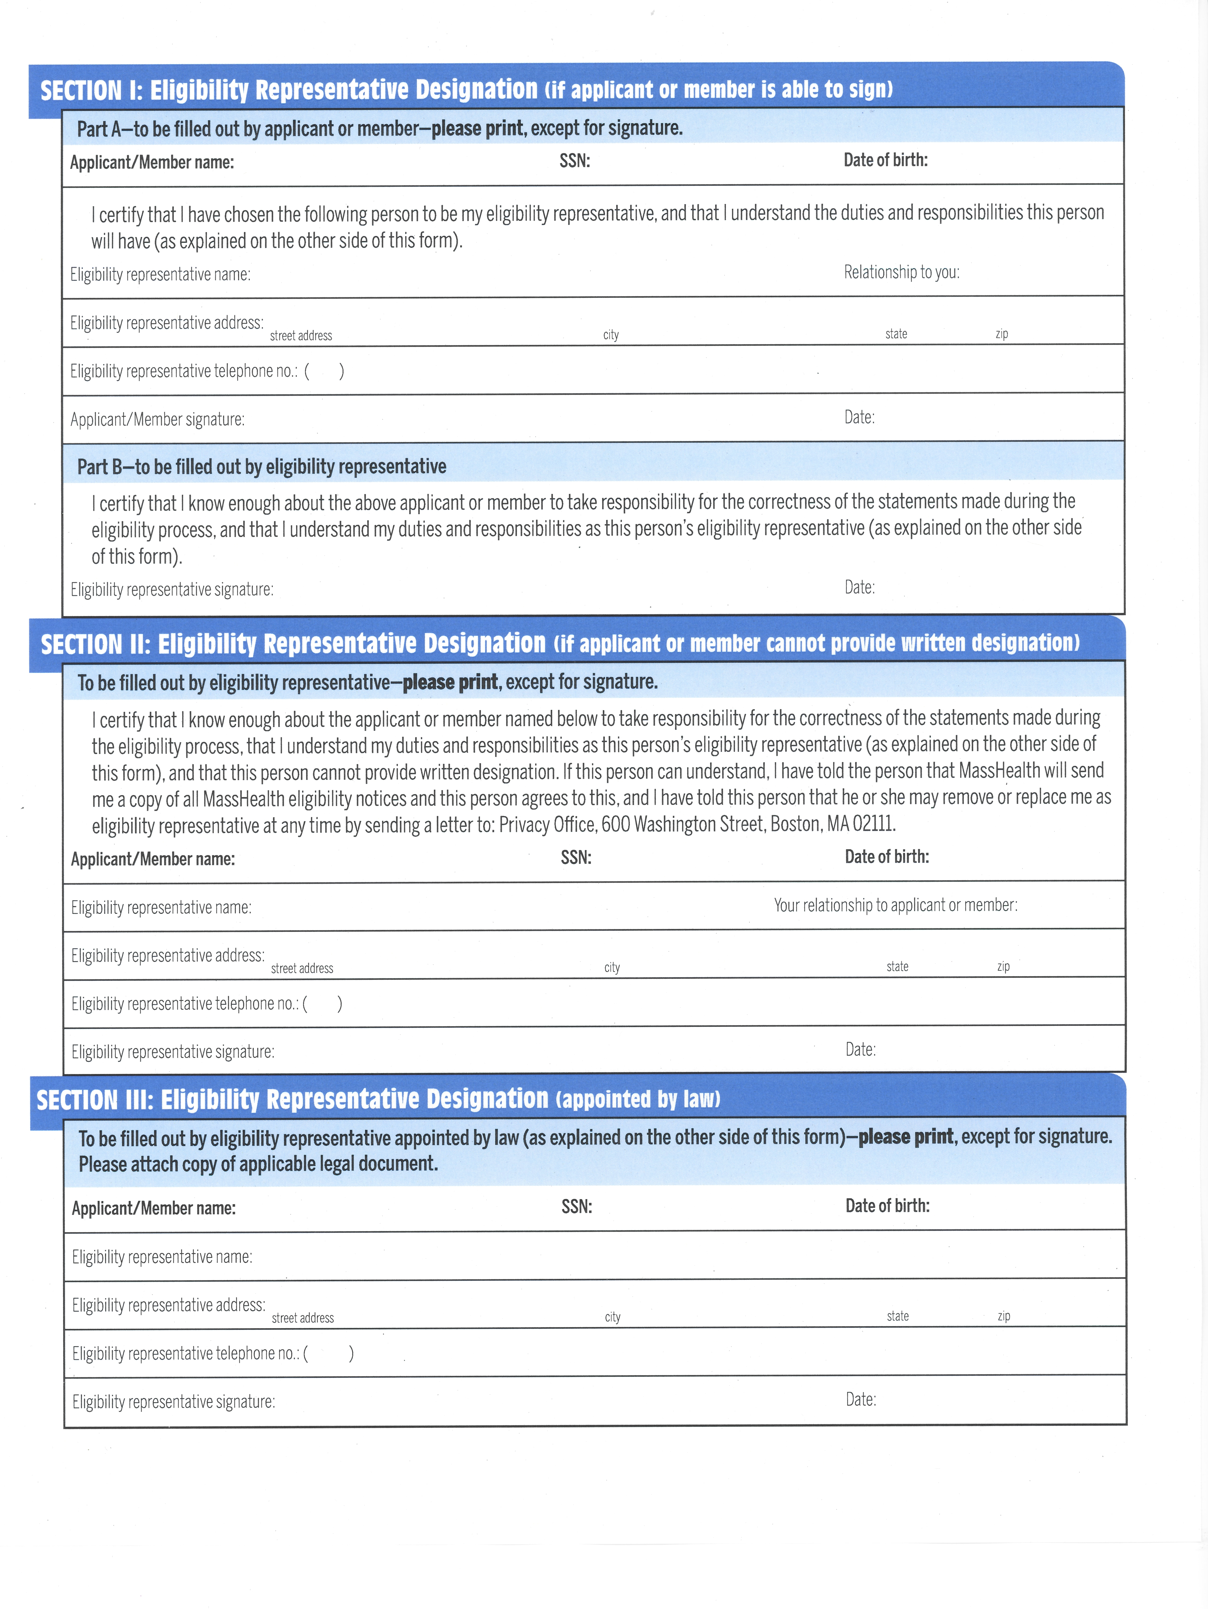

S.M.A.R.T.E.R.
OBJECTIVES

Historical information is maintained by the Department in accordance with applicable Retention Policies and may be accessed by the Service Coordinator. Service Coordinators may summarize historical information on the Social and Developmental and/or Medical History Forms and file these summaries in the individual’s Confidential Record.
A Ricci Class member who is not in need of or is refusing any supports may decline an ISP. However, an ISP shall be offered to such individuals on an annual basis. Documentation of the offer must be recorded in Meditech.
The ISP Delivery/Distribution Letters must reference the rights of relevant parties to a meeting upon request with the Service Coordinator within ten (10) days of receipt of the ISP (see 115 CMR 6.23(5)(a)).
The ISP Delivery/Distribution Letters must reference the rights of relevant parties to a meeting upon request with the Service Coordinator within ten (10) days of receipt of the ISP (see 115 CMR 6.23(5)(a)).
Defined as support provided to an individual living in an AFC situation in order to meet the unique needs of the person’s ISP which are not already being addressed through the AFC arrangement itself and are not available through the AFC program. Such support may include (but is not limited to) instruction in community living skills, engagement in community integration activities, and implementation of behavior plans.
i.e., ISP Approved Absence
Placement Services are also commonly referred to as Shared Living and Specialized Home Care and are provided in the home of a paid Home Care Provider.
Defined as services not otherwise available under the Medicaid state plan, which DDS has determined are necessary to enable the individual to participate in the Day Habilitation program. The supplemental services consist of staff assistance in addition to that available under state plan services.

