DDS Southeast Region

Learning and Development

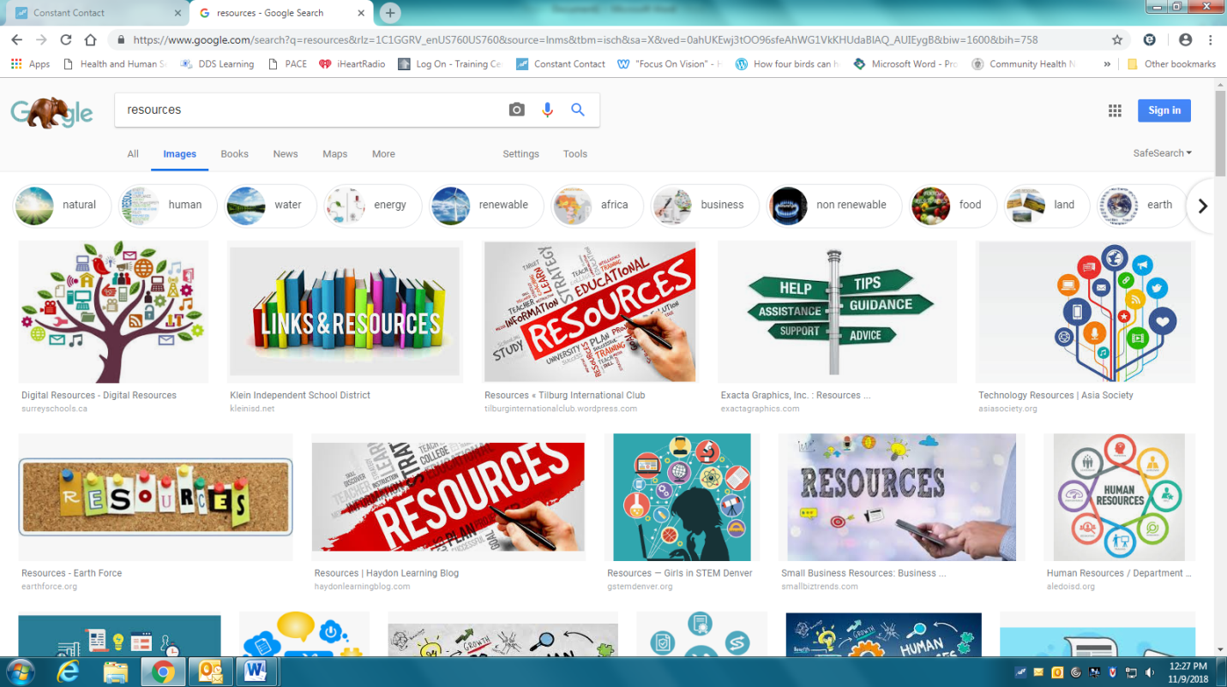

Training and Educational Resources Guide

*In the following pages, you will find a variety of training opportunities, support groups and other resources available to individuals with disabilities, agencies, families and provider staff. Please share this resource!*

**Table of Contents**

DDS Learning Website Information 2

**On-Site Training Opportunities:**

Water Safety Training by Well Adapted Trainings 3

Explore-Prepare-Act: Finding the Job You Want 4

Awareness and Action: Recognizing, Reporting, and Responding to Abuse 5

Food for Health (EO509 Training): On-site or Online 6

Visiting Rehab and Nursing Services Trainings with Greg Stelmach 7

Getting Ready for an Emergency: Emergency Preparedness 8

Seizure Training 9

Diabetes Training 10

American Sign Language Training/Consultation 11

Wellness Workshops 12

Adaptive Yoga 13

Diverse Abilities Inclusion Consulting 14

Well Adapted Trainings with Susannah Sapir 15

**Support Groups:**

Diabetes Support Group 16

H.U.G.S Group: For those caring for individuals with Autism 17

Mass Advocates Standing Strong 18

Rainbow Support Group of Massachusetts 19

**Additional Resources:**

DDS Service Method Options Pamphlet 20-21

Disabled Persons Protection Commission (DPPC) 22

DPPC Mandated Reporter Trainings 23

DPPC Sexual Assault Response Unit (SARU) 24

Disability Law Center 25

Family Support Centers 26-29

Rewarding Work Online Directory and Job Board 30



**DDSLEARNING.COM**

 **Please use google chrome as your browser**

**Welcome to DDS Learning!!! This website is for staff, provider employees, families, and people receiving services from the Massachusetts Department of Developmental Services (DDS).  It is developed and managed in collaboration with the University of Massachusetts Donahue Institute (UMDI).  Our goal is to build a central, accessible, and useful tool that can assist people to locate and participate in learning opportunities throughout the Commonwealth.**

**Please take advantage of this wonderful learning tool! There are many learning opportunities right at your fingertips! From Positive Behavioral Supports to Acquired Brain Injury there are resources readily available to support your learning and that of your team. Webinars, power point presentations, and the training schedules for classes offered across the state can be easily located. Make full use of the menu tabs on the left side—be sure to open each one for even more learning!!**

**ARE YOU LOOKING FOR**

**ON-SITE WATER SAFETY TRAINERS TO**

**COME TO YOUR AGENCY?**

**Contact:**

**Well Adapted Water Safety Training**

**Email: welladaptedtrainings@gmail.com**

Well Adapted is an approved vendor for the Commonwealth specializing in on-site water safety trainings for human service professionals. We offer 11 years of direct human service experience working with swimmers of varying abilities combined with 15 years of water safety experience for special populations including the developmentally disabled, autistic, visually/hearing impaired, swimmers with traumatic brain injury and physical disabilities. Our two hour training meets the DDS Water Safety training requirement for agencies attending lifeguarded locations.

**BENEFITS OF ON-SITE TRAINING?**

☑ Cost effective to train staff all at once.

☑ Reduces agency costs by eliminating employee travel which adds up!

☑ Training can be tailored to your agency needs.

☑ Pick a time that works for YOU! We train on Mondays anytime!

☑ Staff only need to take it once-it is a one and done!

**We train on-site for an agency minimum of *15 employees.**

*(*You can invite other agencies to meet the minimum number.)*

**Cost per person varies based on where your agency is located.**

*South Shore of MA: $40 per person (minimum 15 people)*

*Cape & Islands/Boston/Central/Western MA: $75per person (minimum 15 people)*

Explore-Prepare-Act was developed in response to concerns raised by self-advocates who were not getting the help they needed to find a job that they wanted. Individuals wanted to better understand the process of finding a job so that they could take action themselves and better access supports that would help them achieve their goals.

Explore-Prepare-Act consists of a video as well as a training curriculum that has been developed by self-advocates in partnership with the Institute for Community Inclusion, the Massachusetts Department of Developmental Services and the Massachusetts Advocates Standing Strong.

This three hour curriculum, presented by self-advocates for self-advocates, provides an overview of the basic steps involved in finding a job with an emphasis on understanding oneself and the community, development of job seeking skills, and taking steps to find a job. The training, designed for individuals interested in learning more about work, includes presentations, discussion, videos clips and small group activities, and is limited to 12 participants. Support staff are welcome to attend as well. Currently funded by the Massachusetts Rehabilitation Commission and the Massachusetts Department of Developmental Services, this training is currently offered free of charge throughout Massachusetts.

**For more information about the training curriculum contact:**

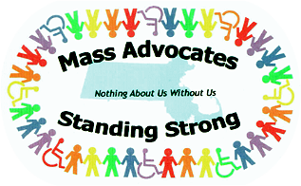Cindy Thomas   
Institute for Community Inclusion  
University of Massachusetts Boston  
cindy.thomas@umb.edu   
617-287-4312

**To schedule a training session in Massachusetts contact:**

Massachusetts Advocates Standing Strong  
617-624-7549

Training@ma-advocates.org

This curriculum was developed with support from Work Without Limits, a Massachusetts Disability Employment Initiative funded by the Centers for Medicare and Medicaid Services (CFDA No. 93.768).



#### 

#### Awareness & Action

#### Training

This FREE training, taught by persons with disabilities and others,

is designed to educate persons with disabilities and others about recognizing, reporting and responding to abuse.

If you are interested in having an

Awareness & Action Training at your

organization, please contact:

Anne Monti at

Anne.Monti@state.ma.us

Phone: 1-617-727-6465 x234

*The training is three hours long, intended for everyone,*

*and limited to 20 people.*

***Neglect***

***Financial Abuse***

***Verbal Abuse***

***Sexual Abuse***

***Physical Abuse***



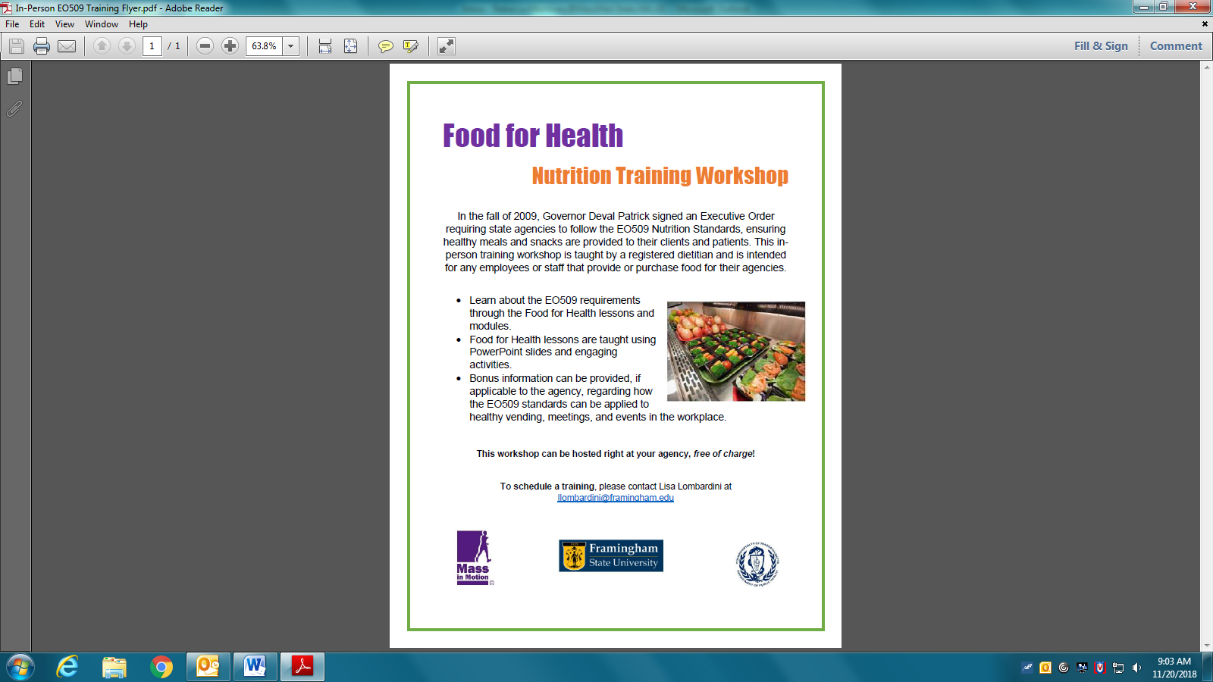

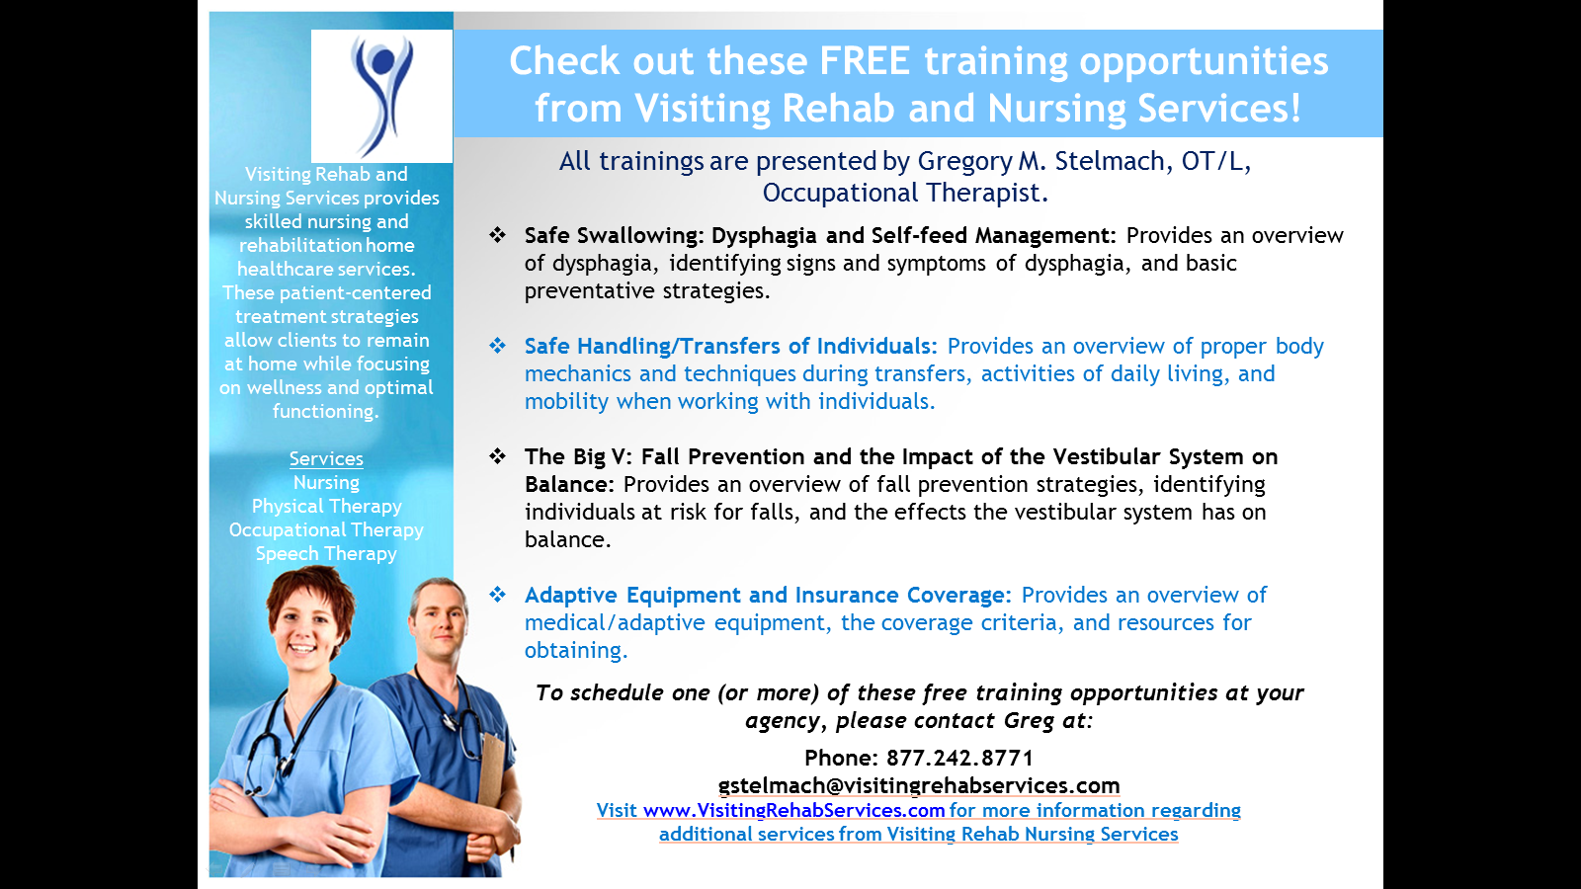

**Getting Ready For An Emergency**

Emergencies like floods, storms or pandemic flu can happen to lots of people at once.

Be prepared so you know what to do!

**Would your group like a *free* emergency preparedness training?**

Self-advocate Nate Trull trains consumers and support staff about getting ready for emergencies.

*He has trained over 100 people in Massachusetts!*

**He can train your group in two ways**:

(1) A two-part training where each part takes about an hour and a half on

two different days

(2) A one-time training that takes about two hours.

There is *no cost* for the training, but your group will need to provide a room, a screen or wall for a PowerPoint® presentation, a power point projector, and an audience. People who come to the workshop will get presentation handouts, a folder of information, and consumers will receive small items to start their own supply kits.

**For More Info Contact: Nate Trull at** [**nate.trull@comcast.net**](mailto:nate.trull@comcast.net)

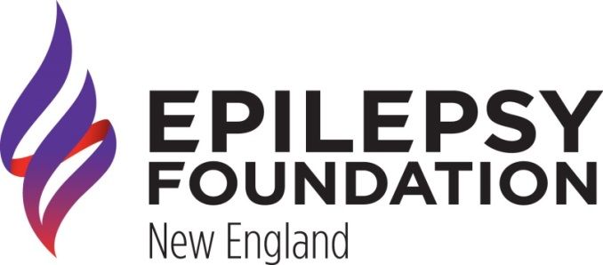

**Seizure Training**

This training is designed to provide caregivers and staff with strategies to better recognize and respond to seizures.

Participants will be able to demonstrate a basic understanding of epilepsy and identify, recognize, and respond to different types of seizures.

***For more information or to schedule this training,***

***please contact:***

Susan Welby

Director of Education & Volunteer Services

[Epilepsy Foundation New England](https://urldefense.proofpoint.com/v2/url?u=http-3A__www.epilepsynewengland.org_&d=DwMFAg&c=lDF7oMaPKXpkYvev9V-fVahWL0QWnGCCAfCDz1Bns_w&r=v3lL4llsNl0kkV1AyTQuTtjsVQWmh5Avsnrm0nxHNgI&m=WVdbQ-H8NbZXLGGK0Jjc-AHVMkKMBbNAkWNgPhAvZZ4&s=G7mkglfb-_NlPDOjm80YMmjB4Zi0USrg5LPnbEm7bC0&e=)

617.506.6042

335 Main Street

Wilmington MA 01887



**Diabetes Training**

This Training is designed to provide caregivers and staff with an overview of diabetes, types, risk factors and treatments.

[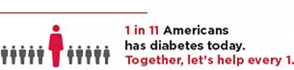](https://urldefense.proofpoint.com/v2/url?u=https-3A__donations.diabetes.org_site_Donation2-3Bjsessionid-3DBC82A9A00A387ABA4F564C3EA9C021B1.app244b-3Fdf-5Fid-3D19045-2619045.donation-3Dform1-26loc-3Dheader-26s-5Fsrc-3Ddorg-26s-5Fsubsrc-3Ddonate-2Dnow&d=DwMGaQ&c=lDF7oMaPKXpkYvev9V-fVahWL0QWnGCCAfCDz1Bns_w&r=v3lL4llsNl0kkV1AyTQuTtjsVQWmh5Avsnrm0nxHNgI&m=WGS8TcoyqRgddAB6jSW-xGlVz7JDXjuMDNkdFIB0Ubc&s=p1-AUicWWzMqFgVi3IICuHaNV-T-x7XN4FOCP2Udsh8&e=)

***For more information or to schedule this training, please contact:***

Rev. Albert Whitaker  
Northeast Region Director Community Health Strategies  
260 Cochituate Rd. Suite 200  
Framingham, MA 01701  
617-482-4580 ext. 3469  
1-508-872-3087

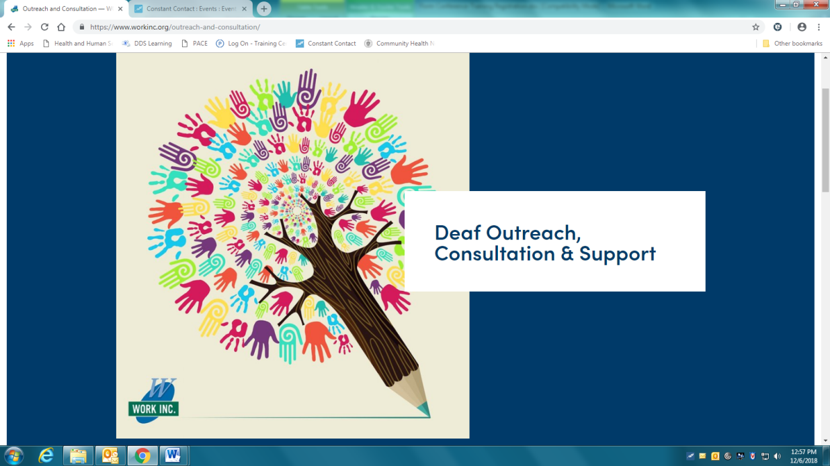

**Consulting Service Offerings**

**Communication** – A communication profile to include current communication

modes and the potential for enhancements.

**Technology** – Identifying the current use of technology and recommending any

Additional technology, for example video phones and mobile devices.

**Environment** – Assessing the need for any environmental modifications.

Recommendations may include flashing fire alarms, or signaling

doorbell as well as space layout to enhance visual communication.

**Clinical** – Identifying current clinical supports which may include therapist,

psychiatrist, behaviorist and personal care attendants.

**Education & Training** – To provide or make connections to classes on topics such as

Deaf culture, American Sign Language, interpreter use,

technology and communication access.

**For more information on Deaf Outreach and Consulting, Contact:**

Monica Bradley

617-326-8437

[mbradley@workinc.org](mailto:mbradley@workinc.org)

Wellness Workshops for

Individuals with Disabilities

with Patricia Murphy, Certified Health Coach &

Founder of *Teach Your Children Wellness*



**Workshop Topics Include:**

Health and Wellness Overview

Virtual Supermarket Tour

Small Change Diet

Benefits of Exercise

Cooking Made Easy

What You Should Know About Sugar

Eating Healthy When Eating Out

For more information and/or to schedule,

contact Patty at Patty@tycwellness.com

Workshops vary from 1 – 2 hours in length.

Cost: $150 per Workshop

Or $750 for Series of 6 Workshops ($125 per Workshop)

About Patricia Murphy: Patty is the mother of a young man diagnosed with Nonverbal Learning Disability. She recognizes the many challenges he faces daily, including a lack of understanding of the physical and psychological benefits of a healthy diet. Patty became a Health Coach to provide individuals with disabilities concrete information regarding their health and wellness by teaching them the “why” and most importantly the “how” of living a healthy life while emphasizing accountability. Her practice is based on bio-individuality, with the understanding that there is no one right way for everyone.



**MANTRA**

We are committed to sharing the practice of yoga and mindfulness in an adaptive and nurturing way to improve the well-being of ALL individuals with developmental, emotional, and physical challenges.

**PROGRAMS**

Onsite adaptive yoga programs for those with developmental, emotional, and physical challenges

Full and half day education programs for special educators, certified occupational therapist assistants, occupational therapists, physical therapists, parents and caregivers.

**CLIENTS, OUR HEART CENTER**

## We have been working with Lisa for about two years and we couldn't be happier.  She has the skill to transition seamlessly between working with adults and children, as well as those with significant behavioral challenges.  Lisa's positive attitude and unique approach to mindfulness and movement make her an incredible instructor.  She is creative, fun, reliable and organized.  Venture Community Services highly recommends Brave Yoga for All!

— Paige Mador, Director of Development, Venture Community Services

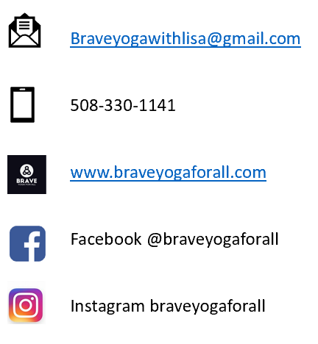

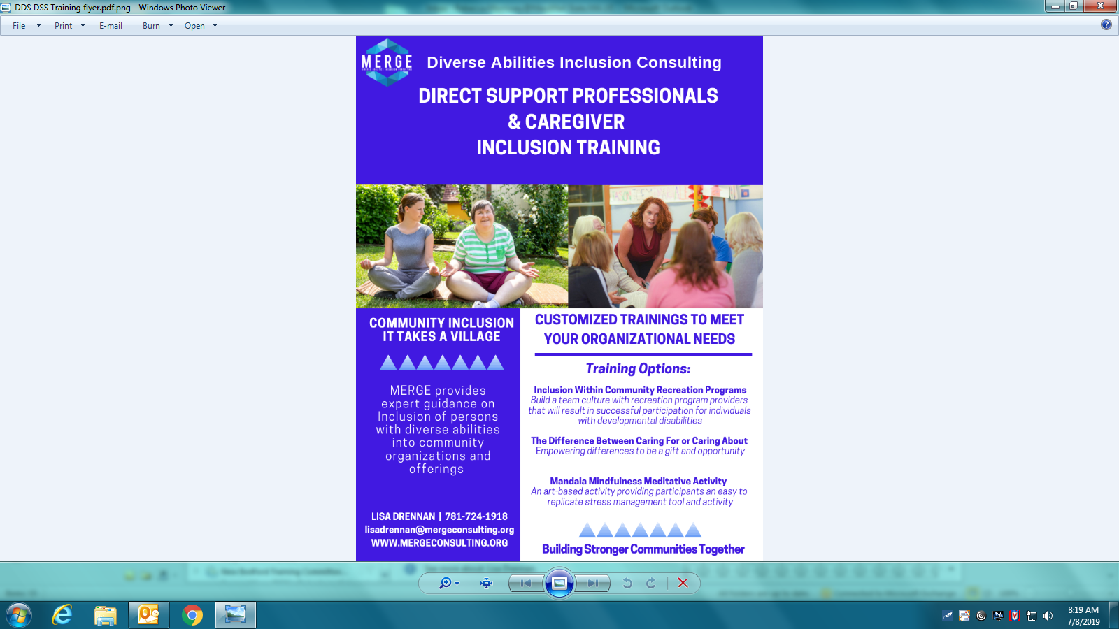

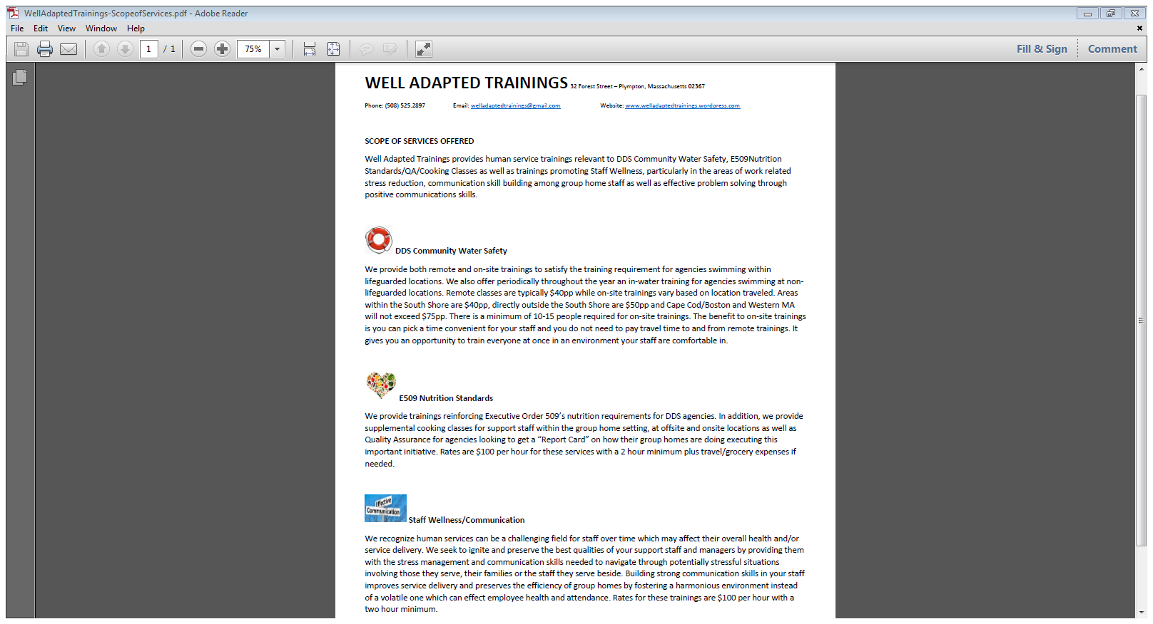

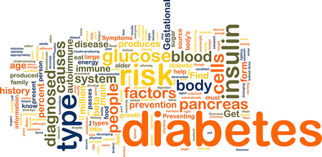

***Monthly Diabetes Support and Information Group***

Offered through the DDS Fall River Training Committee

This group incorporates nutrition games, cooking demos and general diabetes management information.

Open to ***anyone***! If you have diabetes, are pre-diabetic or are simply interested in learning more about diabetes and preventing diabetes, you are welcome and encouraged to attend.

This group is appropriate for individuals supported by DDS, family, friends and caregivers.

**When: The 2nd Monday of Every Month**

**Where: DDS Fall River Area Office**

**1 Father DeValles Blvd., 3rd Floor**

**Fall River, MA 02723**

Register with Anna Viveiros at [AnnaM.Viveiros@State.MA.US](mailto:AnnaM.Viveiros@State.MA.US) or

by phone at 508-730-1209/VOIP 2001038

Please pass this information on to anyone that you feel may be interested in attending this group.

*We will offer this every month as long as there is interest.*

*New participants are always welcome!*

# 

***For More Information, Please Call:***

***IVONE REGO-CASS***

***The Nemasket Group***

***508-999-4436 EXT. 118***

# Time and Location vary each month, please call Ivone for more details and future dates!

**All Are Welcome!**

# MASSACHUSETTS ADVOCATES

# STANDING STRONG

M.A.S.S. would like to work with providers, DDS staff, family organizations, self-advocacy groups, and community groups to offer training on the following topics:

* Self Determination and Choice
* Self Advocacy- What It Is? How to Start a Local Group? Leadership!
* New Staff Orientation
* How to Be an Effective Board Member
* Design a training with you to meet your needs

M.A.S.S. is a statewide self-advocacy organization started and operated by individuals with cognitive or developmental disabilities. We work with local self-advocacy groups across the Commonwealth. We know that our voice is stronger when we work with people who have the same beliefs and values as we do.

***Our Mission: To empower self advocates through education so we make choices that improve and enrich our lives.***

Some of our most recent work has been:

* Self Advocacy Leadership Series with MDDC taught by self advocates and their advisors
* Tools for Tomorrow Project with ARCMASS, Families Organizing for Change, and MDDC to help people achieve their hopes and dreams. Access Living of Chicago to teach self advocates about housing options
* The Bridges Project with DMR, Central Mass Self Advocacy Workteam, and Worcester ARC to support people moving out of nursing homes
* Active participants on the federally funded Real Choices Project

**We can be reached at:**

Phone: 1 866 IAM-ABLE (1 866 426-2253)

Email: [mass1998@earthlink.net](mailto:mass1998@earthlink.net)

Address: PO Box 6025

N. Plymouth, MA 02362

Website: <https://ma-advocates.org/>

***“Nothing about us without us.”***



*Do you sometimes think that no one understands what you are feeling?*

*Do you wonder if you’re the only one who has these feelings?*

*Do you wish you had some friends who felt the same way that you do?*

***Think about joining the***

**Rainbow Support Group of Massachusetts!**

**The Rainbow Support Group provides support and information to individuals with intellectual challenges who are gay, lesbian, bisexual, transgendered, cross-dressers or are questioning their sexuality. Meetings give you the chance to talk about your sexual interests with other people who are trying to be comfortable and happy about their sexuality.**

**We are now in the process of starting groups in all five regions of the self advocacy organization, Massachusetts Advocates Standing Strong.**

**Contact us to learn more and find out if there is a Rainbow Support Group in your area. Agencies can contact us if you are interested in sponsoring a Rainbow Support Group.**

**For additional information - Please call Pauline Bosma – Program Coordinator at 508-944-5797 or e-mail her at (**[**rainbowbos@charter.net**](mailto:rainbowbos@charter.net)**) or e-mail Christopher Perrault (Southeast/Metro Contact Person at** [**cperrault@deltaprojects.org**](mailto:cperrault@deltaprojects.org)**.**

**Additionally, you can visit** [**https://ma-advocates.org/rainbow-support-group/**](https://ma-advocates.org/rainbow-support-group/)

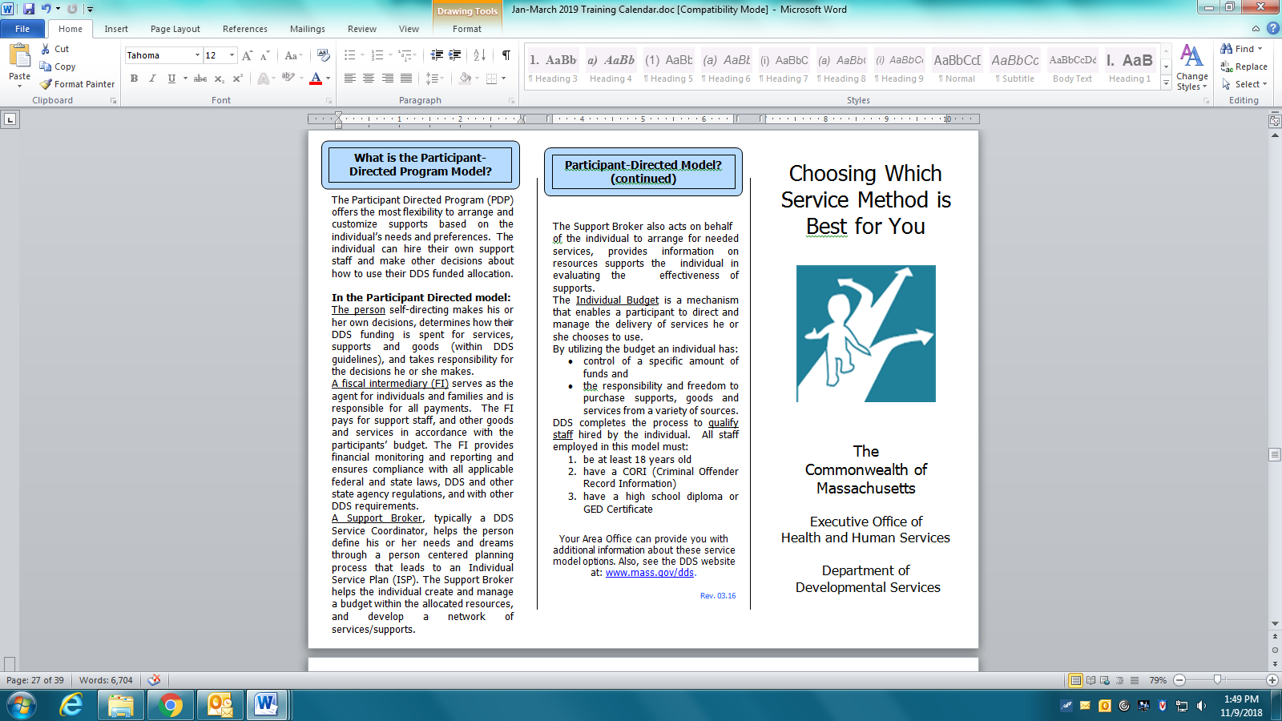

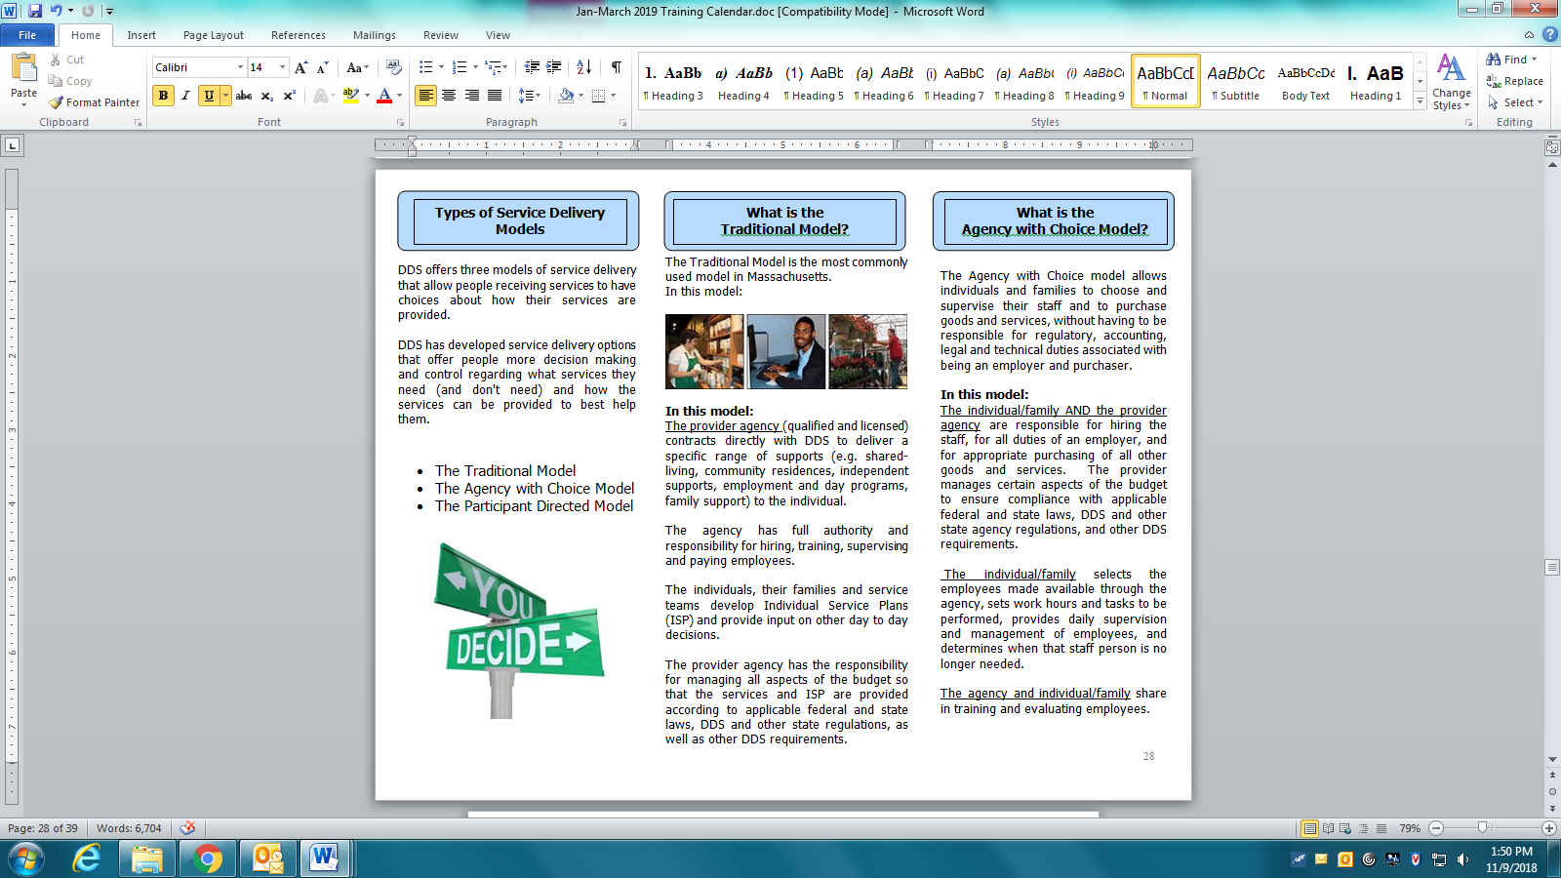

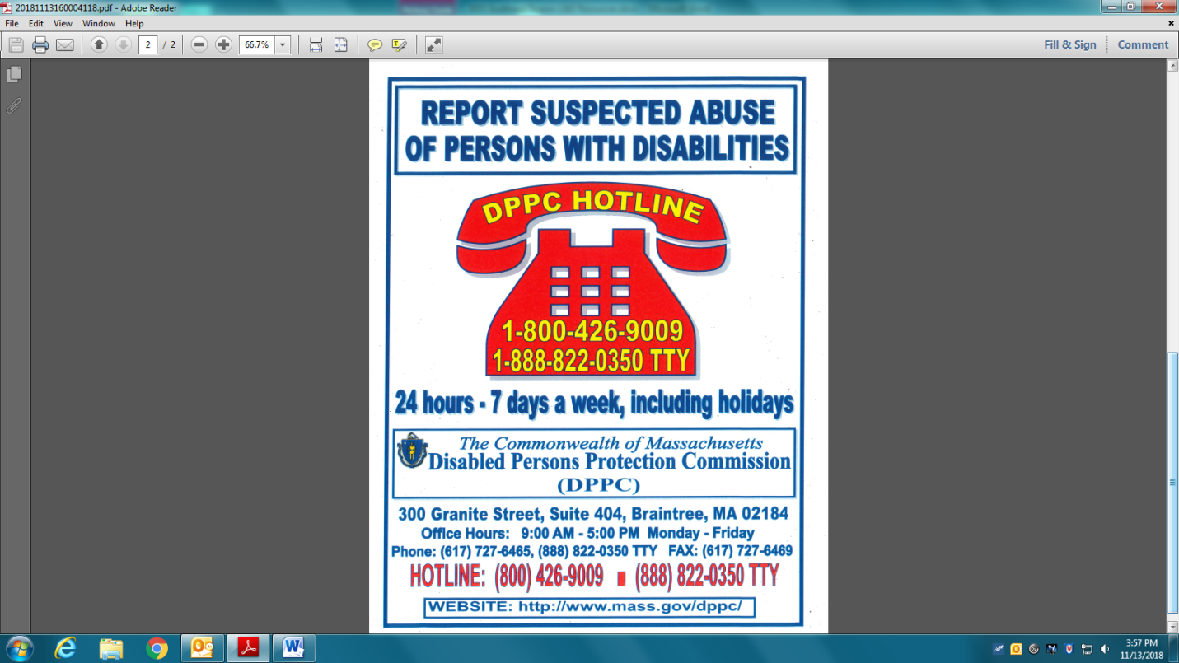

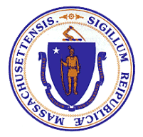**Disabled Persons Protection Commission (DPPC)**

***Mandated Reporter Trainings***

DPPC is now offering monthly, mandated reporter trainings at the DPPC office in Braintree, Massachusetts.  This training will provide mandated reporting professionals with information on recognizing, reporting and responding to abuse of persons with disabilities.  **All interested participants are required to** [**REGISTER**](https://dppcmandatedreportertraining.eventbrite.com/). Each scheduled training has a capacity of 25 people.  Participation in preferred training will be on a first register, first come basis.  Trainings are free of charge.

**Where:** Disabled Persons Protection Commission

   300 Granite Street

   Suite 404

   Braintree, MA 02184

**When**: At time of registration, choose ONE date and ONE time preference

* **January 17th 2019**

10:30 am to 12:00 pm ***OR***2:30 pm to 4:00 pm

* **February 21st 2019**

10:30 am to 12:00 pm ***OR*** 2:30 pm to 4:00 pm

* **March 21st 2019**

10:30 am to 12:00 pm ***OR*** 2:30 pm to 4:00 pm

* **April 18th 2019**

10:30 am to 12:00 pm ***OR*** 2:30 pm to 4:00 pm

* **May 16th 2019**

10:30 am to 12:00 pm ***OR*** 2:30 pm to 4:00 pm

* **June 20th 2019**

10:30 am to 12:00 pm ***OR*** 2:30 pm to 4:00 pm

**To register, please click on the following link to complete and submit form.**

[**https://dppcmandatedreportertraining.eventbrite.com**](https://dppcmandatedreportertraining.eventbrite.com)

For more information, please contact Jennefer Raymond, DPPC Training Specialist, at:

[**Jennefer.Raymond@state.ma.us**](mailto:Jennefer.Raymond@state.ma.us)

DPPC ● 300 Granite Street ● Suite 404 ● Braintree ● MA 02184 ● Phone: 617-727-6465

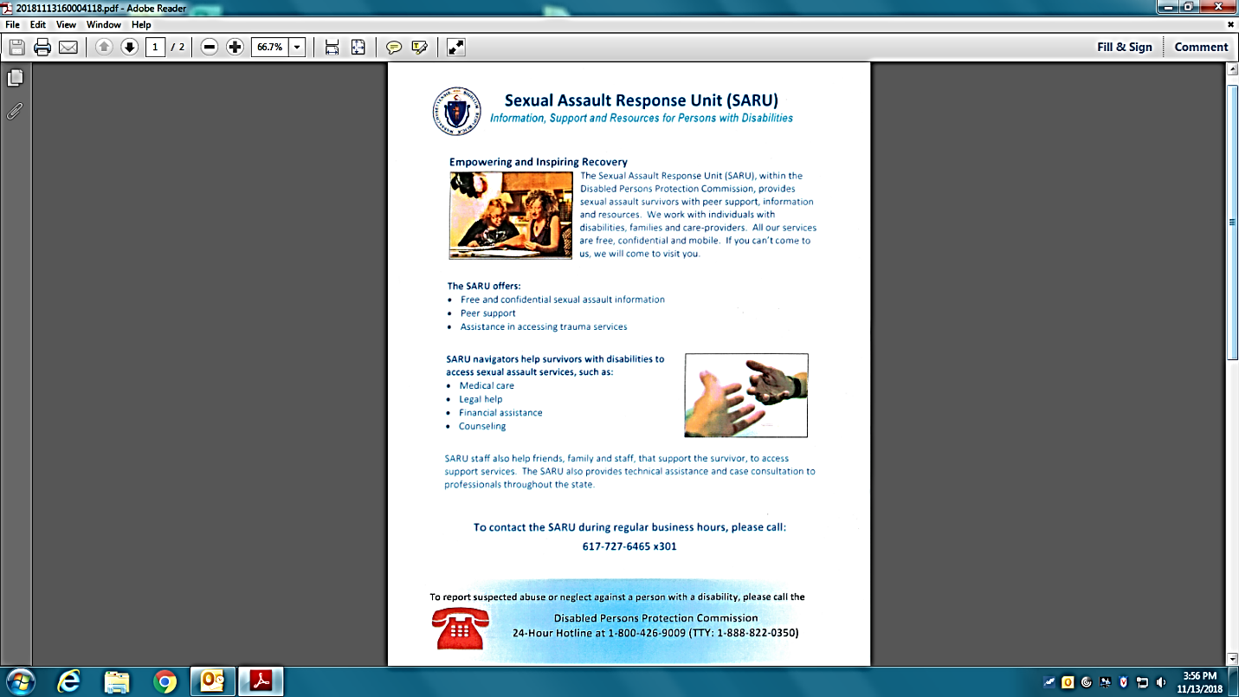

For Assistance, Contact:

Bonnie Crehan

Protective Services Navigator

300 Granite Street

Braintree, MA 02184

[Bonnie.Crehan@massmail.state.ma.us](mailto:Bonnie.Crehan@massmail.state.ma.us)

617-727-6465 X304

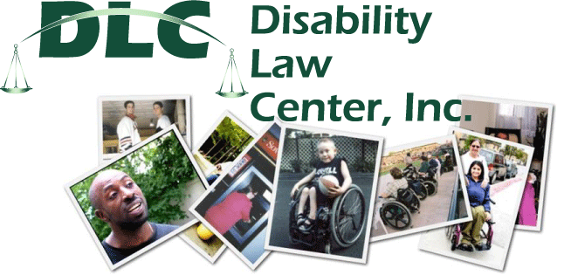

A private, non-profit public interest law firm

Disability Law Center provides legal advocacy on disability issues that promote the rights of people with disabilities to participate fully and equally in the social and economic life of Massachusetts

Our office is accessible and is open Monday through Friday, 9 A.M. to 5 P.M.

DLC can make arrangements for sign language and foreign language interpreters or other accommodations that you may need.

For More Information:

<http://dlc-ma.org>

1-800-872-9992 voice

1-800-381-0577 TTY

**Family Support Centers**

Family Support Centers across the state, funded by the Department of Developmental Services (DDS), provide information, assistance, and a variety of supportive services to families with children and adults with intellectual and developmental disabilities who are living at home.These services include:

* Providing information and assistance in obtaining a wide array of services including but not limited to:
  + Social and recreational opportunities
  + Support groups for parents, siblings and family members
  + Resources in the community
  + Public benefits
* Hosting trainings or providing information on topics such as:
  + Guardianship/Trusts
  + Planning for the Future
  + Social Skills
  + Human Relationships
  + Specific disabilities and/or conditions
* Offering opportunities for families to meet through networking and

organized social and community activities

Families who are eligible for services from DDS are encouraged to contact one of the Family Support Centers near them.

***The Family Support Centers in the Southeast Region are included here***.

A directory with the contact information for all Statewide Centers is available on the DDS web-site at [www.mass.gov/dds](http://www.mass.gov/dds).

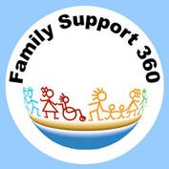

**FAMILY SUPPORT CENTERS**

**SOUTHEAST REGION**

**Funded by the Department of Developmental Services**

**Brockton Area**

**Brockton Area Arc**

Center Name: Brockton Area Arc

Address: 1250 West Chestnut Street, Brockton, MA 02301

Phone: (508) 583-8030 x224

Contact: Kathy Kerwin

Email: [kkerwin@brocktonarc.net](mailto:kkerwin@brocktonarc.net)

Website: [www.brocktonareaarc.org](http://www.brocktonareaarc.org)

**Cape Cod and the Islands Area**

**Kennedy-Donovan Center**

Center Name: Kennedy-Donovan Center

Address: 30 Ansel Hallet Road, West Yarmouth, MA 02673

Phone: (774) 352-1305

Contact: Heather L. Alden

Email: [halden@kdc.org](mailto:halden@kdc.org)

Website: www.kdc.org

**Martha’s Vineyard Community Services**

Center Name: Martha’s Vineyard Community Services

Address: 111 Edgartown Road, Vineyard Haven, MA 02568

Phone: (508) 693-7900

Contact: Kathi Hackett, x249

Email: [KHackett@mvcommunityservices.com](mailto:KHackett@mvcommunityservices.com)

Website: [www.mvcommunityservices.com](http://www.mvcommunityservices.com)

**Fall River Area**

**People Inc.**

Center Name: Family Advocacy & Community Education (FACE) Center

Address: 4 South Main Street, Fall River, MA 02721

Phone: (508) 679-5233

Contact: Marilyn Grubb

Email: [MGrubb@Peopleinc-fr.org](mailto:MGrubb@Peopleinc-fr.org)

Website: [www.peopleinc-fr.org](http://www.peopleinc-fr.org)

**New Bedford Area**

**Nemasket**

Center Name: Family Connections Center, Nemasket

Address: 109 Fairhaven Road, Mattapoisett, MA 02739

Phone: (508) 999-4436

Contact: Sandra Kinney

Email: [sandykinney@nemasketgroup.org](mailto:sandykinney@nemasketgroup.org)

Website: [www.nemasketgroup.org](http://www.nemasketgroup.org)

Updated 10/2017

**FAMILY SUPPORT CENTERS Continued**

**Plymouth Area**

**The Arc of Greater Plymouth**

Center Name: The Arc of Greater Plymouth

Address: 52 Armstrong Road, Plymouth, MA 02360

Phone: (508) 732-9292

Contact: Kristine Marquis/FS Coordinator

Email: [Kristinem@thearcofgp.org](mailto:Kristinem@thearcofgp.org)

Website: [www.thearcofgp.org](http://www.thearcofgp.org)

**South Coastal Area**

**Advocates, Inc.**

Center Name: South Coastal Family Support Center

Address: 1189 R North Main Street, Randolph, MA 02368

Phone: (781) 767-3048

Contact: Alicia Cannon

Email: [acannon@advocates.org](mailto:acannon@advocates.org)

Contact: Fatima Baptista

Email: [fbaptista@advocates.org](mailto:fbaptista@advocates.org)

Website: <http://southcoastalfamilysupport.org>/

**South Shore Support Services**

Center Name: South Shore Support Services

Address: 435 Columbian Street, Weymouth, MA 02190

Phone: (781) 331-7878

Contact: Renee McCorkle

Email: [rmmccorkle@soshoresupport.org](mailto:rmmccorkle@soshoresupport.org)

Website: [www.soshoresupport.org](http://www.soshoresupport.org)

**Taunton/Attleboro Area**

**The Arc of Bristol County**

Center Name: The Arc of Bristol County

Address: 141 Park Street, Attleboro, MA 02703

Phone: (508) 226-1445

Contact: Joan Badger

Email: [jbadger@arcnbc.org](mailto:jbadger@arcnbc.org)

Contact: Donna Brown

Email: [dbrown@arcnbc.org](mailto:dbrown@arcnbc.org)

Website: [www.arcnbc.org](http://www.arcnbc.org)

**Tri- Area (Brockton, Plymouth, South Coastal)**

**BAMSI**

Center Name: BAMSI Family Support Center

Address: 155 Webster Street – Unit D, Hanover, MA 02339

Phone: (781) 878-4074 ext. 11

Contact: Michael Lonergan

Email: [michaellonergan@bamsi.org](mailto:michaellonergan@bamsi.org)

Website: [www.bamsi.org](http://www.bamsi.org)

Updated 10/2017

**Autism Support Center**

**Southeast Region**

**Community Autism Resources**

Address: 33 James Reynolds Road, Unit C, Swansea, MA 02777

**Northern Office:**

Stonehill College Downtown Center for Community Enhancement

68 Legion Parkway (inside Harbor One Bank)

Brockton, MA 02301

Phone: (508) 379-0371 / (800) 588-9239

Contact: Barbara Domingue

Email: [Barbaradomingue@community-autism-resources.com](mailto:Barbaradomingue@community-autism-resources.com)

Contact: Patricia Leonard-Toomey

Email: patriciatoomey@community-autism-resources.com

Website: [www.community-autism-resources.org](http://www.community-autism-resources.org) or

[www.community-autism-resources.com](http://www.community-autism-resources.com/)

**Medically Complex Program**

**Southeast Region**

**BAMSI**

Program Name: Family Partnerships of the Southeast

Address: 155 Webster Street, Unit D, Hanover, MA 02339

Contact: Susan Sullivan

Phone: 781 878-4074

Email: [susansullivan@bamsi.org](mailto:susansullivan@bamsi.org)

Contact: Theresa McNulty

Phone: (508) 562-9208

Email: [theresamcnulty@bamsi.org](mailto:theresamcnulty@bamsi.org)

Website: [www.bamsi.org](http://www.bamsi.org)

**Family Leadership Program**

**Southeast Region**

**The Nemasket Group**

Contact Kathleen Amaral, Coordinator- Southeast

Email: [kathleenamaral@nemasketgroup.org](mailto:kathleenamaral@nemasketgroup.org)

[www.nemasketgroup.org](http://www.nemasketgroup.org)

Updated 10/2017

