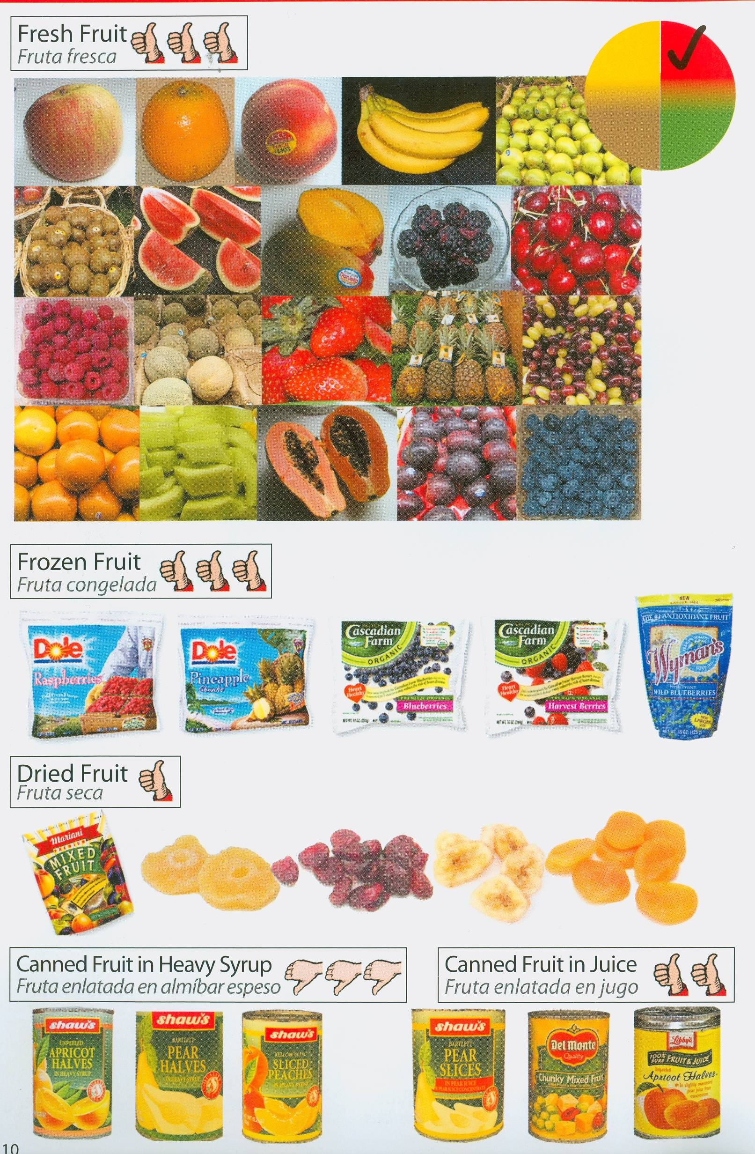

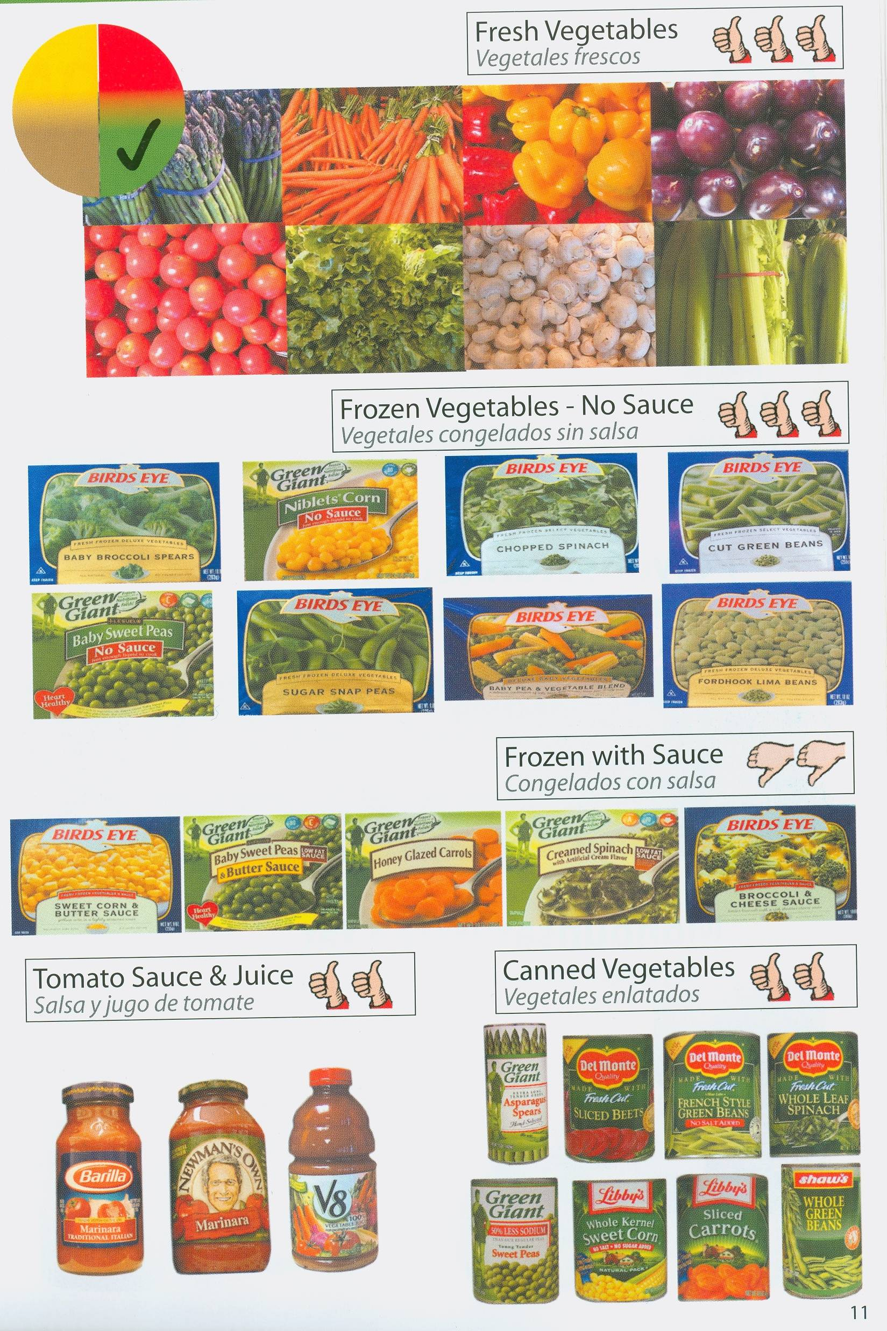

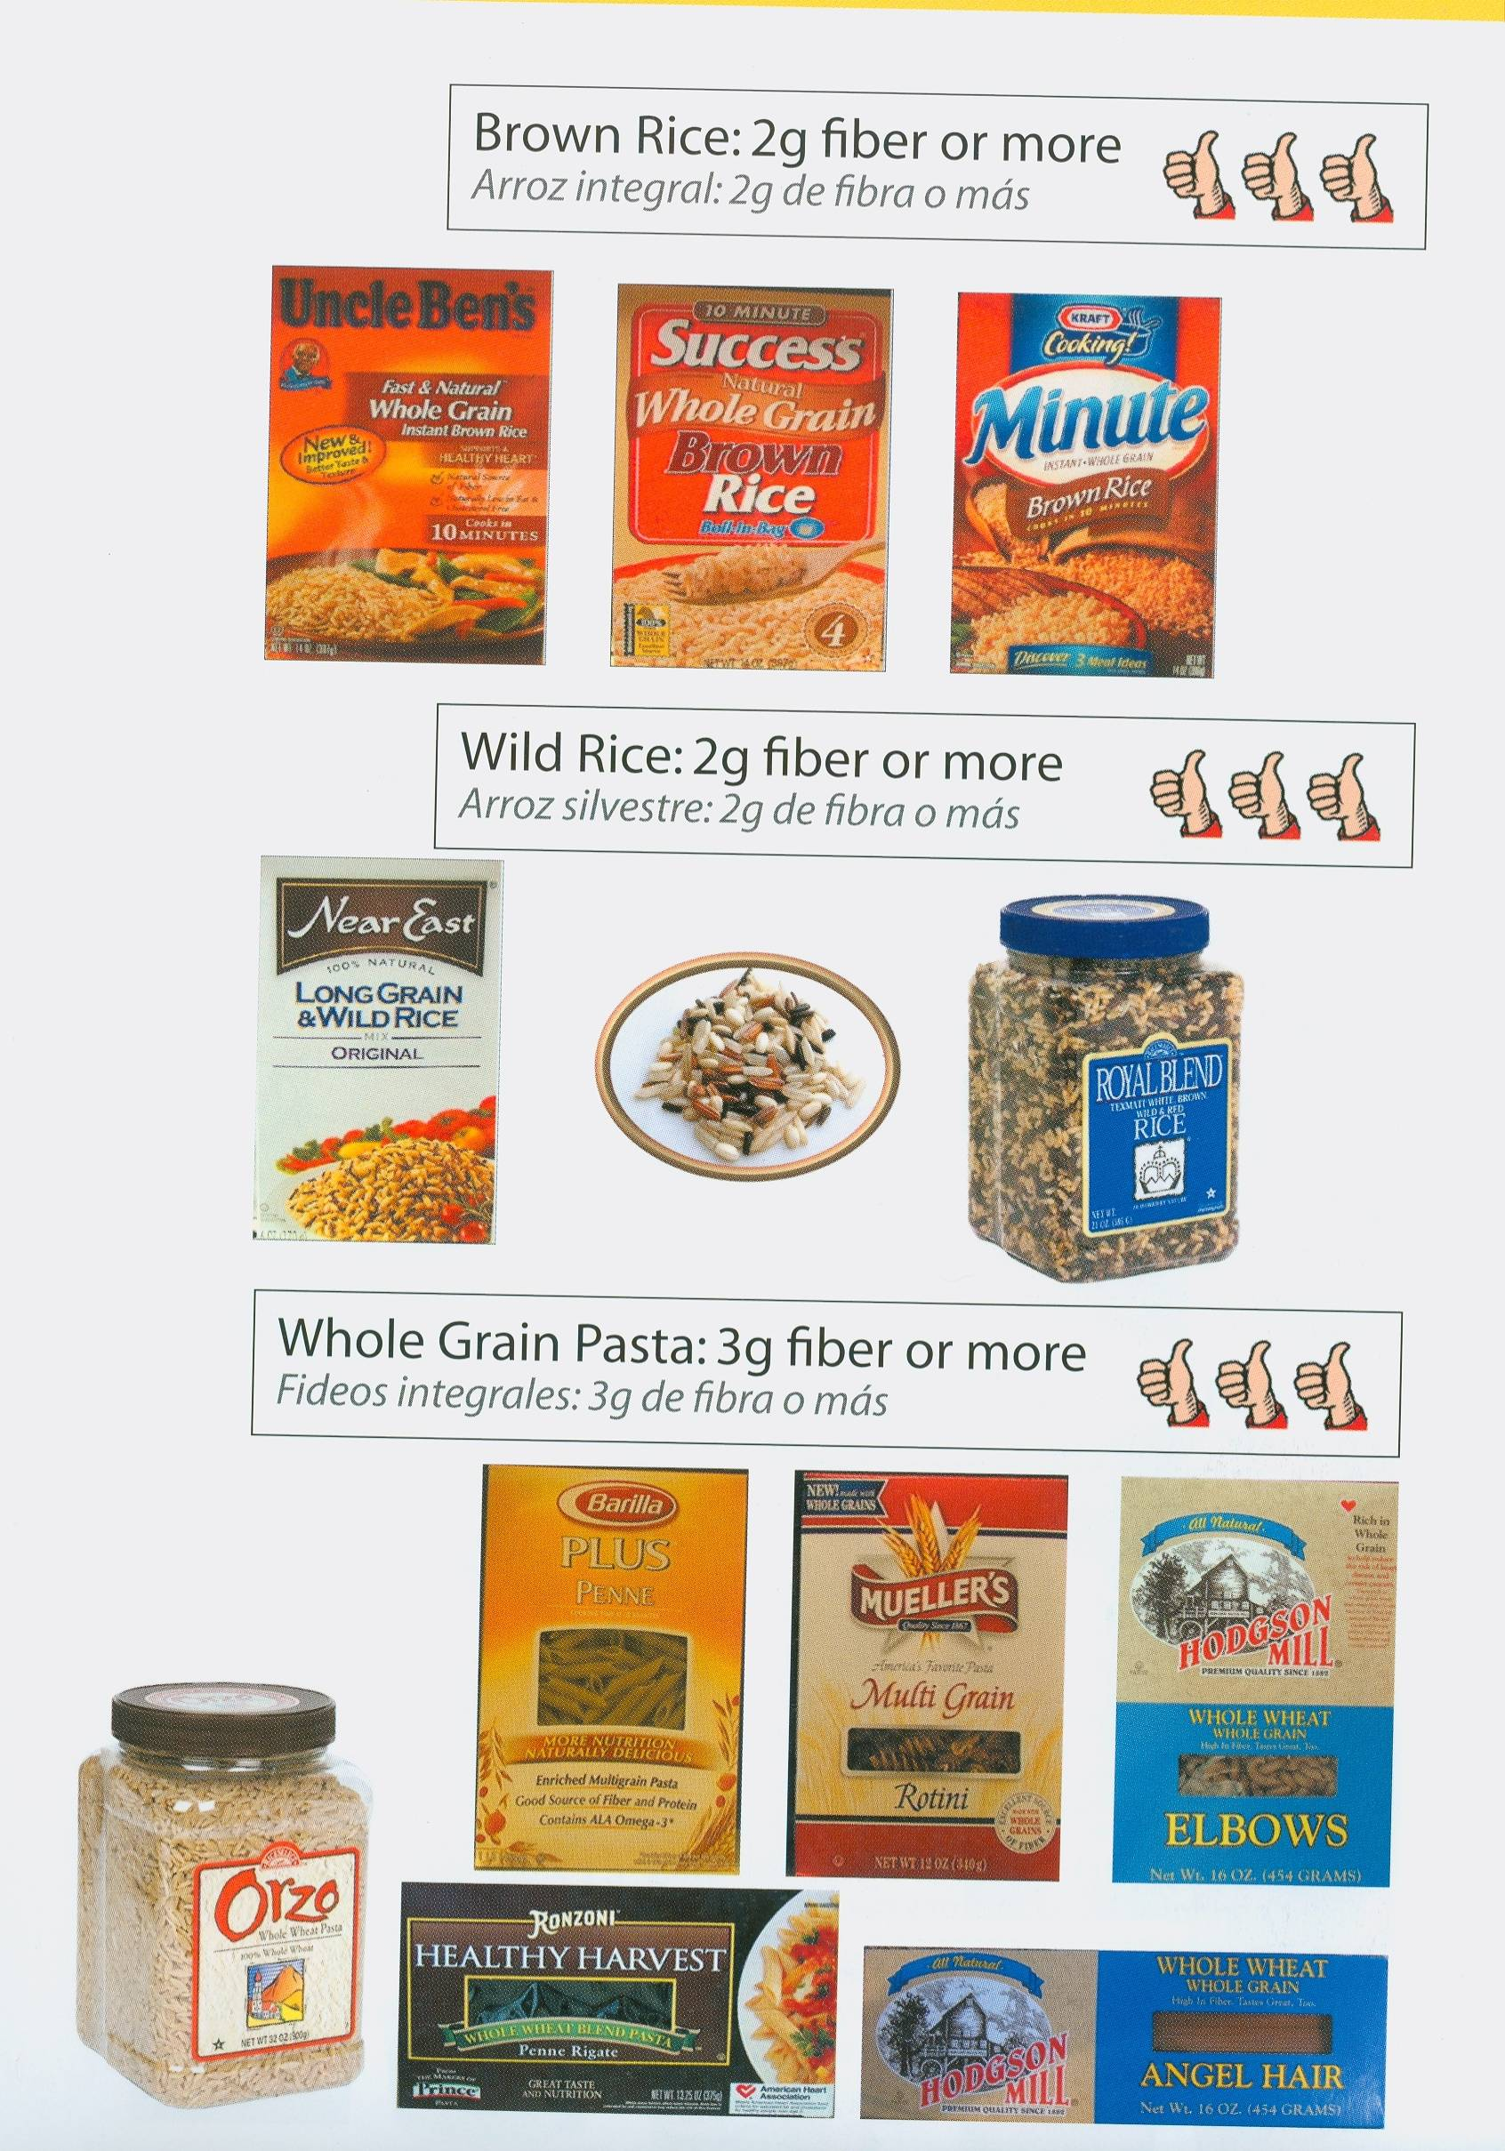

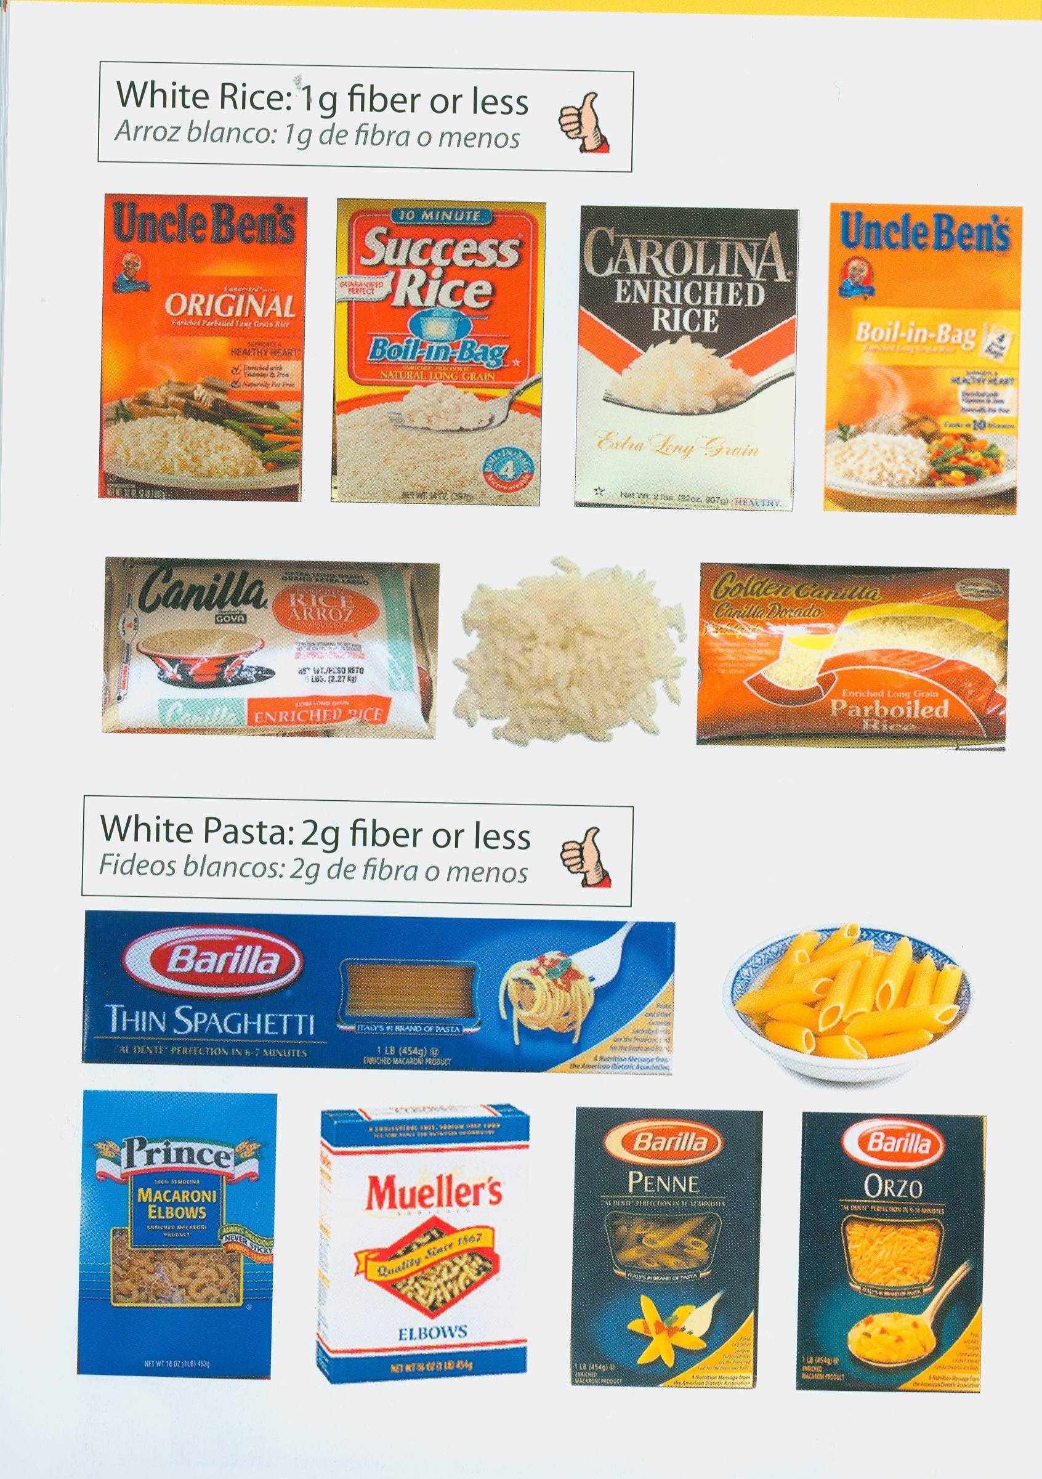

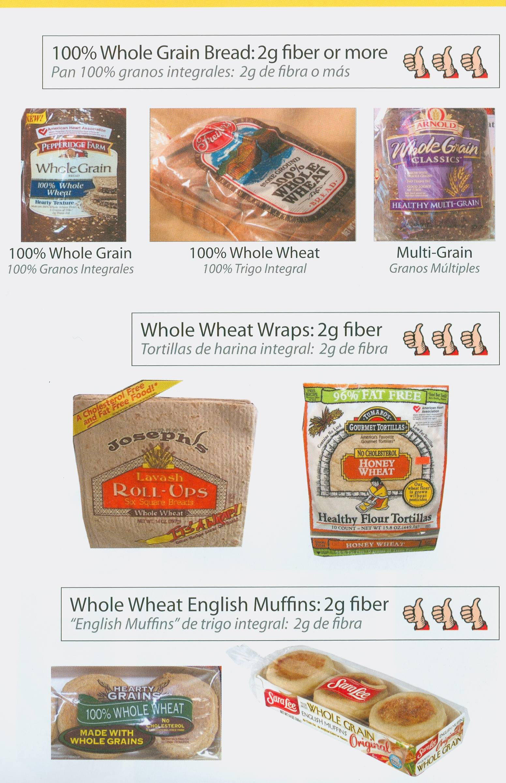

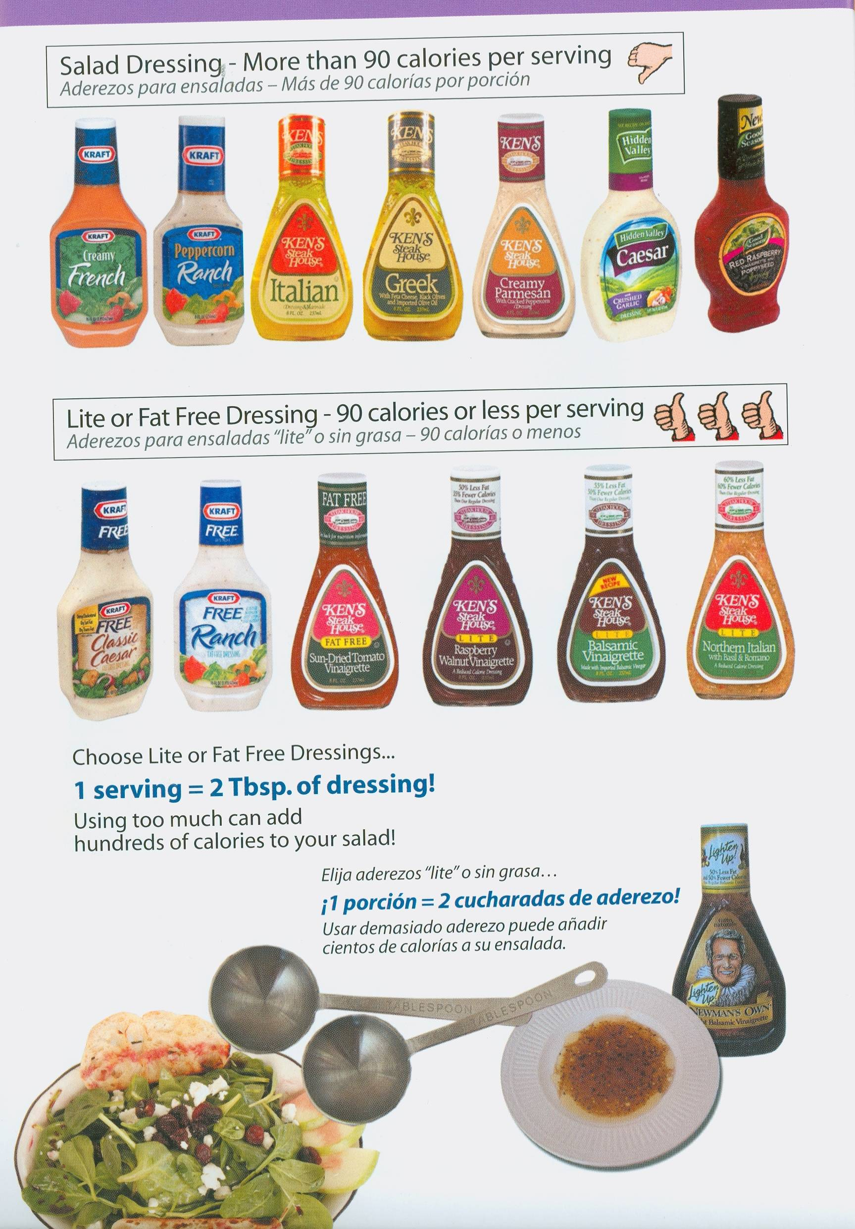

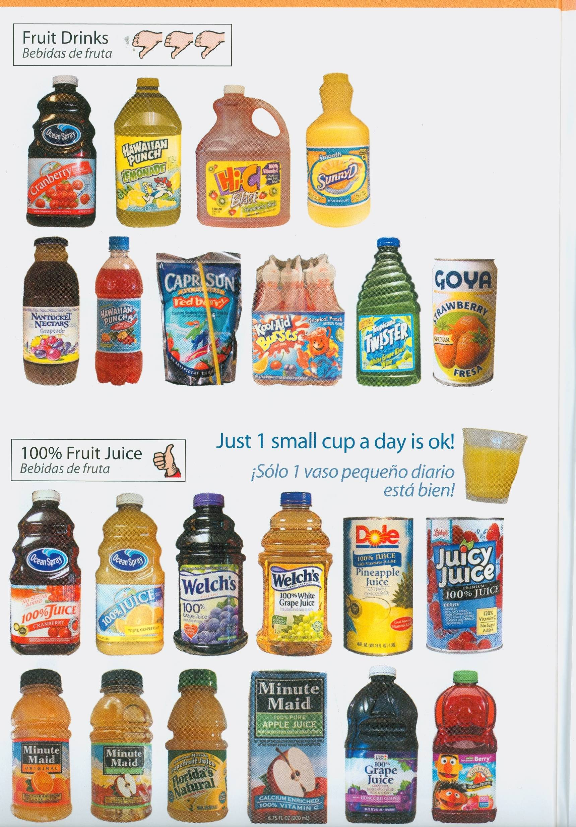

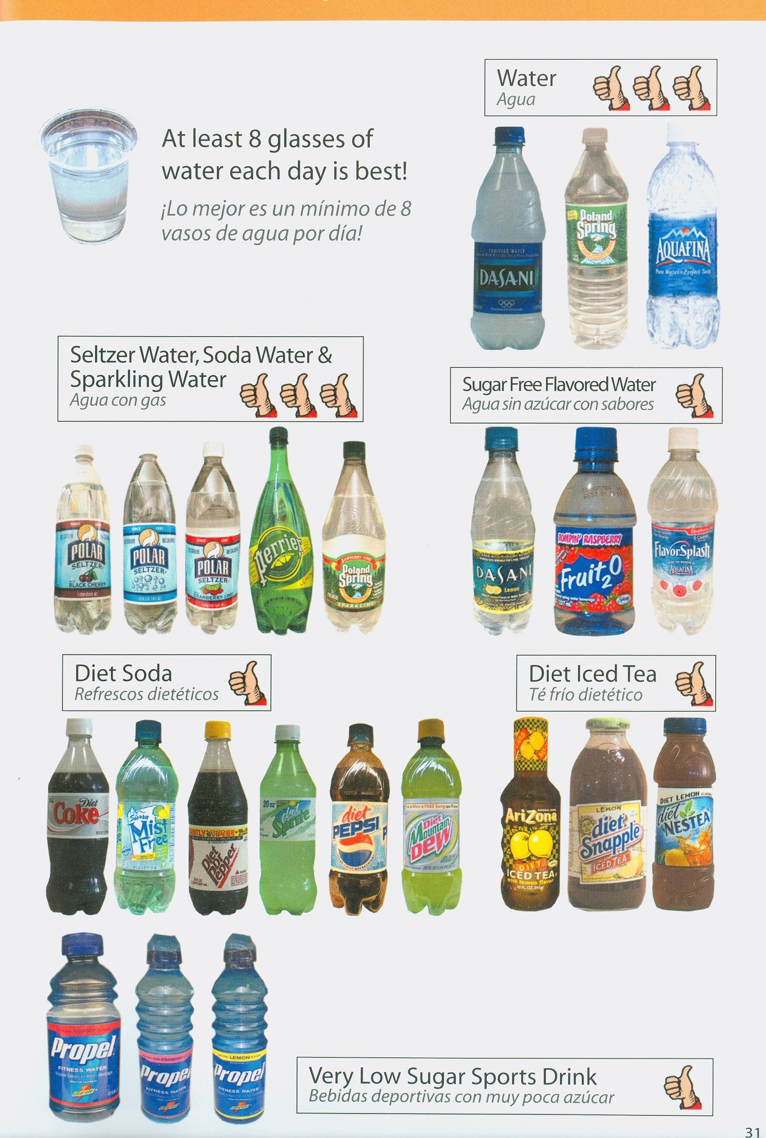

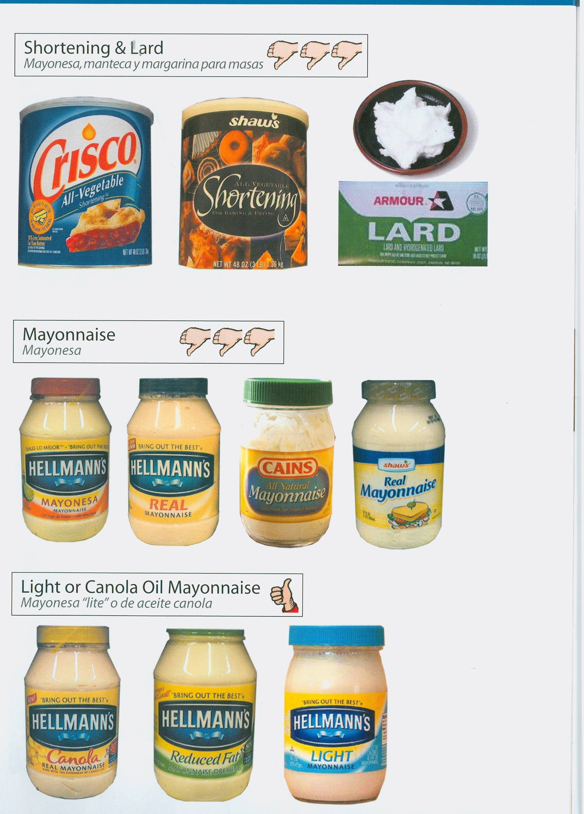

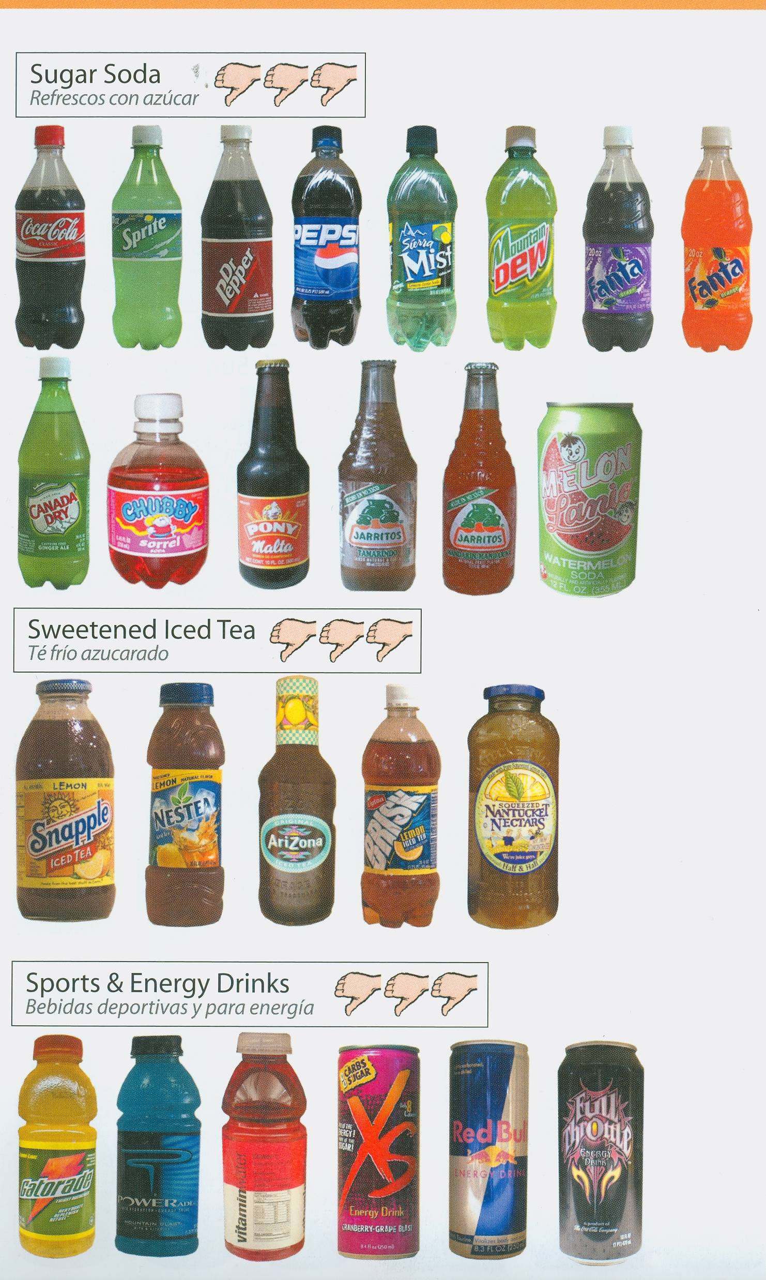

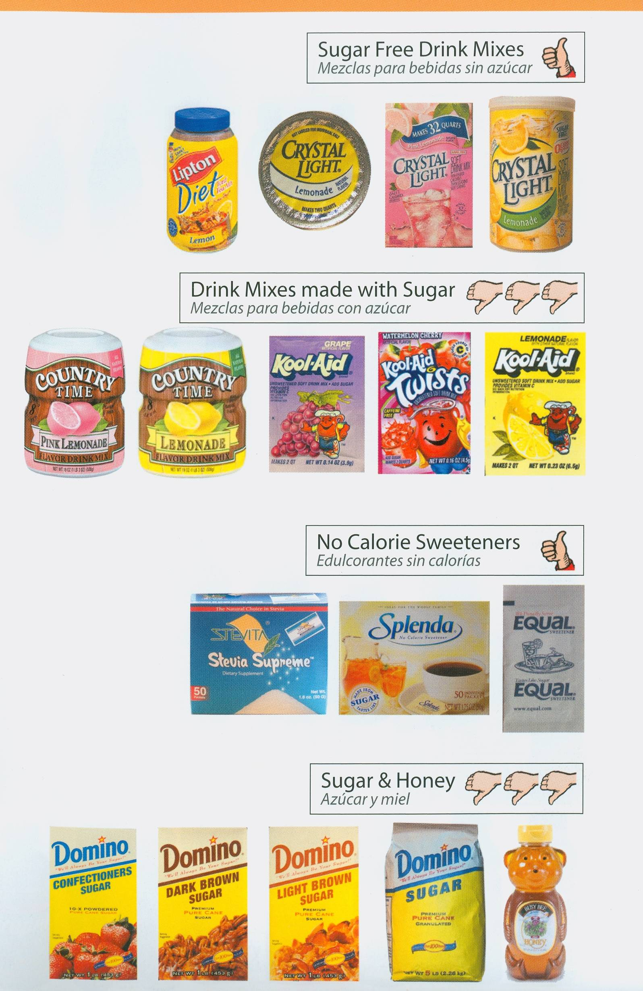

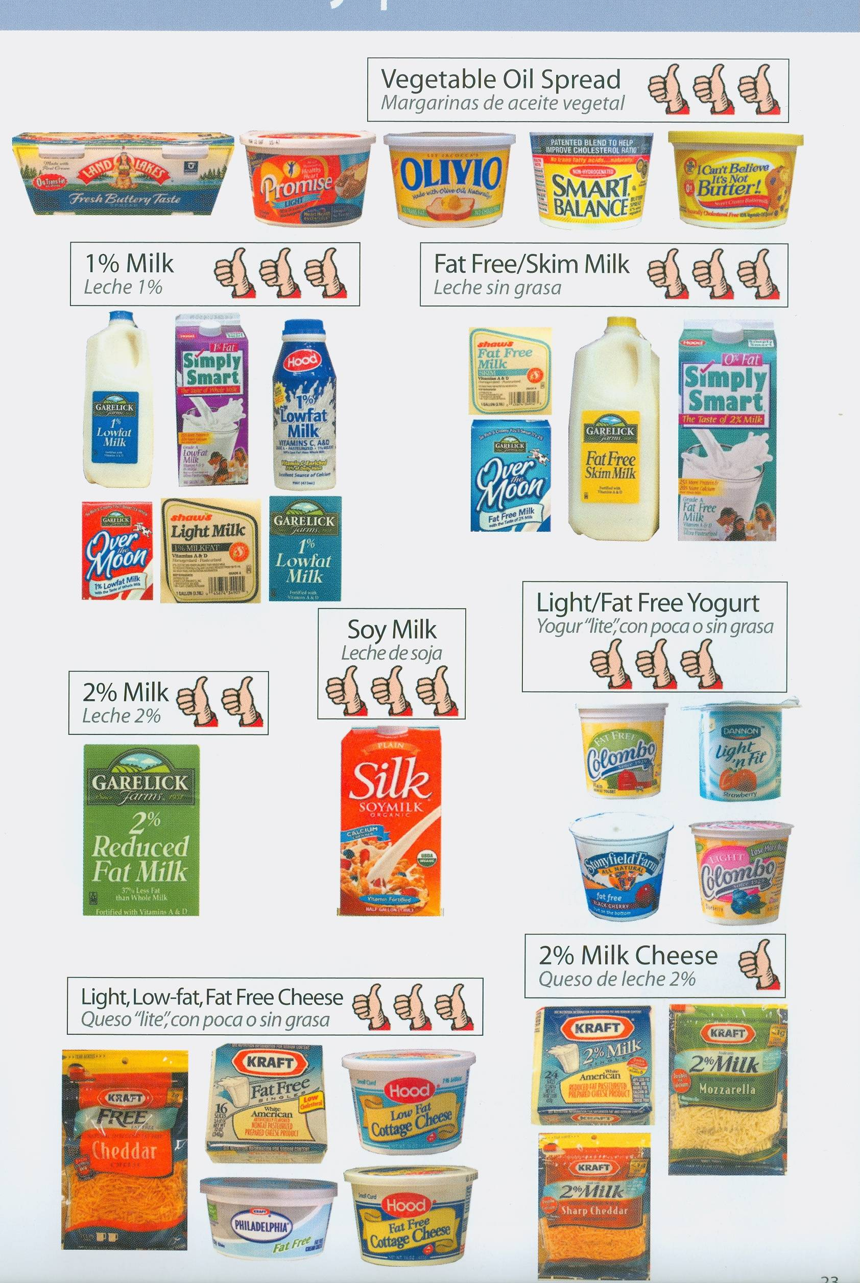

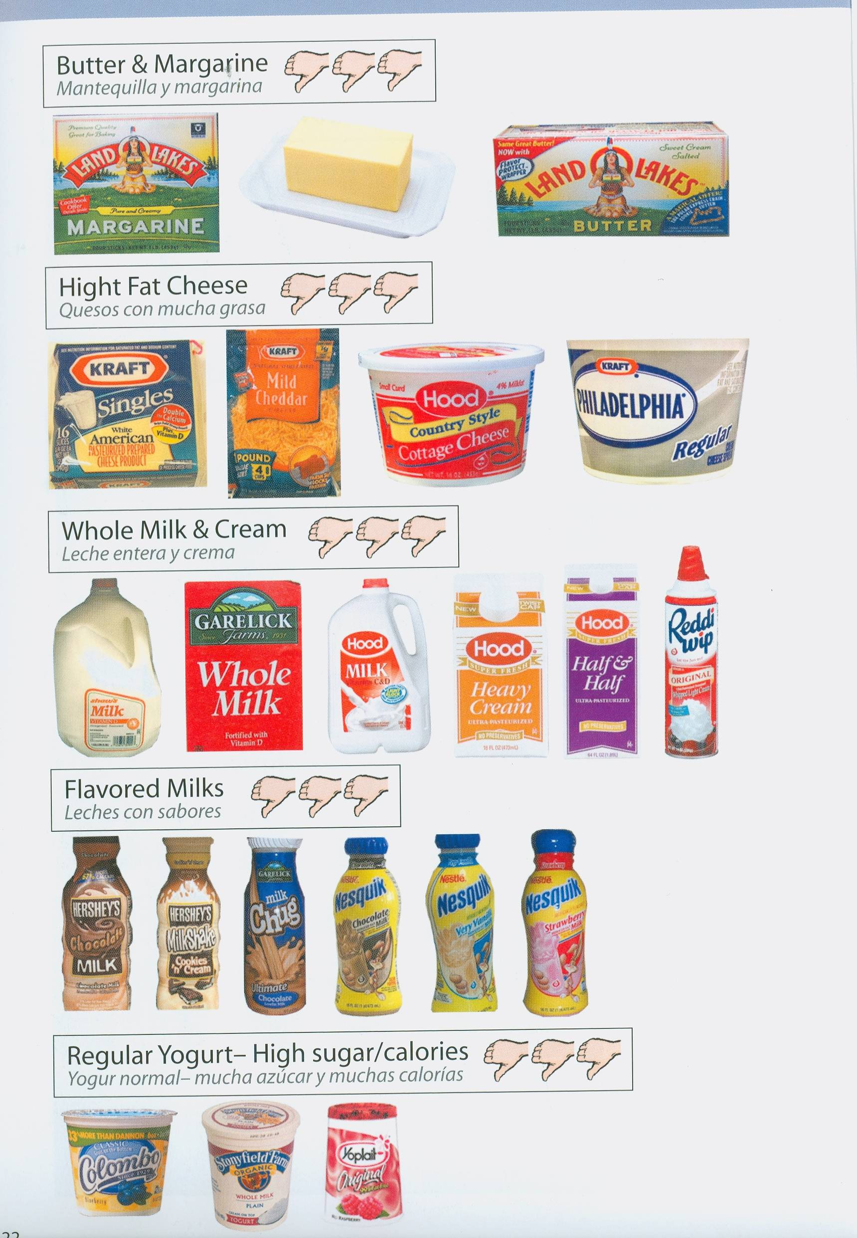

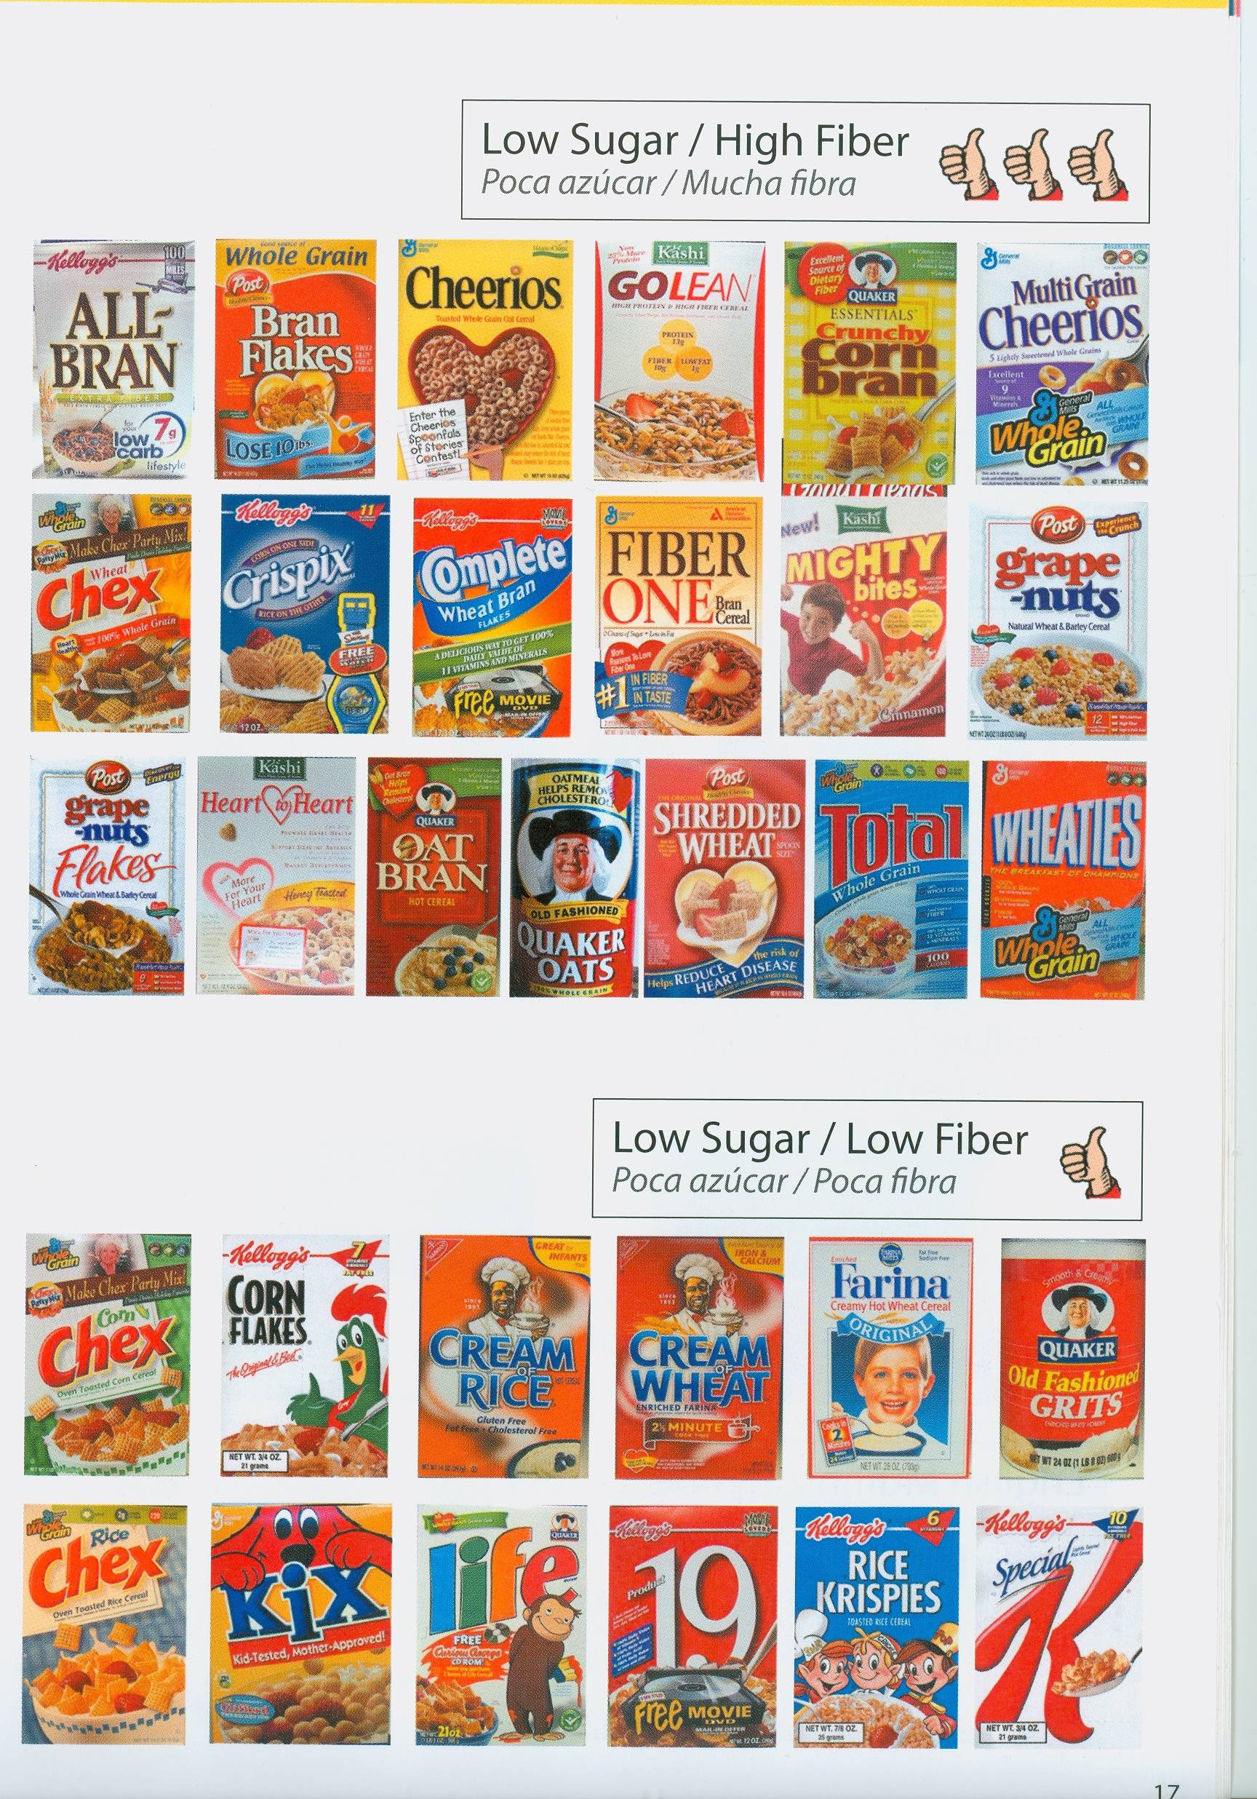

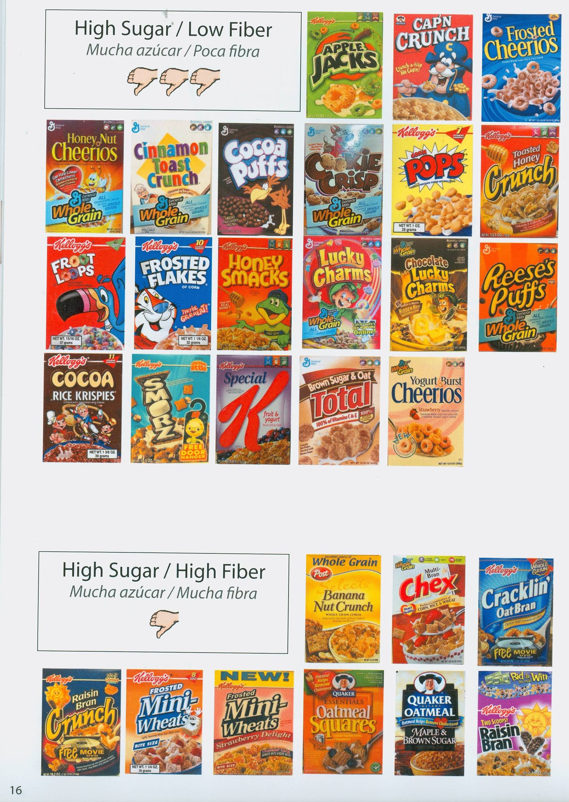

Vegetable and fruit aisle
□ Bananas
□ Oranges
□ Apples
□ Seasonal fresh fruits:
□ Peaches
□ Pears
□Plums
□ Berries (strawberries, raspberries, blackberries, blueberries)
□ Red or green seedless grapes
□ melon

□ Spinach or other leafy greens
□ Onions
□ Broccoli
□ Tomatoes
□ Sweet potatoes
□ Red-skinned potatoes
□ Coleslaw mix
□ Red peppers
□ Baby carrots
□ Mushrooms
□ Diced garlic (usually sold packed with oil, in jars) or fresh garlic

Snack aisle
□ Unsalted Baked tortilla chips
□ Salsa
□ Almonds or walnuts (unsalted)
□ Whole grain baked crackers (unsalted)
□ Graham crackers
□ Unsalted pretzels
□ Baked Vegetable “Chips”
□ unbuttered microwaveable popcorn

Beverage aisle
□ Sugar-free hot chocolate mix
□ Reduced-sugar fruit juice
□ 100% real fruit juice
□ sugar-free beverages (“Crystal Light, sugar free Kool Aid, etc.)
□ Reduced-sodium tomato or vegetable juice

Baking goods aisle
□ Nonstick cooking spray
□ □ Reduced-sugar maple syrup
□ Olive oil and/or canola oil
□ □ Raisins
□ Vinegar (try apple cider or red-wine vinegar)
□ Cooking wine (red or white)

-

□ Herbs and spices—
Garlic powder/onion powder
- Italian seasoning/basil
– parsley

– Cinnamon

Grain aisles
□ Whole-grain pasta
□ Brown rice
□ 100% whole wheat bread
□ 100% whole grain dinner rolls
□ Small (1 oz) whole grain bagels
□ Whole-grain English muffins
□ Whole-wheat tortillas/high fiber flat bread

Canned food aisles
The following foods are good to keep on hand in your pantry:
□ Stewed tomatoes (no salt added)
□ Spaghetti sauce/tomato sauce (no salt added)

□ Low-sodium soups
- unsweetened pineapple chunks
□ unsweetened canned fruit ________________
Beans (packed without added salt)
– Kidney beans
– Black beans
– Chickpeas
– Cannellini beans
– Other beans _____________
□ Unsweetened applesauce
□ mandarin oranges (drain/rinse)
□ Canned salmon and/or tuna (no salt added)
□ Peanut butter/almond butter

Condiment aisle
The following items are good alternatives to standard condiments, which have more fat and/or sodium:
□ Low-sodium soy sauce
□ Reduced-fat mayonnaise
□ Reduced-fat tartar sauce
□ Low-fat or fat-free salad dressings
□ jam (unsweetened)
□ ketchup (no salt added)
□ mustard
□ vinegar

Frozen food aisles

□ Low-fat ice cream or frozen yogurt, or unsweetened frozen pops
□ Vegetables (without added sauces)
□ Black-bean burgers or other soy “meat” products (veggie burgers)
□ Whole-grain waffles
□
□ Unsweetened frozen berries (strawberries, blueberries, blackberries, raspberries)
□ Low-fat whipped topping
□ Pizza dough or pre-baked pizza crust
□

Meat, poultry, fish, and deli counters and aisles
□ Frozen salmon patties (wild Alaskan)
□ whole roasting chickens
□ Lean beef or pork cubes for stir-frying
□ beef or pork roast
□ Deli turkey or lean ham (low sodium)
□ Boneless/skinless turkey or chicken breast cutlets
□ Extra lean ground beef
□ Extra lean ground turkey
□ Other fresh (unbreaded) fish

Dairy case
□ Reduced-fat sour cream
□ Low cholesterol egg substitute
□ Fresh pasteurized eggs
□ Skim or 1% milk
□ Fat free half-and-half
□ low fat sliced cheese
□ Low fat shredded cheese
□ Low fat string mozzarella cheese
□ Low fat cream cheese
□ Soft tub margarine (trans fat free) (first ingredient should be liquid oil)
□ Low-fat, unsweetened vanilla or flavored yogurts
□ Reduced-fat cottage cheese
□ Tofu

Cereal*
_____ Old fashioned oatmeal
_____ Shredded wheat
_____ Whole-grain cereal
*3 grams (g) fiber, less than 10 g sugar

Section 8 Food Safety
Food Safety
- Wash hands before food preparation
- Wash and sanitize all surfaces before food preparation
- Wash/sanitize cutting boards before and after contact with raw meats/poultry/
seafood/or eggs
- Keep raw meats/poultry/seafood/eggs separate from any foods that will not be
cooked
- Thoroughly rinse all produce (fresh fruits and vegetables) before handling
- Use a meat thermometer to insure food is cooked to proper temperatures

  - Meats should be cooked to an internal temperature of 165 degrees
  - Reheat all leftovers to 165 degrees
- Cooked foods should be held at 135 degrees before service (for best quality, avoid
cooking vegetables more than 15 – 20 minutes before service)
- Perishable foods should be refrigerated immediately after meal service at
35 – 40 degrees
- Avoid eating raw and undercooked eggs, as they may cause food-borne illnesses; use pasteurized eggs when eggs may be undercooked

- Follow recommended guidelines for storing foods:

Guidelines for keeping perishable foods safe and at peak quality

Fresh Food Refrigerator Freezer
Beef, roasts, steak 3-5 days 4-9 months
Pork roasts 3-5 days 4-8 months
Pork chops 3-5 days 3-4 months
Ground meat 1-2 days 3-4 months
Leftover cooked meats 3-4 days 2-3 months
Fresh poultry 1-2 days 4-6 months
Cooked poultry 3-4 days 4-6 months
Fish 1-2 days 2-3 months
Deli meats 3-5 days 1-2 months (airtight)
Hotdogs (opened) 7 days 1-2 months (airtight)
Bacon 7 days 9 months
Milk 7 days 3 months
Eggs 2-5 weeks not recommended
Processed/hard cheese 2-3 weeks 6 months (airtight)
Berries 1-2 days (fresh) 8-12 months
Fruit (citrus, apples) 1-3 weeks (fresh) 8-12 months
Vegetables 3-7 days (fresh) 8-12 months (frozen)

Dry Good Food Dry Storage
Flour 6-8 months
Cereals (unopened) 6-12 months
Mayonnaise (unopened) 2-3 months
Salad oil (unopened) 6 months
Pasta 24 months
Cake and muffin mixes 9 months
Spices and herbs 6 months
Berries 6 months dried; 12 months canned
Canned fruit 9 months
Vegetables 1 month dehydrated; 12 months canned

Additional Food storage information
- Foods that stay too long in the refrigerator, freezer, or pantry may be (but are not always) unsafe to eat. Bacteria, molds, and yeasts may start to grow, potentially causing a food- borne illness if eaten, or causing loss of quality and/or nutrients
- Be careful when buying prepared meat, fish, poultry, eggs, or salads with meat, fish, poultry or eggs from salad bars, grocery stores, or restaurants. These can spoil quickly. Be sure they are stored and served at the proper temperatures, and consume them quickly (1 – 2 days)
- Read expiration dates carefully.
- Clearly label foods that are frozen with a “made on” date or “throw out by” date.
- When in doubt about a food, throw it out. Food can taste fine even though it has spoiled
- Serve food with a clean serving spoon. Never put a utensil that has been in contact with someone’s mouth, plate, etc. into any stored food product since this would cause germs to contaminate the food and hasten food spoilage.
(Dietitian Menues)
Recipes for
Soft cooked foods
Suggestions for cooking food
That is easily ground or pureed
Prepared by
Massachusetts Department of Developmental Services Northeast Region Department of Occupational Therapy
and
Department of Food and Nutritional Services

Food Texture Definitions and Purpose

Regular

This texture is for individuals who have adequate chewing and swallowing skills.
- This texture consists of food served in a whole form.

Cut-Up
- This texture is for individuals who need assistance to assure that food reaches their mouths in bite-size pieces.
- This texture consists of food cut in ½” cubes or bite-sized pieces.

Chopped
- This texture is for individuals who have some chewing skills but do not use chewing/mashing skills to adequately pulverize food for safe swallowing.
- This texture consists of food items chopped to pea size. Each food item is soft or cooked until soft.

Ground
- This texture is for individuals who have limited chewing or mashing skills but are able to push food together in their mouths for safe swallowing.
- This texture consists of small pieces of each food item that has been processed down to the size of an apple seed. It includes enough sauce or liquid to moisten the food and/or bind food items together.

Pureed
- This texture is for individuals who have no chewing skills and may have significant swallowing problems.
- This texture is smooth, moist, pudding-like and contains no lumps. All food items should drop off the spoon in globs when the spoon is tilted. Food should not run off in a steady stream, nor be pasty or sticky.

Strained
- This texture is for individuals who have severe aspiration and/or swallowing problems. These individuals are unable to handle a pureed texture because of the presence of minuscule particles that stimulate coughing and gagging episodes. These individuals are at risk for aspiration and/or choking.
- This texture is strained through a fine mesh strainer. It is smooth, moist, and of absolute pudding-like consistency.

Soups
Regular: Soups may be thick or thin and contain small pieces of food. Regular soup is appropriate for regular and cut-up texture orders.
Textured: Soups may be thick or thin, but should be of uniform consistency. It is appropriate for chopped, ground, and pureed texture orders.
Strained: Soup may be thick or thin, but should be strained through a fine mesh strainer. It should be of a uniform consistency. Strained soup is only for individuals on a strained texture order.

Tips for Preparation and Serving
Creating a pleasant dining environment can increase safety during dining. It can also help to lessen anxiety as well as increase appetite and interest in the people and environment around us. Good nutrition leads to better cognitive functioning. Some ways to ensure a pleasant dining experience in your home are to:
- Decrease distractions: Turn off the TV. Try using soft calming music during meal. Have only one conversation happening at a time during meals. Staff should sit down and relax during the meal if possible.
- Make it a group activity: Try to involve all the individuals who live in your house in meal preparation! Find a job for everyone, opening packages, stirring, using the oven or measuring ingredients. This will provide a sense of accomplishment, teamwork, and a better understanding and interest in nutrition.
- Set the table: If appropriate, place a colorful centerpiece on the table and change it often. Set the table with colored napkins and matching tablecloths. Use good lighting in the room, especially for those with decreased vision.
- Use visual contrast on plates: People who have difficulty at meal time may benefit from using visual contrast in order to help distinguish their food from the environment. This will also make food more visually appealing. Use red or blue plates for white or beige foods such as mashed potatoes. Contrast the colors of foods on the plate. For example serve bright vegetables or sauces on bland colored foods.
- If trying to control portion size: Use smaller plates and bowls. Smaller forks and spoons work well for those who need to pace their eating. Smaller cups and smaller diameter straws slow the pace of drinking.
- Create a sensory experience: Increasing the aroma of cooking food is a great motivator for successful dining. Use fresh spices, garlic or onions when possible.
- Don’t forget leftovers: Make extra food and save it in single-serve dishes for busy nights. Most food can be safely frozen and re-heated in the microwave later and is typically healthier than frozen dinners.
- Good nutrition is important: Whole grains, fruits, vegetables and lean proteins are the building blocks of a good diet. Reducing fat, salt and excess calories is an important aspect of a healthy lifestyle.
- Get active: Increasing physical activity by going on walks or for a swim will increase appetite and physical fitness.

Ideas for Naturally Soft Foods

Dairy

Cheese Sauces
Melted Cheese
Cottage Cheese
Ricotta Cheese
Yogurt and yogurt drinks

Fruits

Applesauce
Ripe Banana
Melon Cubes

Soft Well-Cooked Vegetables without Seeds or Skins
Tomato Puree Juice

Meats

Ground Chicken or Beef (moistened with gravy)
Tofu

Low sodium soups with no meat or veggie chunks
Low sodium cream soup
Pureed or Blended Soups

Starches

Cooked Cereal
Well-cooked Macaroni, Pasta or Noodles
Mashed potatoes without skins

Mashed sweet potato
Pancakes
Crackers softened in soup or drinks
Soft Bread or Soft Tortilla (wheat is healthiest)

Fats

Avocado

Hummus

Low fat cream cheese

Smooth or Creamy Peanut Butter

Sweets

Jelly/Jam with no skin or seeds (avoid “fruit preserves”)

Frozen Juice Pop
Jell-O Dessert (with or without soft canned fruit)
Soft Ice Cream

Popsicles
Frozen Yogurt
Pudding

Quick Mushroom Soup

Ingredients:
4 tablespoons margarine
3 ½ tablespoons flour
1 cup chicken stock
1½ cups low fat milk
½ cup mushrooms, puree in food processor
1 teaspoon garlic powder
1 tablespoon lemon juice
1 teaspoon parsley, ground
Salt and pepper

Items Needed:
Food Processor
Medium Saucepan
Measuring Spoons
Measuring Cups

Skills Addressed:
Hand washing
Stirring
Measuring
Pouring
Stove and oven safety
Using a timer
Opening containers

Preparation:
Grind mushrooms in food processor.
Melt margarine in saucepan then stir in flour. Cook for 1 minute.
Add chicken stock and 1 cup of milk. Boil, stirring constantly until thickens.
Add mushrooms, garlic powder, salt, pepper, and lemon juice.
Cook for 5 minutes on low heat.
Stir in parsley and ½ cup of milk.
Puree before serving per Texture Manual protocol for soup
Option: Sauté mushrooms, puree then add to soup

This recipe may need to be thickened according to each individual’s specific need for thickened liquids.

Cheese Chowder

Ingredients:
½ teaspoon onion powder
2 tablespoons margarine
¼ cup flour
2 cups low fat milk
1 13.75 oz can of low sodium chicken broth
¼ cup carrots, cooked and pureed in food processor
½ cup reduced fat cheddar cheese, grated
Dash of salt and paprika

Items Needed:
Medium Saucepan
Food processor
Measuring spoons
Measuring cups
Cheese grater

Preparation:
Cook carrots until very soft; puree, set aside
Grate cheddar cheese, set aside
Melt margarine in saucepan.
Add flour, stir until well mixed.
Add milk and broth, cook until thick and bubbly.
Add onion powder and pureed carrots.
Reduce heat to low
Add cheese and simmer for 15 minutes.

This recipe may need to be thickened according to each individual’s specific need for thickened liquids.
Pumpkin Soup

Ingredients:
1 teaspoon onion powder
¼ cup margarine
½ teaspoon curry powder
2 cups canned pumpkin
1 ½ teaspoons salt
2 cups 1% milk
2 ½ cups low sodium chicken broth

Items Needed:
Food Processor
Large saucepan
Measuring cups
Measuring spoons

Preparation:
Place pumpkin, milk and salt in food processor until well mixed
Melt margarine in saucepan; add onion powder and curry powder
Cook 1-2 minutes
Add pumpkin mixture to saucepan and stir until mixed with onion powder and curry powder
Add chicken stock and cook until hot

Makes 4 servings

This recipe may need to be thickened according to each individual’s specific need for thickened liquids.

Ham with Sweet Potatoes Meatballs

Ingredients:
1 egg
½ cup milk
1 ½ cups fine bread crumbs
2 cups cooked ham, finely ground
1 teaspoon dry mustard
1 pound canned sweet potatoes, or fresh sweet potato cooked soft and pureed
2 tablespoons melted margarine
½ cup honey
2 tablespoons vinegar

Items Needed:
Food processor
Large bowl
Electric mixer
Baking dish
Measuring cups
Measuring spoons

Preparation:
Grease baking dish.
Grind ham in food processor, set aside
Beat eggs lightly in large bowl
Add milk, breadcrumbs, ground ham, ½ teaspoon mustard to egg
Mix with electric mixer until blended then shape into about 12 balls
Put balls in baking dish, evenly spaced
Spread mashed sweet potatoes between balls of ham
Mix melted margarine, honey, vinegar and mustard together and drizzle over ham and potatoes
Bake at 375° for 40 minutes
Serve with gravy
Mash with fork before serving for chopped and ground diets. Puree in food processor for puree diets

Makes 4 servings

Turkey Patties

Ingredients:
1 ½ pounds ground turkey
¼ cup fine bread crumbs
1 egg
2 tablespoons ground mushrooms
2 teaspoons garlic powder
1 teaspoon onion powder
1 ½ teaspoons ground ginger
2 ½ tablespoons soy sauce

Items Needed:
Food processor
Bowl
Broiler pan
Measuring spoons

Preparation:
Grind mushrooms in food processor, transfer to bowl
Add rest of ingredients, mix well.
Shape into 6 patties
Broil in oven 4” from heat for 5 minutes on each side
Grind in food processor before serving
Serve with gravy
Mash with fork before serving for chopped and ground diets. Puree in food processor for puree diets

Makes 6 servings

Chicken Encore

Ingredients:
1 pound cooked chicken, ground in food processor
8 ounces small pasta (such as pastina)
2 cans cream of mushroom soup
4 hard boiled eggs ground in food processor
1 teaspoon onion powder
1 cup low fat milk
1 cup low sodium chicken broth
½ pound cheddar cheese, cubed

Items Needed:
Food processor
9x13 baking dish
Measuring cups
Measuring spoons

Preparation:
Cook chicken. Grind in food processor.
Boil and peel eggs
Grind cream of mushroom soup and peeled eggs in food processor
Cook pasta until very well done and soft.
Combine all ingredients in baking dish, mixing well.
Cover and refrigerate over night
Bake at 350° for 1 hour
Mash with fork before serving for chopped and ground diets. Puree in food processor for puree diets

Makes 4 servings

Potato Pie

Ingredients:
2 cups mashed potatoes
1 pound low fat cottage cheese
½ cup low fat sour cream
2 eggs, beat well
1/8 teaspoon pepper
3 tablespoons parmesan cheese

Items Needed:
Food Processor
Bowl
Baking dish
Measuring cups
Measuring spoons

Preparation:
Blend cottage cheese in food processor until smooth
Mix cottage cheese with all other ingredients in large bowl
Put ingredients in baking dish
Cover dish and cook at 400° for 50 minutes
Mash with fork before serving for chopped and ground diets. Puree in food processor for puree diets

Makes 6 Servings

Spinach Casserole

Ingredients:
3 10 oz packages frozen chopped spinach, thawed, drained and ground in food processor
1 pint low-fat sour cream
1 package dry onion soup mix

Items Needed:
Bowl
Casserole Dish
Food processor

Preparation:
Squeeze dry spinach and grind in food processor
Mix all ingredients in large bowl
Spoon ingredients into casserole dish
Bake at 350° for 30 minutes
Mash with fork before serving for chopped and ground diets. Puree in food processor for puree diets

Makes 6 servings

Squash Delight

Ingredients:
1 large squash (acorn, butternut, hubbard) – peeled; all seeds removed
1 jar roasted red pepper
1 teaspoon onion powder
¾ cups peeled, canned tomatoes, chopped (remove skin for puree diets)
parmesan cheese
margarine

Items Needed:
Food Processor
Saucepan
Measuring spoons
Measuring cups

Preparation:
Puree canned tomatoes, set aside
Peel pepper, remove seeds, and grind in food processor
Puree red peppers, set aside.
Cook squash in sauce pan until soft, drain
Mix pureed pepper, onion powder and tomato in food processer
Add drained, cooked squash and blend until smooth
Re-heat in saucepan until bubbly and hot
Serve with margarine and parmesan cheese on top
Mash with fork before serving for chopped and ground diets. Puree in food processor for puree diets

Baked Cheddar Fish

Ingredients:
4 fish cutlets (cod, scrod, haddock, tilapia)- skins removed
2 teaspoons lemon juice
2 tablespoons margarine
2 tablespoons flour
1 cup low fat milk
½ cup low-fat cheddar cheese, grated
½ teaspoon mustard

Items Needed:
Baking dish
Cheese grater
Whisk
Saucepan
Measuring cups
Measuring spoons

Preparation:
Rinse and dry fish and place in shallow baking dish
Sprinkle fish with lemon juice, salt and pepper
Melt margarine in saucepan,
Add flour, stir well
Stir in milk with whisk. Heat until thickened
Add cheese and mustard
Pour sauce over fish and bake at 350° for 30 minutes
Mash with fork before serving for chopped and ground diets. Puree in food processor for puree diets

Makes 4 servings
Spinach Frittata

Ingredients:
½ cup jarred, roasted red pepper
¼ teaspoon onion powder
2 tablespoons vegetable or olive oil
3 eggs
½ cup low fat milk
1 cup cooked chicken, ground (chicken is optional)
1 10 oz package frozen chopped spinach thawed, squeezed dry and ground
½ cup shredded American cheese
1 tablespoon grated parmesan cheese
½ teaspoon salt
½ teaspoon pepper

Items Needed:
Food processor
Skillet
Bowl
Measuring cups & spoons
Whisk
Cheese grater

Preparation:
Cook chicken and grind in food processor (if adding chicken)
Grind red pepper in food processor
Squeeze spinach dry and grind in food processor
In skillet sauté red pepper with onion powder
In bowl, beat eggs
Stir chicken, ½ cup spinach, American and parmesan cheese, salt, pepper into bowl
Add ingredients from bowl into skillet and cook over medium heat for 7-10 minutes until set.
Mash with fork before serving for chopped and ground diets. Puree in food processor for puree diets

Sweet Potato Casserole

Ingredients:
5 sweet potatoes, peeled and sliced
½ cup reduced fat margarine
½ cup packed brown sugar
3 tablespoons orange juice
1 pinch ground cinnamon

Items Needed:
Large saucepan
Bowl
Electric mixer
Baking dish
Potato masher
Measuring spoons

Preparation:
Preheat oven to 350°
Peel sweet potatoes, slice into 1-inch pieces
Place sliced sweet potatoes in large saucepan with enough water to cover them. Boil and cook for about 15 minutes. Drain and mash potatoes
Place mashed sweet potatoes, margarine, brown sugar, orange juice and cinnamon in large bowl and mix with electric mixer.
Spread into a baking dish
Bake for 25-30 minutes at 350°
Mash with fork before serving for chopped and ground diets. Puree in food processor for puree diets

Meatloaf with Spinach

Ingredients:
1 tablespoon olive oil
1 tablespoon onion powder
¼ teaspoon garlic powder
1 package frozen chopped spinach thawed, squeezed dry, and processed
2 pounds ground beef
2 eggs
½ cup grated Parmesan cheese
½ cup dry bread crumbs
½ teaspoon salt
Pepper to taste

Items Needed:
9x13 baking dish
Skillet
Large bowl
Measuring spoons
Food processor

Preparation:
Preheat oven to 350°
Squeeze spinach dry and grind in food processor
In a skillet, heat oil, garlic powder, onion powder and spinach for 5 minutes.
Remove from heat and allow to cool
In large bowl combine ground beef, eggs, breadcrumbs, Parmesan cheese, salt and pepper. Stir in spinach.
Put mixture into baking dish
Cook at 350° for 50-60 minutes until cooked through
Mash with fork for chopped and ground diets. Puree in food processor for puree diets. Serve with gravy.

Serves 6
Spinach Ricotta Pie

Ingredients:
1 10 oz package frozen chopped spinach, thawed and squeezed dry
1 15 oz container low fat ricotta cheese
8 oz garlic herb cheese spread
4 large eggs
1 cup marinated artichokes, finely ground (omit for puree)
½ teaspoon salt
¼ teaspoon pepper

Items Needed:
9” pie pan
Whisk
Large bowl
Measuring spoons

Preparation:
Preheat oven to 375°
Grease pan with olive oil or spray
In large bowl, whisk together ricotta cheese, garlic herb spread, and eggs
Add spinach, artichokes (omit for puree), salt and pepper
Pour into pie pan and bake about 45 minutes at 375°
Mash with fork before serving for chopped and ground diets. Puree in food processor for puree diets

BBQ Meatloaf

Ingredients:
2 cups breadcrumbs
1 tablespoon onion powder
1 tablespoon horseradish
2 teaspoons barbeque sauce
2 teaspoons celery salt
1 teaspoon garlic powder
¼ teaspoon pepper
2 eggs
11/2 pounds ground beef
1/2 cup barbeque sauce

Items Needed:
Food processor
Large bowl
Loaf pan
Measuring spoons
Measuring cups

Preparation:
Combine bread crumbs, onion powder, 2 tablespoons of water, horseradish, celery salt, barbeque sauce, garlic salt, pepper and eggs
Add beef to mixture and mix well
Grind all ingredients in food processor
Place ingredients in loaf pan
Bake at 350° for 30 minutes
Pour off grease (this should be done by a staff member for safety)
Pour on barbeque sauce and bake 45 minutes more
Fork mash and serve with gravy for ground and chopped diets. Puree in food processor for puree diets.

Turkey Tamale Pie
Ingredients:
12 oz package corn muffin mix
½ cup shredded cheddar cheese
1 can cream of celery soup (process for puree diets)
1 teaspoon chili powder
1/8 teaspoon garlic powder
1 (4 oz) can green chilies, finely chopped, seeds removed
½ teaspoon onion powder
1 cup evaporated milk
1 ½ cups ground turkey

Items Needed:
Food processor Saucepan
2 quart casserole dish Measuring cups
Large bowl Measuring spoons
Sauté pan

Preparation:
Preheat oven to 350°
Grease 2 quart casserole dish
Chop green chilies and remove seeds
Cook turkey in sauté pan, grind it in food processer, once cooked
Prepare muffin mix according to directions, and stir in cheddar cheese
Set bowl with mix aside
In saucepan, combine soup, chili powder, onion powder, evaporated milk and cooked turkey until blended and heated through
Grind soup/turkey mixture in food processor until smooth
Spoon muffin mixture into casserole dish
Spoon turkey mixture on top of muffin mixture
Bake for 25 minutes at 350°
Mash with fork before serving for chopped and ground diets. Puree in food processor for puree diets

Shepherd’s Pie

Ingredients:
1 pound ground beef or turkey
1 tablespoon onion powder
½ pound mushrooms,
½ teaspoon garlic powder
1 12 oz can cream of mushroom soup
1 cup canned peas
4 cups mashed potatoes
Salt and pepper
½ cup grated cheddar cheese

Items Needed:
Sauté pan
Bowl
Baking dish
Measuring cups
Measuring spoons
Food processor

Preparation:
Preheat oven to 375°
Prepare mashed potatoes
Puree mushroom, set aside
Sauté beef or turkey with onion powder and fresh mushrooms but do not drain, then grind
Add garlic powder to cream of mushroom soup and stir well in small bowl
Add soup to meat and mushrooms on stove top, mixing thoroughly
Mash peas well and spread on bottom of baking dish
Cover with meat mixture and top with mashed potatoes
Bake 20-25 minutes
Top with cheddar cheese and bake additional 5 minutes
Fork mash for chopped and ground diets and serve with gravy, puree in food processor for puree diets.

Spinach and Feta Stuffed Baked Potatoes

Ingredients:
4 Baking potatoes
1 ½ tablespoons extra-virgin olive oil
½ pound mushrooms, ground in food processor
1 10 oz package chopped frozen spinach, thawed, squeezed dry and ground
1 tablespoon white wine vinegar
8 ounces feta cheese, crumbled
1 tsp dill
Salt and Pepper
Margarine

Items Needed:
Food processor Measuring spoons
Skillet Large bowl

Preparation:
Bake potatoes in 400° oven for 55-60 minutes, until cooked through and soft
Grind mushrooms in food processor
Squeeze spinach dry and grind in food processor
In large skillet heat 1 tablespoon olive oil over medium high heat
Add mushrooms and stir. Cook about 3 minutes, until mushrooms are soft
Transfer mushrooms to large bowl
Cook spinach in remaining ½ tablespoon olive oil
Stir in vinegar and cook 1 minute
Add spinach to bowl with mushrooms
Stir in dill, salt and pepper
When potatoes are well cooked, take out of oven and cut large X into the top of each one.
Add ½ tablespoon butter to each and stuff with spinach mixture.

FOR PUREE: prepare mashed potatoes.
Puree topping before putting on potatoes

Mash with fork before serving for chopped and ground diets. Puree in food processor for puree diets

Southern Potato Salad

Ingredients:
4 potatoes, peeled
4 eggs, hard cooked
½ teaspoon pickle juice, add more or less for flavor
1/8 teaspoon garlic powder
2 tablespoons mustard
½ cup mayonnaise
Salt and pepper to taste

Items Needed:
Large pot
Colander
Cutting board
Medium saucepan
Food processor
Large bowl
Measuring spoons
Measuring cups

Preparation:
Bring large pot of water to boiling. Add potatoes and cook until soft/tender, about 18-20 minutes. Drain and finely chop
Place eggs in medium saucepan and cover with cold water.
Bring water to boil; cover, remove from heat, and let eggs stand in hot water for 10-12 minutes. Remove from hot water. Peel. Finely chop.
In a large bowl, combine potatoes, eggs, ground relish, garlic powder, mustard, mayonnaise, salt and pepper. Gently mix together and serve warm.
Puree in food processor for puree diets. Fork mash for ground and chopped.
5-Minute Guacamole: Side dish or dip

Ingredients:
1 medium ripe avocado, peeled and cubed
1 tablespoon taco sauce
1 clove garlic OR 1/8 teaspoon garlic powder
¼ teaspoon salt

Items Needed:
Food processor
Bowl
Measuring spoons

Preparation:
Peel and cube avocado
Combine all ingredients in food processor
Process until smooth
Transfer to small bowl and serve

No Crust Cheesecake

Ingredients:
2 8oz packages low fat cream cheese, soft
1/8 teaspoon almond extract
3 eggs
2/3 cup sugar
3 tablespoons sugar
1 teaspoon vanilla
1 cup low fat sour cream
1 Can cherry pie filling, drain sauce and keep to use as topping

Items Needed:
Electric mixer
9” pie plate, greased
Large bowl
Measuring spoons
Measuring cups

Preparation:
Preheat oven to 350°
Grease pie plate
Beat cream cheese and almond extract with electric mixer until fluffy
Beat in eggs one at a time
Gradually beat in 2/3 cup sugar
Pour mixture into pie plate
Bake in preheated oven for 50 minutes
Take out of oven and cool for 20 minutes (center will sink)
Turn oven down to 325°
Beat together sour cream, 3 tablespoons sugar and vanilla
Spoon mixture over cake, top with cherry sauce (omit cherries)
Return cake to oven at 325 for 15 minutes
Cool, and then chill in refrigerator
Remove thin browned cheese layer for puree diets
Mash with fork before serving for chopped and ground diets. Puree in food processor for puree diets

Hot Artichoke and Spinach Dip
(not for puree diets)

Ingredients:
1 (8oz) package of low fat cream cheese, softened
¼ cup mayonnaise
¼ cup grated Parmesan cheese
¼ cup grated Romano cheese
1/8 teaspoon garlic powder
½ teaspoon dried basil
¼ teaspoon garlic salt
Salt and pepper to taste
1 (14 oz) can artichoke hearts, chopped in food processor
½ cup frozen chopped spinach, thawed and drained
¼ cup shredded American cheese

Items Needed:
Small baking dish
Medium size bowl
Measuring cups
Measuring spoons

Preparation:
Preheat oven to 350°
Grind artichoke hearts in food processor
Lightly grease small baking dish
In medium bowl, mix together cream cheese, mayonnaise, Parmesan cheese, Romano cheese, garlic powder, garlic salt, salt and pepper
Stir in artichoke hearts and spinach
Transfer mixture to baking dish
Top with American cheese
Bake in oven 25 minutes until bubbly
Mash with fork before serving for chopped and ground diets. Puree in food processor for puree diets

Egg Salad

Ingredients:
8 eggs
½ cup mayonnaise
1 teaspoon yellow mustard
¼ tablespoon onion powder
Salt and pepper to taste
¼ teaspoon paprika

Items Needed:
Saucepan with cover
Medium bowl
Measuring spoons
Measuring cups

Preparation:
Place eggs in saucepan and cover with cold water
Bring water to boil and immediately remove from heat
Cover
Let eggs stand in hot water for 10-12 minutes
Remove eggs and allow to cool
Peel eggs and finely chop or puree
Place eggs in bowl
Stir in mayonnaise, mustard and onion powder
Season with salt, pepper and paprika
Fork mash for chopped and ground diets. Puree in food processor for puree diets.

Serves 4

Microwave Baked Apples

Ingredients:
2 apples
2 tablespoons brown sugar
1 teaspoon ground nutmeg
1 teaspoon ground cinnamon
2 teaspoons margarine

Items Needed:
Small bowl
Microwave safe casserole dish
Measuring spoons
Vegetable peeler
Apple corer/ slicer

Preparation:
Peel apples
Core apples and slice into ½ inch slices
In bowl mix brown sugar, cinnamon, and nutmeg
Place apple slices in casserole dish
Spoon mixture onto apples and add butter to top
Cover casserole dish
Microwave 4 minutes until soft and tender
Let apples sit for a couple of minutes before serving
Fork mash for ground and chopped diets. Puree in food processor for puree diets.

No Crust Pumpkin Pie

Ingredients:
½ cup buttermilk baking mix (Bisquick; Jiffy mix)
1 2/3 cups canned pumpkin
1 (12 oz) can evaporated milk
1/3 cup low fat milk
4 eggs
2 teaspoons pumpkin pie spice
1 teaspoon vanilla extract
½ teaspoon salt
½ cup brown sugar
½ cup white sugar

Items Needed:
10” pie pan
Large bowl
Measuring cups
Measuring spoons

Preparation:
Preheat oven to 375°
Grease 10” pie dish and dust with baking mix
In large bowl, mix pumpkin, evaporated milk, milk and eggs.
Stir in baking mix, pie spice, vanilla and salt.
Continue to stir and add in brown and white sugars. Mix well.
Pour into pie pan
Bake in preheated oven for 45 minutes
Mash with fork before serving for chopped and ground diets. Puree in food processor for puree diets

Zucchini Casserole

Ingredients:
2 tablespoons margarine
8 medium zucchini, peeled and sliced
1 cup carrots
1 tablespoon onion powder
¼ teaspoon salt
¼ teaspoon pepper
2 ½ cups herb-flavored stuffing mix
1 103/4 oz. can condensed low fat cream of mushroom soup
½ cup fat free sour cream
Cooking spray

Items Needed:
Measuring cups
Measuring spoons
Food processor
Casserole dish
Large skillet
Large mixing bowl

Preparation:
Preheat oven to 350°
Cook carrots until soft
Peel and thinly slice zucchini
Melt margarine in large skillet. Add zucchini, and onion powder.
Cook until tender and remove from heat.
Put zucchini and carrots into food processor and process until smooth
Put vegetable mix into large bowl and add salt, pepper, 1½ cups stuffing mix (process to bread crumbs), soup and sour cream. Stir to mix well and spoon into casserole dish.
Bake for 30-40 minutes.
Fork mash for chopped and ground diets, puree in food processor for puree.
Custard Pie

Ingredients:
4 large eggs, lightly beaten
2 cups fat-free milk
½ cup fat-free half and half
½ cup sugar
¼ teaspoon salt
1 teaspoon vanilla
¼ teaspoon allspice
¼ teaspoon nutmeg

Items Needed:
Mixing Cups
Mixing Spoons
Pie pan
Medium mixing bowl

Preparation:
Preheat oven to 400°
In medium bowl, combine all ingredients
Pour into pie pan
Bake for 10 minutes
Turn oven temperature down to 325° and bake an additional 45 minutes.
When pie is done, a knife inserted in the middle of the pie should come out clean.
Mash with fork before serving for chopped and ground diets. Puree in food processor for puree diets
Polenta

Ingredients:
1 tablespoon course salt
1 2/3 cup course polenta (yellow or white cornmeal)
1 tablespoon extra-virgin olive oil
Salt and Pepper

Items Needed:
Medium Pot
Wooden Spoon
Measuring Cups
Measuring Spoons

Preparation:
Put 7 cups of cold water, salt into medium pot
Stir in polenta
Bring ingredients to a boil over high heat
Add oil
Reduce heat to medium low
Continue cooking, stirring constantly with wooden spoon until polenta thickens and pulls away from sides of pot, about 30-40 minutes
Season to taste with salt and pepper
Mash with fork before serving for chopped and ground diets. Puree in food processor for puree diets
Baked Pumpkin Casserole
Ingredients:
2 cups pumpkin puree
1 cup evaporated milk
½ cup white sugar
½ cup flour
1 ½ teaspoon baking powder
½ teaspoon salt
2 eggs
1 teaspoon vanilla extract
½ cup applesauce
2 pinches ground cinnamon

Items Needed:
Bowl
Casserole Dish
Mixer or Mixing Spoon

Preparation:
Preheat oven to 350°
Combine the pumpkin, evaporated milk, sugar, flour, eggs, vanilla, applesauce and ground cinnamon to taste.
Spoon into a casserole dish.
Bake at 350° for 1 hour
Mash with fork before serving for chopped and ground diets. Puree in food processor for puree diets

Low Fat Strata
Ingredients:
6 slices wheat bread
2 cups lean ground turkey or beef, cooked and ground in processer
1 cup mashed squash
2/3 cup frozen chopped spinach, thawed and ground in processer
½ cup chopped canned mushrooms ground in processer
1 teaspoon Italian seasoning
2 cups cholesterol-free egg product
OR
8 eggs, beaten
1 cup skim milk
1/2 cup shredded low-fat cheddar cheese

Items Needed:
Food Processor
Frying Pan
9 x 13-inch baking pan
Bowl
Wire Whisk

Preparation:
Preheat oven to 400°
Place bread slices in single layer in 9 x 13-inch baking pan sprayed with nonstick cooking spray
Top with cooked meat and Italian seasoning
Mix egg product and milk with wire whisk until well blended; mix in squash and spinach Pour evenly over meat mixture
Sprinkle with cheese
Bake 30 to 35 minutes until puffed and browned
Mash with fork before serving for chopped and ground diets. Puree in food processor for puree diets

Serves 6
Crab Salad

Ingredients:
1/4 cup lime juice
1/4 cup rice wine vinegar
1 teaspoon sugar
12 ounces canned crab meat, flaked
4 cups chopped frozen spinach, thawed
**May substitute tuna, hard boiled eggs or thinly-sliced, finely-chopped ham for crab

Items Needed:
Hand washing
Measuring
Peeling
Cutting

Preparation:
In a small bowl, combine the lime juice, vinegar, and sugar
Add the crab and spinach.
Toss to coat well.
Serve on plate alone or on soft wheat bread
Mash with fork before serving for chopped and ground diets. Puree in food processor for puree diets

Serves 4

